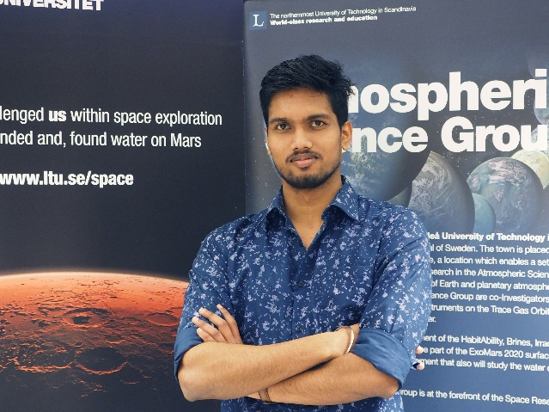

Abhilash received his bachelor’s degree in Industrial engineering and Management from Visvesvaraya Technological University, India. His master degree in Space Science and Technology from Lulea University of Technology (LTU), Sweden. He joined Group of Atmospheric Science (GAS) at LTU as a Master student collaborator. He has been working on developing a chamber to simulate different space environment and a TRL-8 instrument ‘PACKMAN’ to monitor radiations from Sun entering lower layers of atmosphere. He is currently a PhD student in GAS with research focus on space environmental chambers, space weather, space qualification and planetary protection for Mars and space exploration.

