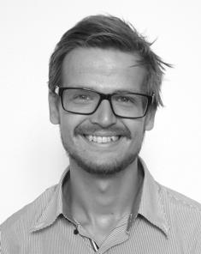
Lars Michael Skjolding completed his Ph.D. in 2015 at Technical University of Denmark, in the Department for Environmental Engineering with Prof. Anders Baun including a research stay at Gothenburg University in the group of docent Joachim Sturve. After his graduation, he stayed as a postdoctoral researcher in the group of Prof. Anders Baun with main research area being ecotoxicological effects and environmental risk assessment of chemicals with special focus on bioaccumulation, trophic transfer, imaging and characterization of engineered nanoparticles in aquatic organisms.

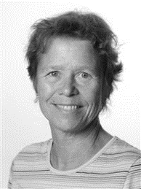

Susanne Kruse is a senior lab technician employed at the Technical University of Denmark. She has more than 30 years of experience planning and carrying out field and laboratory experiments related to site remediation, wastewater treatment, and ecotoxicology.

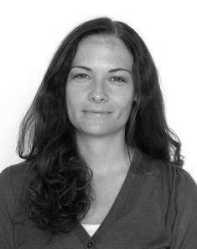
Sara Nørgaard Sørensen is Postdoc at the Department of Environmental Engineering, Technical University of Denmark, working with environmental risk assessment of nanomaterials. She has a M.Sc. in environmental engineering (2006), a Ph.D. in aquatic toxicity testing of engineered nanoparticles (2016) and has worked as consultant within the area of chemical regulations relating to human, occupational and environmental risk assessment of chemicals (2006-2012).

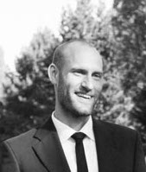
Rune Hjorth is a Ph.D. student in nanoecotoxicology and risk assessment. His research focus is on the risks and benefits of nanoremediation, alternative testing strategies and advancing nanosafety through early decision-making. He holds degrees in environmental engineering and pharmaceutical science.

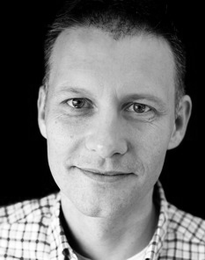
Anders Baun is professor in risk assessment of nanomaterials and head of the Environmental Chemistry section at the Department of Environmental Engineering, Technical University of Denmark. He has a M.Sc. in Environmental Engineering (DTU, 1994) and holds a Ph.D. in application of biotests for characterization of contaminated water samples (DTU, 1998). His post doc. research focused at risk assessment, chemical, and biological aspects of groundwater pollution. His main research area is today environmental risk assessment of nanomaterials.

