Dear Author(s),
This document is divided into sections in which you can add your comments to the video and voiceover. Please be aware that our policy is to do a single complimentary revision, so it is critical that all participants in this project offer their comments collectively. In addition, please make sure that your comments are easily interpreted and transparent.
Have fun!
Protocol Name: In Vivo Targeting of Neural Progenitor Cells in Ferret Neocortex by In Utero Electroporation
Date: 20/10/2020

Authors and Affiliations
Please fill in any missing author information not included in the video.
Order | Author | Affiliation
 | Hiroshi Kawasaki | The name of the Kanazawa University is missing on the first (title) slide (see also comment 1 below).
 | Nereo Kalebic | Max Planck Institute of Molecular Cell Biology and Genetics (MPI-CBG)  Human Technopole
 | Nereo Kalebic | Please use both of these affiliations at 0:07.
 | Barbara Langen | Next to "MPI-CBG" please also add "Landesdirektion Dresden" at 1:29
 | Wieland B. Huttner | Please add "B." initial at 6:13

Video Comments
Please fill in any comments you wish to make using the table below using the example as a guide. If you need more space to write, please do so below the table. DO NOT ADD CORRECTIONS TO THE NARRATION HERE. PLEASE DO THIS IN THE AUDIO COMMENTS SECTION.
 | Time code | Comment | Requested Change
Example | 2:52 | Onscreen text says use 0.25 mM Fluo-4 | Text should say use 0.50 mM Fluo-4
1. | 0:03 | Title slide - affiliation 4 | Text should say "4Department of Medical Neuroscience, Graduate School of Medical Sciences, Kanazawa University"  Currently "Kanazawa University" is missing.
2. | 0:07 | Onscreen text says "institution" | Please add both institutions of the affiliation: "MPI-CBG" and "Human Technopole"
3. | 01:20 | Onscreen text says Katrin Reppe, animal welfare officer | please change “animal welfare officer” into “veterinarian” and add the name of the institution "MPI-CBG"
4. | 03:05 | When audio comment says "pigmented iris" | Please add an arrow to indicate the pigmented iris since this should be helpful to the reader. We attach below a screenshot with the iris indicated as an example. Please make it the way you think is the most informative and appealing visually (the same is true for the next comment).
5. | 03:34 | When audio comment says "injected ventricle, which will now be visible..." | Please mark the injection area. We attach below a screenshot with an example of marking. Please make it the way you think is the most informative and appealing visually (the same is true for the previous comment).
6. | 04:13 | When the narrator says to press "pulse"... | It would be more logical to show the embryo with electrodes at this moment rather than immediately the PBS. Since the electroporation itself lasts several seconds it is strange that when the camera moves to the embryos the electrode is already gone and only PBS is being added. We would suggest to show another frame of electrodes on the embryo and then the narrator can mention the PBS and you can show drops of PBS.
7. | 05:02 | Magenta rectangles appear on B and C | Please remove the upper (smaller) rectangle from C and increase the size of the lower (larger) rectangle so that it covers also the area marked with "OSVZ" and finishes around the area marked with IZ (see also next comment)
8. | 05:08 | Red rectangle appears on D | Please remove the upper (smaller) rectangle.
9. | 06:13 | Onscreen text says "Wieland Huttner" | Please change to "Wieland B. Huttner"
10.
11.
12.
14.
15.
16.
17.
18.
19.
20.

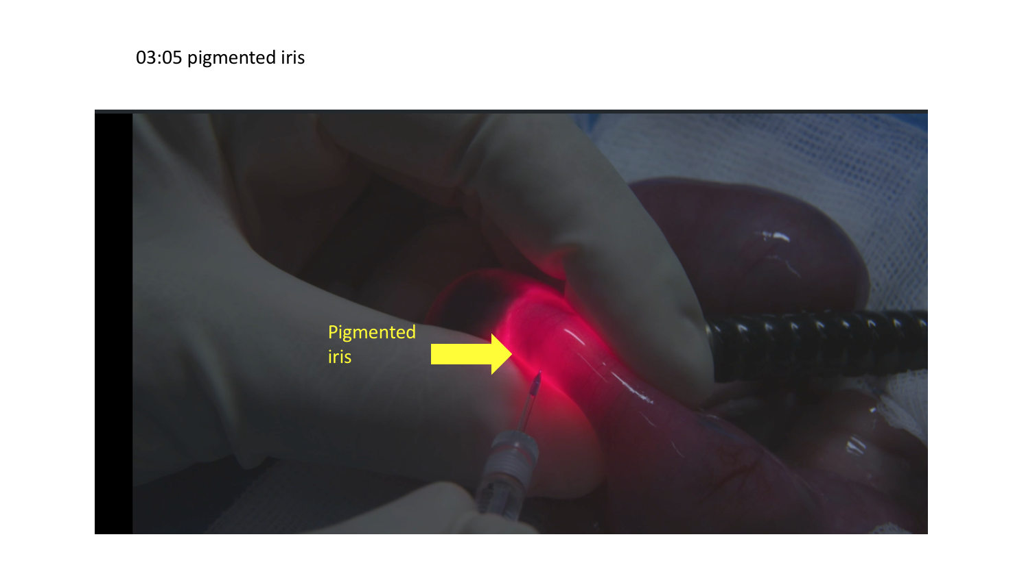

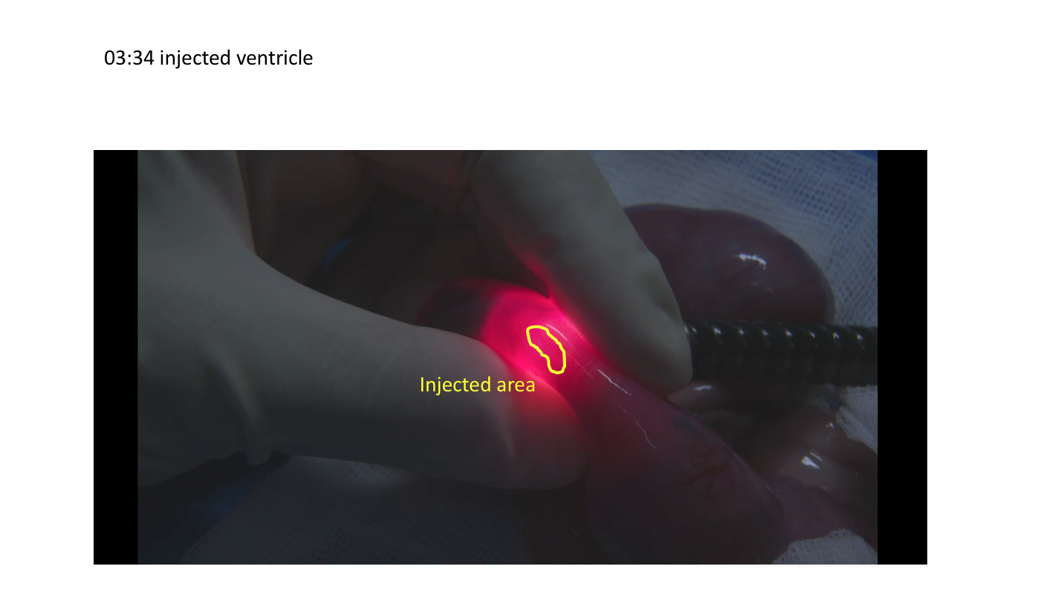

Audio Comments
This section is used to specify the changes that need to be made to the narration. Please follow the example below as a guide to list your changes. If there is a pronunciation change, please provide a phonetic pronunciation key or a web link.

 | Time code | Comment | Step(s) in Shotlist | Rewritten Text or Corrected Pronunciation (highlight in bold)
Example | 1:49 | Original Script Text:  “Then, show the participant their electromyography, or EMG patterns, which correspond to eight specific and unique polar plots.” | 2.2 | Rewritten Script Text:  “Then, show the participant the unique and specific polar plots, which correspond to their electromyography, or EMG (pronounced E-M-G) patterns.”
1.
2.
3.
4.
5.
6.
7.
8.
9.
10.
11.
12.
13.
14.
15.
16.
17.
18.
19.
20.

