Responses
Editorial comments:
1. Please note that the editor has formatted the manuscript and made changes to the protocol section according to JoVE guidelines. The updated manuscript is attached; please review for accuracy and use this version to incorporate the changes that are requested. Please clarify unclear language throughout the manuscript and ensure that there are no spelling or grammar issues.
Response: Many thanks, we have carefully checked the whole manuscript, and the changes were tracked.
2. Please address reviewers’ following comments by providing clear explanations and including limitations of the protocol in the introduction/discussion section: a. PEI and CT-PEG both have multiple active groups, how to block the crosslink action? b. What's the basic mechanism for the synthesis of PEI-g-PEG@AuNP, DOX-g-PEI-g-PEG@AuNP, and AS1411-DOX-g-PEI-g-PEG@AuNP? c. DOX release behavior should be investigated. d. The only major concern is that the branched PEI is a synthetic polymer that can attach induce non-specific toxicity. So, how authors rationalize this issue?
Response: Thanks for the comments from the reviewers.
- Because of amide reactions between amino groups from PEI, and carboxyl groups from CT-PEG polymer, it is difficult to block the crosslink action. However, we tried to use some skills, such as adding the second reactant dropwise very slowly, and dialysis, the potential synthesized polymer was kept, and unreacted polymer and crosslinked parts were removed during the dialysis process. We gave more details in the Protocol section, and discussed this point in the Discussion section, so that the readers can repeat the experiments.
- The basic mechanism for the synthesis of PEI-g-PEG@AuNP, DOX-g-PEI-g-PEG@AuNP, and AS1411-DOX-g-PEI-g-PEG@AuNP was based on amide reaction, as shown in following figure. We have clearly described such mechanism in the Discussion section.
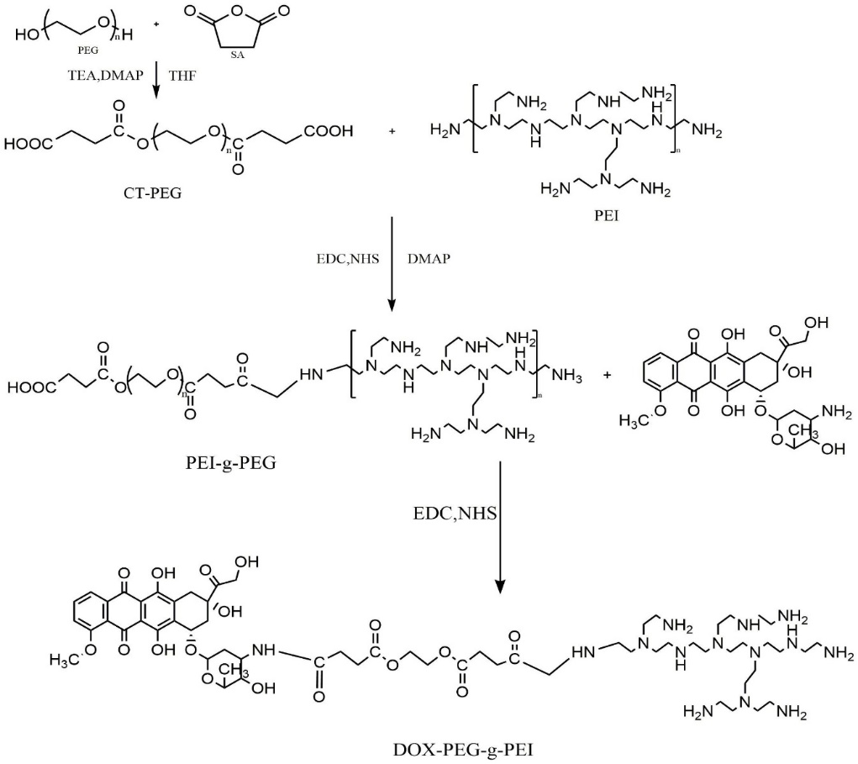
- The DOX release profile was given in Figure 9.
- It was confirmed that the branched PEI polymer can induce non-specific toxicity, because of some amino groups and structure of polymer. However, in this study, the branched PEI was grafted to PEG, the structure of copolymer changed, and according to CCK-8 results, PEI-g-PEG@AuNP was non-toxic to cells. We have described this issue in the discussion part.
3. Please address specific comments marked in the attached manuscript.
Response: comments in the manuscript were answered and addressed correspondingly.
4. JoVE is a methods-based journal. Thus, the discussion section of the article should be focused on the protocol and not on the representative results. Please revise the Discussion to explicitly cover the following in detail in 3-6 paragraphs with citations:
a) Critical steps in the protocol
b) Modifications and troubleshooting of the method
c) Limitations of the method
d) The significance of the method with respect to existing/alternative methods
e) Future applications or directions of the method
Response: many thanks, according to your suggestion, we have revised the Discussion part.
5. Figure 7: Please use the micro symbol µ instead of u (i.e., µg/mL).
Response: thanks, the figure was revised, “u” was changed to “µ”.
6. Table of Materials: Please ensure that it has information on all relevant supplies, reagents, equipment and software used, especially those mentioned in the Protocol. Please sort the materials alphabetically by material name.
Response: thanks, the Table of Materials was revised.

