Explicit Copyright Permission (Author License Agreement [ALA])

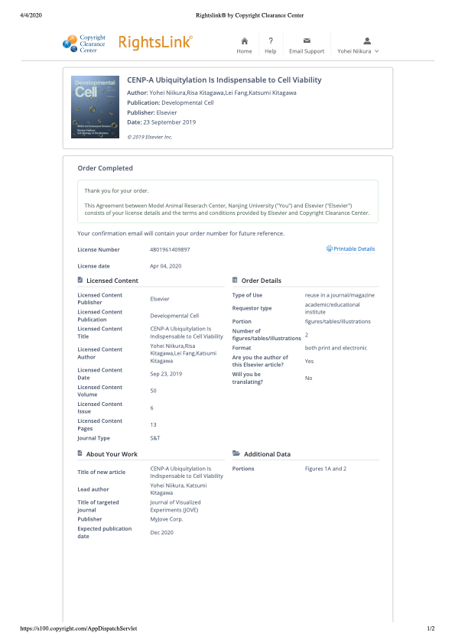

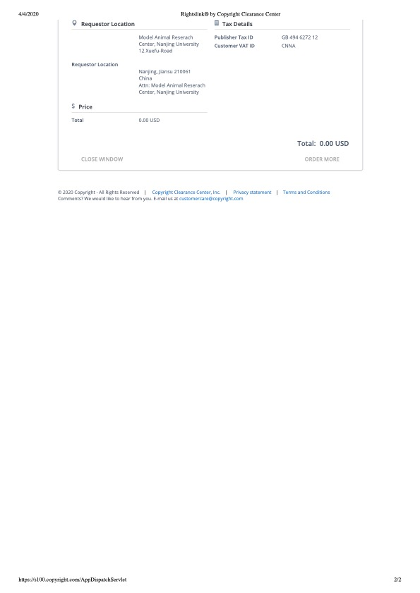

Dear Dr. Niikura,

Thank you for the email, and I apologize for the delay in responding—I was just trying to ensure I had the right information to convey to you. Please refer to the following excerpt from our website for more information:

Permissions
If you want to use excerpts or images, original or adapted, from articles that you have published in a Cell Press journal, you do not need to ask our permission. Our policy only requires that you cite the original publication.
If you want to use excerpts from copyrighted work in your Cell Press submission, you must obtain written permission from the copyright owners and cite the original publication. For information about how to request permission to use copyrighted material, including work published elsewhere at Elsevier, please visit our permissions page.
If you have adapted a published figure, you may or may not need permission from the copyright owner, depending on how much the adaptation resembles the original. When in doubt, check with the copyright owner and cite the original article.
Obtaining permission can take several weeks. To avoid any delays to publication, we recommend that you seek permission before or at the time of submission.

Best,

Joel Schanke
Editorial Operations Associate
Cancer Cell and Developmental Cell
cancer@cell.com ; devcelleditor@cell.com
50 Hampshire St. 5th Floor Cambridge, MA
781-663-2241

Dear Yohei,

Thank you for your e-mail and your patience while I figured out how to address your question. To re-use a figure, which originally appeared in a Dev Cell paper, you do need to get Elsevier permission. I would recommend to contact the Elsevier Permissions Helpdesk Support Center here: https://service.elsevier.com/app/contact/supporthub/permissions-helpdesk/. This Permissions FAQ page might also be helpful: https://www.elsevier.com/about/policies/copyright/permissions

I hope this is helpful.

Best wishes,
Julie

*****************************
Julie Sollier, Ph.D.
Editor-in-Chief, Developmental Cell
Twitter
jsollier

