

Environment and Infectious Risks
Research and Expertise Unit
(ERI)
Laboratory for Urgent Response to Biological Threats (CIBU)

Jean-Claude MANUGUERRA
Christophe BATEJAT

Paris, December 12th 2019

Dear Editor,

Please find enclosed our manuscript entitled “Monitoring influenza virus survival outside the host by using Real-Time Cell Analysis (RTCA)” for publication in JoVE journal:

In the present article we aimed at describing the protocol used to monitor Influenza A virus persistence in laboratory environmental conditions with Real-Time Cell Analysis (RTCA) system.

We hope that you will find our manuscript a suitable candidate for publication in JoVE journal.

Sincerely,

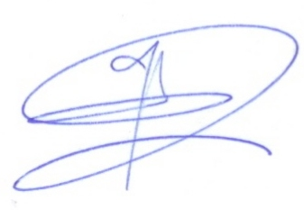

Dr. India Leclercq
Environment and Infectious Risk Unit (ERI)
Laboratory for Urgent Response to Biological Threats (CIBU)

