Dear Editor and reviewers:

Thank you for the thorough review and constructive suggestions. We have made corrections and modification according to each comment in blue, and our revision in the manuscript was highlighted in red.

Editorial comments:
1. Please take this opportunity to thoroughly proofread the manuscript to ensure that there are no spelling or grammar issues. The JoVE editor will not copy-edit your manuscript and any errors in the submitted revision may be present in the published version.
- All authors have proofread the manuscript.
2. JoVE cannot publish manuscripts containing commercial language. Please remove all commercial language from your manuscript and use generic terms instead. All commercial products should be sufficiently referenced in the Table of Materials and Reagents.
For example: Liberase TM buffer, Worthington Biochemical, Cat# LK003172, Sigma-Aldrich, Cat# 5401119001P, EGM-2 Medium (Lonza, Cat# CC-3162), Gibco, Cat# 10010023, Gibco, Cat# 14025092, Gibco, Cat# A1049201, Miltenyi Biotec, Cat# 130-116-505, Miltenyi Biotec, Cat# 130-048-801, Quick-RNA Microprep Kit (Zymo Research, Cat# R1050), MACS, Eppendorf, etc.
- All commercial language has been removed from the manuscript, excluding the Materials and Reagents excel document.
3. Please ensure that all text in the protocol section is written in the imperative tense as if telling someone how to do the technique (e.g., “Do this,” “Ensure that,” etc.). The actions should be described in the imperative tense in complete sentences wherever possible. Avoid usage of phrases such as “could be,” “should be,” and “would be” throughout the Protocol. Any text that cannot be written in the imperative tense may be added as a “Note.” However, notes should be concise and used sparingly. Please include all safety procedures and use of hoods, etc.
- The protocol has been revised to contain only the imperative tense, in complete sentences, and without aforementioned phrases.
4. The Protocol should contain only action items that direct the reader to do something.
- The protocol has been revised to contain only action items.
5. Please add more details to your protocol steps. Please ensure you answer the “how” question, i.e., how is the step performed?
- The protocol has been revised to include more detail, specifically those addressing the “how” question. For instance, all instruments used are addressed in each step, further instruction on dissection has been added, and qPCR conditions are outlined.
6. Please remove the embedded Table from the manuscript. All tables should be uploaded separately to your Editorial Manager account in the form of an .xls or .xlsx file. Each table must be accompanied by a title and a description after the Representative Results of the manuscript text.
- The embedded tables have been removed and are submitted separately as .xlsx files.
7. Please move all the materials to the table of materials instead.
- All materials have been removed from the protocol.
8. 2.2: Where is the needle inserted? How much blood is collected and how?
- The needle is inserted into the portion of the posterior vena cava located behind the intestines. The blood is removed by withdrawing the plunger of the syringe, and this is done until the tissue of the liver appears lighter in color and no blood can be further withdrew. These specifics have been added to the protocol.
9. 2.4: Please include volume and concentrations of all the solutions and reagents used.
- The volume and concentration of all the solutions and reagents has been added to the protocol.
10. 2.5: How is this done? How do you visually identify each of them?
- You can visually determine the ventricles by laying the heart on the flatter posterior face, enabling the identification of the left and right ventricles. The pulmonary artery is identified as the most anterior of the veins and arteries that branch from the top of the heart, and the aorta is directly behind it. The right ventricle is removed by starting from the branching point of the pulmonary artery from the right ventricle, and cutting down the anterior face of the heart along the septum and back up the posterior face. Starting from the same branching point, one cuts perpendicular to the previous dissection, away from the septum, until the ventricle is liberated from the remaining heart. This same procedure is repeated to remove the left ventricle, but utilizing the branching point of the aorta from the left ventricle. This detail has been added to the protocol. Please see image below for clarity. Both the image and this description have been added to the protocol on page 7, Figure 1.

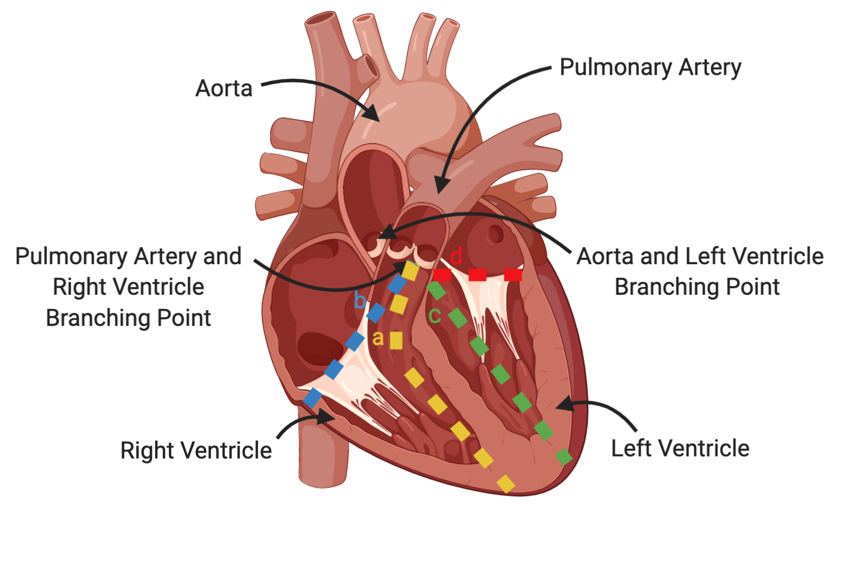
Figure legend: Diagram of heart dissection. a) First cut made to separate the right ventricle free wall from the septum; b) Second cut made to liberate the right ventricle completely; c) First cut made to separate the left ventricle free wall from the septum; d) Second cut made to liberate the left ventricle completely.
11. 3: How do you visually differentiate between inner and outer surface of left ventricle.
- The ventricles maintain a slight concave shape, enabling the differentiation between the inner and outer surface. This specification has been added to the protocol.
12. 6.14: How do you perform qPCR. Please detail the conditions.
- The detail conditions have been added to the protocol on page 6, steps 6.15.1-6.15.4. These details include the addition of 5uL of EEC or CEC cDNA into wells of a 384 qPCR plate, the mixing of 6ul of 2X qPCR SYBR Green buffer with 1 ul of each primer, the addition of the buffer and primer mixture into the wells, the final preparation of the plate with a plastic seal and 1 min 300 g at room temperature centrifuge, and the qPCR protocol. This consists of starting with 95 ºC for 3 minutes, followed by 95 ºC for 15 seconds, and then 55 ºC for 60 seconds, and repeating the subsequent two steps for 45 cycles. The detailed information has been added to the protocol (6.15).
13. There is a 10-page limit for the Protocol, but there is a 2.75-page limit for filmable content. Please highlight 2.75 pages or less of the Protocol (including headings and spacing) that identifies the essential steps of the protocol for the video, i.e., the steps that should be visualized to tell the most cohesive story of the Protocol.
- Approximately 2.5 pages of the protocol have been highlighted.
14. Please obtain explicit copyright permission to reuse any figures from a previous publication. Explicit permission can be expressed in the form of a letter from the editor or a link to the editorial policy that allows re-prints. Please upload this information as a .doc or .docx file to your Editorial Manager account. The Figure must be cited appropriately in the Figure Legend, i.e. “This figure has been modified from [citation].”
- The manuscript does not contain any figures form a previous publication.
15. As we are a methods journal, please revise the Discussion to explicitly cover the following in detail in 3-6 paragraphs with citations:
a) Critical steps within the protocol
- The critical steps highlighted in the discussion include digestion time, digestion termination, RBC lysis, lysis termination, HBSS wash, and digestion buffer preparation. Digestion time was discussed on page 7, paragraph 5, lines 1-3; digestion termination was noted on page 7, paragraph 5, lines 4 and 5; RBC lysis was highlighted on page 7, paragraph 5, lines 5-7; lysis termination was mentioned on page 7, paragraph 5, lines 7 and 8; HBSS wash was discussed on page 7 and 8, paragraph 6, lines 1-4; and digestion buffer was noted on page 8, paragraph 1, lines 4-9.
b) Any modifications and troubleshooting of the technique
- The discussion notes a modification in the digestion time of the endocardium, on page 7, paragraph 5, lines 1-3, which we reduced to prevent cellular damage. Meanwhile, the potential EC populations cross-contamination was also discussed on page 8, paragraph 3, lines 1-8, with feasible solutions.

c) Any limitations of the technique
- The greatest limitations of the technique are the small number of EECs in rat tissue, noted on page 7, paragraph 5, lines 1-3, and potential cross-contamination of EC populations, discussed on page 8, paragraph 3, lines 1-8. Additionally, the delicate timing of digestion and incubation with lysis buffer creates opportunity for error, mentioned on page 7, paragraph 5, lines 4 and 5. Under digestion could lead to insufficient collection of cells, but over digestion results in cell damage. Similarly, as highlighted on page 7, paragraph 5, lines 5-8, if incubation with lysis buffer is terminated too quickly, RBCs may still be present. However, if left for too long, the lysis buffer will damage the CECs and EECs.

d) The significance with respect to existing methods
- Existing methods of endothelial cell isolation, added on page 7, paragraph 4, lines 2-4, are limited to macrovascular tissues, and thus do not provide a mechanism for collecting endocardial endothelial cells. The inability to collect EECs and CECs independently prevents the examination and identification of cell specific functions and unique roles in diseases. This significance has been added to the discussion.
e) Any future applications of the technique
- In the discussion, it is mentioned on page 7, paragraph 4, lines that this technique can be used to understand cell specific roles in development and disease; which could be used as a reference for iPSC differentiation, or the examination of these cell populations as therapeutic targets.

Reviewer #1:
1. The only concern I have is how to avoid contamination of coronary ECs when authors use digestion buffer to the immersed inner surface. It is very likely that some coronary ECs on the flanks or in the subendocardial myocardium could be digested and collected. It would be more valuable if authors could find a surface marker that could distinguish endocardial cells from coronary ECs, which would permit FACS isolation and purification. Since there are published data (RNA-Seq or scRNA-Seq) on these two distinct cell populations, exploration of one surface marker for endocardial cells that distinguish from coronary EC would be future direction. Authors may add some discussion on this point.
- We completely agreed with reviewer’s concern. As we have revealed recently (Miao et al., Single-Cell RNA-Seq Reveals Endocardial Defect in Hypoplastic Left Heart Syndrome. bioRxiv, 2019), EEC and CEC represented distinguished sets of genes. In combination with previous mouse heart single cell gene expression analysis (Zhang et al., Endocardium Minimally Contributes to Coronary Endothelium in the Embryonic Ventricular Free Walls. Circulation Research, 2016), several genes expressed on the cell surface shared high expression specificity to distinct EC populations, e.g. Npr3 to EEC and Cd36/Apj to CECs. As mentioned by reviewer, it will be worthwhile further purifying the cells using FACS or MACS with suitable antibodies specific to these surface markers. In fact, recently we have successfully isolated EECs from a heterogeneous cell population using FACS sorting with Npr3 antibody. These points were well-taken, and added to the 5th paragraph of the Discussion.

2. why Nfatc1 is also high in CECs? Is coronary vessel expressing Nfatc1? could authors discuss on this?
- According to Zhang et al’s research, noted in the paper “Endocardium Minimally Contributes to Coronary Endothelium in the Embryonic Ventricular Free Walls”, Nfatc1 was found to be expressed in both EECs and a subset of CECs, albeit sporadically. This potentially explains its expression pattern in both cell populations from our qPCR data. Plus, our current protocol can not completely exclude minor cross-contamination between the two EC populations, which might also cause Nfatc1 expression in both. Since Nfatc1 is not a clean endocardial marker, we have removed Nfatc1 qPCR data from our results to avoid misunderstanding.

Reviewer #2:
1. Please indicate the strain of rats.
- The rats’ strain is Sprague Dawley, and this information was added to the protocol on page 3, as a note under step 2.
2. Step 3.3: 5%CO2 incubator?
- Yes it is in 5%CO₂ incubator. This has been noted in the protocol.
3. Step 3.4: why is there a range of 1-5ml of volume to add? Why not an exact volume?
- This is due to the variability of digestion buffer used. The protocol specifies that digestion buffer is added until just the inner surface is submerged. Because the size of the ventricles or the number of ventricles digested may vary, the amount of digestion buffer added is inconstant. The amount of EC medium added should be a consistent ratio to the amount of digestion buffer present in the dish. This clarification has been noted.
4. Step 4.2: mince with which instrument?
- The tissue is minced with dissection scissors. This specification has been added.
5. Step 5.3: in water bad?
- Yes, incubation takes place in a water bath. This specification has been added.

