Yutaka Yawata
University of Tsukuba
Tennoudai 1-1-1
Tsukuba, Ibaraki, 305-8572, Japan
Phone: +81 29 853 7098
Email: yawata.yutaka.ga@u.tsukuba.ac.jp

Lyndsay Troyer, Ph.D.
Senior Science Editor
Journal of Visualized Experiments
Feburary 25, 202o

Dear Lyndsay Troyer,

Please find enclosed a revised version of our manuscript previously submitted to the Journal of Visualized Experiments, titled “Reconstruction of single-cell innate fluorescence signature by confocal microscopy”. We have now addressed all comments with great care, as detailed in the attached point-by-point response, through revisions.
We hope you will find the revised manuscript suitable for publication and remain at your disposal for any clarification.

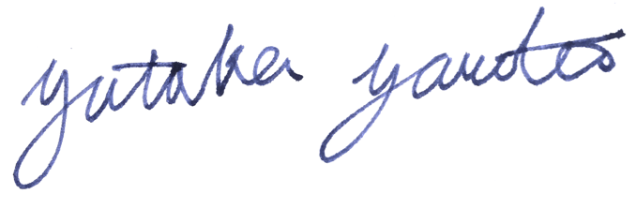
Yutaka Yawata PhD. (on behalf of all authors)
Assistant Professor
Faculty of Life and Environmental Sciences
University of Tsukuba

Editorial comments:
As your highlighted content contains detailed, step-by-step, descriptions of software usage, the inclusion of supplemental screen capture or screenshots for the software usage would greatly expedite the scripting and production. You can either take screenshots of the software GUI or use screen capture software (https://www.jove.com/video/5848/screen-capture-instructions-for-authors?status=a7854k). Please include the manuscript number in these supplemental files and number the files in order of appearance: JoVE61120R1_screenfile1, etc..
Thank you for suggestions. We have now included the screenshots as one of the supplementary materials.
1. Please note that the editor has formatted the manuscript to match the journal's style. Please retain the same. The updated manuscript is attached and please use this version to incorporate the changes that are requested.
We followed the instruction in revising the manuscript.
2. Please revise lines 36-40, 42-44, 53-54, 66-68, 388-400, 402-404, 416-418 to avoid textual overlap with previously published work.
We have revised the suggested sentences.
3. Please address specific comments marked in the attached manuscript.
We have addressed all the comments and attached the marked-up version of main-tex as the rebuttal letter.

