Editorial comments:
Changes to be made by the Author(s):
1. Please take this opportunity to thoroughly proofread the manuscript to ensure that there are no spelling or grammar issues. The JoVE editor will not copy-edit your manuscript and any errors in the submitted revision may be present in the published version.
The manuscript has been carefully proofread and a number of errors have been corrected.
2. Please revise the table of the essential supplies, reagents, and equipment. The table should include the name, company, and catalog number of all relevant materials in separate columns in an xls/xlsx file. Please sort the Materials Table alphabetically by the name of the material.
The table has been revised and reorganized to follow the alphabetical order
3. Figure 1: Please use word labels for min and temperature (°C).
The labels have been modified as required.
4. JoVE cannot publish manuscripts containing commercial language. This includes trademark symbols (™), registered symbols (®), and company names before an instrument or reagent. Please remove all commercial language from your manuscript and use generic terms instead. All commercial products should be sufficiently referenced in the Table of Materials and Reagents.
All trademark and registered symbols have been removed from the manuscript and the products are appropriately referenced in the Table.
5. Please add more details to your protocol steps. Please ensure you answer the “how” question, i.e., how is the step performed? Alternatively, add references to published material specifying how to perform the protocol action.
More details have been added to the protocol.
6. 1.1.1: Dissolve in what container?
It is now specified
7. 1.1.3: Transfer to a glass vial of what size/volume? Separate with the magnet for how long?
It is now specified
8. 1.1.4: Wash using the magnet?
It is now specified
9. 1.1.5: Centrifuge at what speed for how long?
It is now specified
10. 2.1: Amplify the cells how?
It is now specified
11. 3.2: Please quantitate a small volume.
It is now specified
12. 3.3: When/How are the cells counted?
It is now specified in 3.2.
13. 3.4: What happens after centrifugation?
After centrifugation, a cell pellet is formed at the bottom of the tube, which is now better explained.
14. Please remove the embedded figure(s) from the manuscript. All figures should be uploaded separately to your Editorial Manager account. Each figure must be accompanied by a title and a description after the Representative Results of the manuscript text.
The figures have been removed from the manuscript and uploaded separately.
15. As we are a methods journal, please revise the Discussion to explicitly cover the following in detail in 3-6 paragraphs with citations:
a) Critical steps within the protocol
b) Any modifications and troubleshooting of the technique
c) Any limitations of the technique
d) The significance with respect to existing methods
e) Any future applications of the technique
The mentioned points have been addressed in the discussion, which has been increased with two new paragraphs.
Reviewers' comments:
Reviewer #1:
We will consider publishing your paper entitled "Monitoring the cellular incorporation and degradation of magnetic nanoparticles by 6 magnetometry"; after minor revisions based on the below review(s).
1. The title is not catchy and does not reflect essential contents.
The title has been modified to better reflect all main content of the manuscript, as follows:
“Magnetometry as a tool to monitor cellular incorporation and subsequent biodegradation of chemically synthetized iron oxide nanoparticles”

2. The quality of figure 2 is not acceptable.
We agree that the quality of figure 2 was low, we solved this issue by saving the figure in a better format.
3. I was surprised to see that the synthesis method, according to the manuscript (discussion/conclusion), has no major limitations. Is this correct? If not, please specify in the manuscript.
The reviewer is right that we had justified the use of our non-aqueous sol-gel synthesis but not discussed its limitations. In our opinion, the biggest limitation of the non-aqueous sol gel route is the limited size increase of the nanoparticles, which is up to 12 nm. This information is now added to the discussion as follows: “Nevertheless, we can notice that with such microwave assisted non-aqueous sol-gel route, the upper size limit of the obtained nanoparticles is around 12 nm. This procedure would not be adapted for applications using ferromagnetic particles at room temperature.”
4. In the case of particle size, please give size± in nm. Concern approximately 10 particles and average their size.
The average nanoparticles size is obtained by measuring 200 nanoparticles and the standard deviation in nm has been added to the text: “8.8 ± 2.5 nm”

5. It is better to present a Table that compares obtained values with values reported by others.
The present paper is not focusing on the synthesis of magnetic nanoparticles themselves and, from pubmed, you find 14144 items about “iron oxide synthesis” which does not appear suitable for a table comparison within an experimental article.
Nevertheless, in accordance with remark 3, we briefly describe the main ways of iron oxide nanoparticles synthesis as follows: “Each protocol presents advantages and limitations. Iron oxide nanoparticles were usually synthesized in aqueous solutions via coprecipitation of iron ions²⁴. Other synthesis methods such as polyol-mediated sol-gel have then been developed²⁵. To overcome the limitations of nanoparticles size polydispersity control several nonaqueous approaches have been developed for the production of well-calibrated iron oxide nanoparticles²⁶. However, the use of massive amounts of surfactants like oleylamine or oleic acid complicates their functionalization and water transfer for biomedical applications.”
6. Several references, including synthesis of nanoparticles for drug delivery, should be added. Some of the related references are given: Colloids and Surfaces B: Biointerfaces 172 (2018) 244-253, Journal of Molecular Liquids 249 (2018) 1151-1160, Materials Science and Engineering: C 76 (2017) 1085-1093, Rsc Advances 4 (2014, 49), 25993-26001‏; Materials Science and Engineering: C 2014, 45, 29-36‏; Chemical Engineering Journal 252, 2014, 173-184‏; Materials Science and Engineering: C 2014, 40, 288-298‏; Journal of nanoparticle research 16 (2014, 9), 2604‏; Scientific reports 6, 2016, 32539‏; Materials Science and Engineering: C 76, 2017, 1085-1093‏; Microchimica Acta 184 (2017, 3), 825-833‏; International Journal of Hydrogen Energy 42 (2017, 39), 24846-24860‏; Journal of Molecular Liquids 249, 2018, 1151-1160‏; Colloids and Surfaces B: Biointerfaces 172, 2018, 244-253‏;
Consequently we added the possibility of using magnetic nanoparticles as drug delivery systems within the introduction: “The range of possible of these nanoparticles is also extended to drug delivery systems^{7,8} or to magnetic and photo-induced hyperthermal treatment for killing cancerous cells⁹⁻¹¹”
Fairly good paper. However, many technical and formal flaws. If these are eliminated, the paper will be much more attractive.
Reviewer #2:
Manuscript Summary:
The manuscript describes a reliable techniques for monitoring in cellulo degradation of magnetic nanoparticles. Such assay can be suitable for future experiments performed by scientists in the field.
Minor Concerns:
Authors should maintain the same sentence time (either present or past).
The sentences have been corrected such as maintaining a constant time.
References for VSM measurements should be provided.
References are now provided.
Grammar of sentence 1.2.1 should be revised.
We thank the reviewer for pointing it out, the grammar of the sentence has been revised.
In 2.1., please provide the passage ratio.
The cells are amplified until passage 4 or 5, it is now specified in the manuscript.
Why authors wash with RPMI and then use DMEM for spheroid seeding?
The washes in the nanoparticle incubation steps are performed using RMPI media as its ionic force is lower than DMEM and it prevents the aggregation of the nanoparticles. It is now specified in the manuscript as follows:
“RPMI is used for nanoparticle incubation (and the related rinsing steps) as it has a lower ionic strength than DMEM and it better prevents nanoparticle aggregation events.”
IN 2.4. how many times spheroids are washed?
The spheroids are washed once, it is now specified in the manuscript.
Is there any way to monitore the proper formation of spheroids during the 21 days of incubation?
The monitoring of the proper formation of the spheroids over the 21 days of culture is by simple observation. Indeed, it is possible to see the spheroid transitioning from a cell pellet to a spheroid. Photographs that illustrate this transition have been added to the Figure 3 as follows:
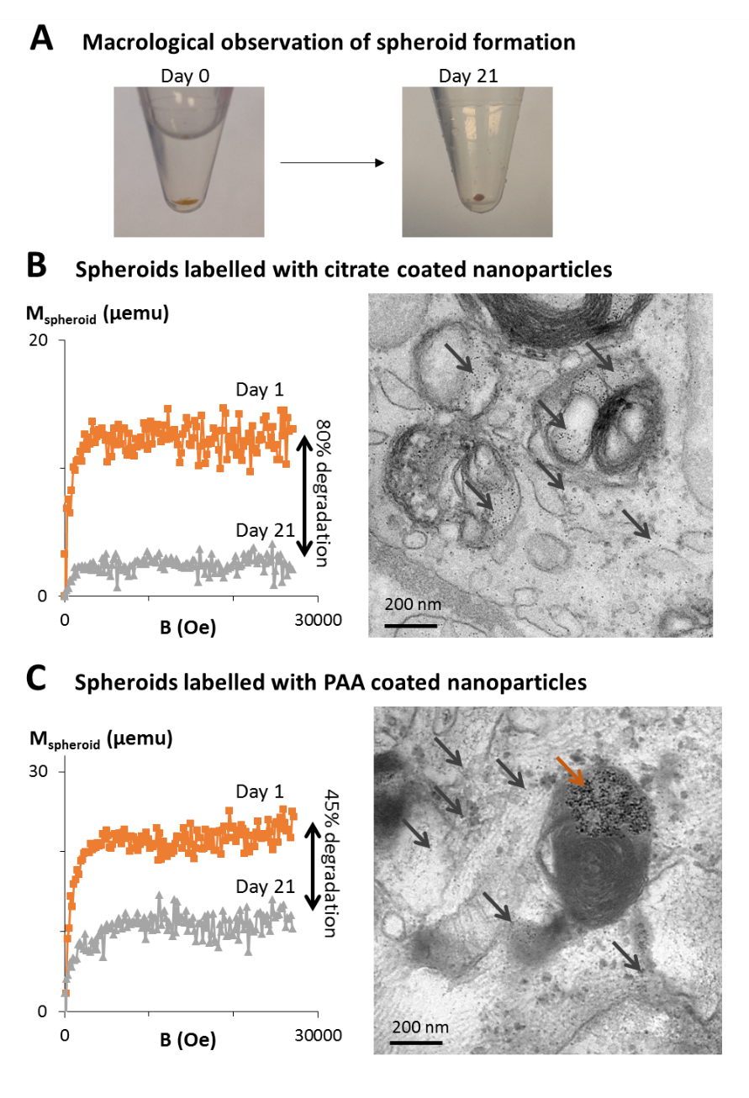
Figure 3: Quantification of magnetic nanoparticle degradation in cellulo via VSM. (A) Upon cell labeling with magnetic nanoparticles, a cell pellet is formed by centrifugation (day 0). The cells then form a cohesive structure resulting in an easy to handle cell-spheroid that can be kept in culture without cell loss for extended time periods (months). (B, C) Herein, two types of magnetic nanoparticles, coated with citrate (B) or PAA (C), are internalized in stem cells and the cells are cultured as spheroids for up to 21 days. Magnetism of spheroids cultured for 1 day (orange curves) and 21 days (grey curves) are measured with the VSM, with a decrease in magnetism indicating a degradation of the nanoparticles. Representative TEM images taken at day 21 show light grey dots about 6 nm is size within the endosomes and the cytoplasm of the cells, typical size and shape of ferritin, the iron storage protein (black arrows). Some intact nanoparticles can also be observed, mostly for the PAA-coated nanoparticles (brown arrow).

During these 21 days cells devide. How much this VSM decrease have to do with a dilution of nanoparticles as cells devide?
The reviewer is right to point out that, in case of cell proliferation, the nanoparticles would be diluted from mother to daughter cell as the cells divide. In the spheroid model used here, the cells are cultured in a specific medium that stops their proliferation, thus avoiding cell division and nanoparticle dilution. It was already specified in the manuscript with the following sentence
“Upon internalization of magnetic nanoparticles into stem cells, spheroids can be formed via a simple centrifugation followed by culture in a medium that stops the proliferation of the cells and drives extracellular matrix production.”
and it is known more thoroughly explained for a better comprehension, as follows
“By stopping cell division, there is no dilution of the nanoparticles from mother to daughter cell, moreover, it has been verified that, with this cell-spheroid model, there is no iron escape over a month of culture^{19, 20, 26}. As a consequence, a decrease in magnetism values can only correspond to a degradation of the nanoparticles and not to iron being exported out of the cells.”

