Dear Author(s),
This document is divided into sections in which you can add your comments to the video and voiceover. Please be aware that our policy is to do a single complimentary revision, so it is critical that all participants in this project offer their comments collectively. In addition, please make sure that your comments are easily interpreted and transparent.
Have fun!
Protocol Name: Model of Ischemic Heart Disease and Video-Based Comparison of Cardiomyocyte Contraction Using hiPSC-Derived Cardiomyocytes
Date: August 31, 2020

Authors and Affiliations
Please fill in any missing author information not included in the video.
Order | Author | Affiliation

Video Comments
Please fill in any comments you wish to make using the table below using the example as a guide. If you need more space to write, please do so below the table. DO NOT ADD CORRECTIONS TO THE NARRATION HERE. PLEASE DO THIS IN THE AUDIO COMMENTS SECTION.
 | Time code | Comment | Requested Change
Example | 2:52 | Onscreen text says use 0.25 mM Fluo-4 | Text should say use 0.50 mM Fluo-4
1. | 3:48 | Yellow line goes up  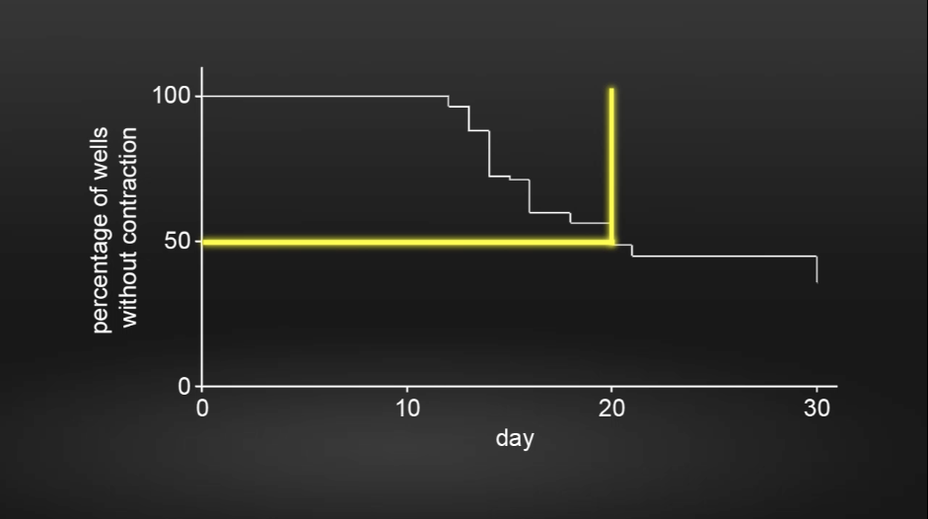 | Yellow line should go down to indicate the date  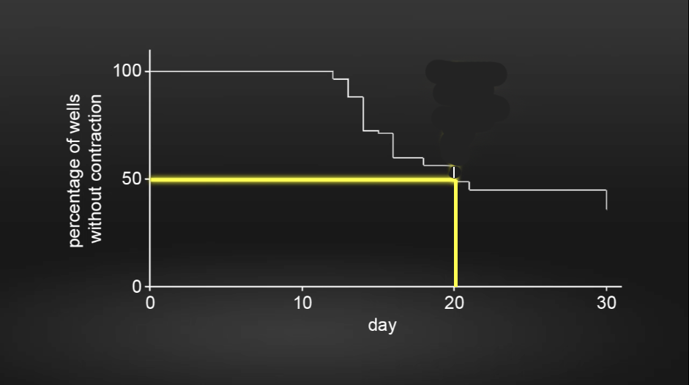
2. | 4:14 | FACS curve area not painted  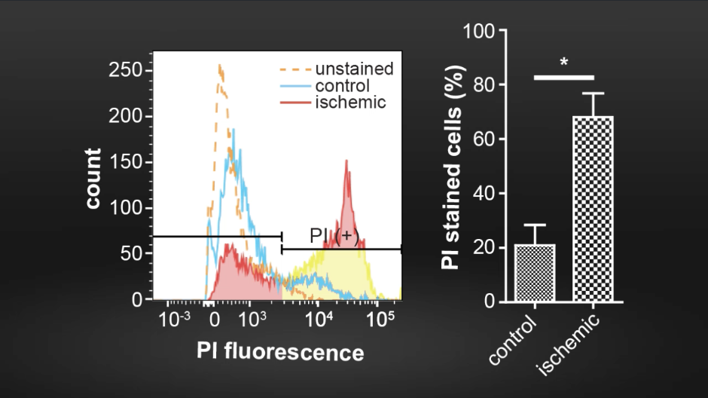 | FACS curve area should be painted  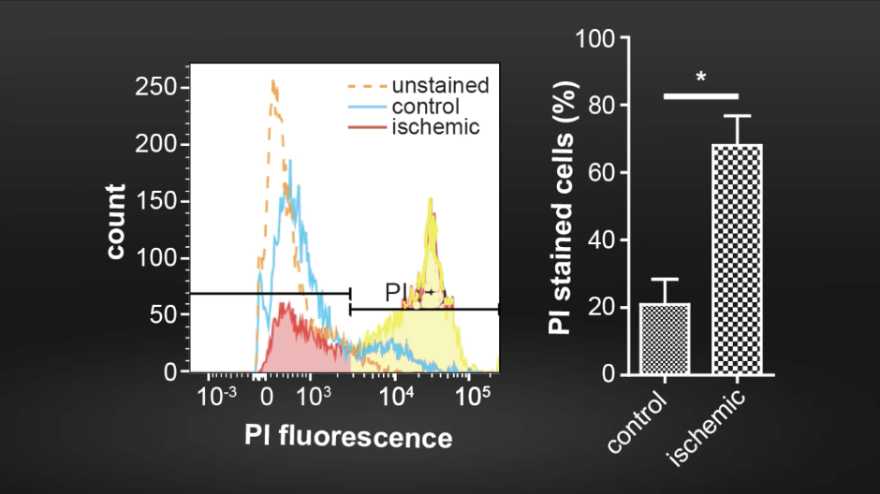
3.
4.
5.
6.
7.
8.
9.
10.
11.
12.
14.
15.
16.
17.
18.
19.
20.

Audio Comments
This section is used to specify the changes that need to be made to the narration. Please follow the example below as a guide to list your changes. If there is a pronunciation change, please provide a phonetic pronunciation key or a web link.

 | Time code | Comment | Step(s) in Shotlist | Rewritten Text or Corrected Pronunciation (highlight in bold)
Example | 1:49 | Original Script Text:  “Then, show the participant their electromyography, or EMG patterns, which correspond to eight specific and unique polar plots.” | 2.2 | Rewritten Script Text:  “Then, show the participant the unique and specific polar plots, which correspond to their electromyography, or EMG (pronounced E-M-G) patterns.”
1.
2.
3.
4.
5.
6.
7.
8.
9.
10.
11.
12.
13.
14.
15.
16.
17.
18.
19.
20.

