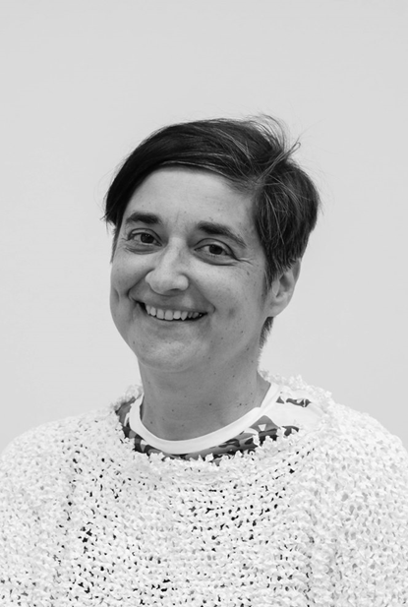Alke Petri-Fink received her Ph.D. in Chemistry from the University of Ulm, Germany, in 1999. After a postdoctoral stay at the University of Gainesville, Florida, she joined the Institute of Materials Science at the école Polytechnique Fédérale de Lausanne (EPFL), first as a postdoctoral researcher, then as a senior scientist. She became an Associate Swiss National Science Foundation Professor in the Department of Chemistry at the University of Fribourg in 2009, and full professor in 2011 at the Adolphe Merkle Institute, Switzerland, as the co-chair in BioNanomaterials. Her research focuses on inorganic nanoparticles, their synthesis, surfaces, and interactions with biological cells.

