We would like to thank the editor and the reviewers for their constructive criticisms and suggestions that have helped us to improve the manuscript. We have addressed editor requests and the concerns raised by the reviewers and we included additional tables with the survival rates of embryos and pups in single vs double electroporation experiments as requested by reviewer # 1.

Below is our point-by point response to the editor and the reviewers´ comments:

Editorial comments:
Changes to be made by the author(s):
1. Please take this opportunity to thoroughly proofread the manuscript to ensure that there are no spelling or grammar issues. The JoVE editor will not copy-edit your manuscript and any errors in the submitted revision may be present in the published version. We have proofread the manuscript trying to fix possible spelling and grammar issues
2. Authors and affiliations: Please provide an email address for each author in the manuscript. We added this info.
3. Please add more details to your protocol steps. There should be enough detail in each step to supplement the actions seen in the video so that viewers can easily replicate the protocol. Please ensure you answer the “how” question, i.e., how is the step performed? Alternatively, add references to published material specifying how to perform the protocol action. See examples below. We added more detail to the protocol as requested.
4. 1.1.1: Please include the maxi-prep kit used in the Table of Materials. Done Obtain plasmid DNA from what? Please specify. We have provided more information about the obtaining of the DNA at the beginning of the protocol.
5. 1.1.2: What volume of TE buffer is used? 9 µL? The amount of TE depends on the concentration of the DNA, which varies. We have provided an example to explain this “For example, take 2 µl of a 5 µg/µl plasmid DNA solution, 1 µl of Fast Green dye and 7 µl of TE buffer”
6. 1.3.4: Please specify the size of the syringe and the volume of the analgesic solution. Done (1 ml, 150 ul).
7. 1.3.5: For plasmid DNA solution, do you mean the solution prepared in step 1.1.2? Yes, we have now specified it.
8. 2.1: Please specify the strain of mouse used. We apologize for this mistake. The strain is C57BL6 we have now specified it in the manuscript.
9. 4.2.2: For how long does the perfusion last? It last around 5 min, duration of the procedure is now specified. Please specify surgical tools used here. We have added this information in the perfusion section.
10. Please combine some of the shorter Protocol steps so that individual steps contain 2-3 actions and maximum of 4 sentences per step. Please include single line spacing between each numbered step or note in the protocol. Done
11. After you have made all the recommended changes to your protocol section (listed above), please highlight in yellow up to 2.75 pages (no less than 1 page) of protocol text (including headers and spacing) to be featured in the video. Bear in mind the goal of the protocol and highlight the critical steps to be filmed. Our scriptwriters will derive the video script directly from the highlighted text. Done
12. Please highlight complete sentences (not parts of sentences). Please ensure that the highlighted steps form a cohesive narrative with a logical flow from one highlighted step to the next. The highlighted text must include at least one action that is written in the imperative voice per step. Notes cannot usually be filmed and should be excluded from the highlighting. We have tried our best to obtain a cohesive narrative. We excluded notes from the highlighting.
13. Please include all relevant details that are required to perform the step in the highlighting. For example: If step 2.5 is highlighted for filming and the details of how to perform the step are given in steps 2.5.1 and 2.5.2, then the sub-steps where the details are provided must be highlighted. We believe we have followed these instructions properly.
14. Please do not highlight any steps describing anesthetization and euthanasia. Done.
15. Figures: Please include a scale bar, ideally at the lower right corner, for all microscopic images to provide context to the magnification used. Define the scale in the appropriate figure Legend. We apologize for forgetting the scale bars. We added them to the figures and defined them on the figure legends
16. Please upload Table 1 to your Editorial Manager account as an .xlsx file. Done
17. Table of Materials: Please sort the materials alphabetically by material name. Done.
18. References: Please do not abbreviate journal titles; use full journal name. Done

Reviewer #1:
1) “The Authors state in the discussion that this new protocol…The protocol is very well described and the experimental examples provided are straightforward. Nevertheless, this protocol fails to show any new procedures; it describes just two consecutive in utero electroporations (IUE) at different time points and at different cortical regions in the same pregnant female.”

We would like first to thank reviewer #1 for his/her comments. We agree that the base of the methodology described here consists in the use of two consecutives in utero electroporations, but electroporation are performed at different ages and places and we believe this is not trivial, because the strategy detailed here provide a powerful tool to study interactions between cells with different spatial and temporal origins that otherwise will be almost impossible to study. The current manuscript offers a detailed explanation of how to successfully perform an a priori complex procedure that involve the two in utero surgeries at different times and locations and provides valuable examples showing its versatility that we think will be of interest to the scientific community.

2) The major concern is the survival rate of electroporated females after two consecutive IUE. The IUE procedure is very invasive and is usually considered a severe procedure in animal licence protocols. I think that in Europe where animal procedures are very strict, a double IUE would not be accepted by the ethical committee. It is thus very important that the authors shows us a table with the survival rate of the progeny after double IUE, compared to a single IUE procedure, before delivery (thus at E17.5 -E18.5) and after delivery (P5-P7). And also the survival rate and fitness of the electroporated mum. What is the strain of the elelctroporated females? Thus, to better evaluate the strength and efficiency of the method, it is important to add a report on the rate of abortion (strategy A) or delivery (strategy B), as well as the rate of survival at postnatal ages (strategy B) in comparison with the single IUE protocol.
We understand the concerns of reviewer #1 probably due to the incomplete explanations about these aspects in the previous version of the manuscript. Method safety for mother survival was already assessed for its use in several experiments described in a publication leaded by current senior author (Gil-Sanz et al, 2013). IUE is an invasive procedure because requires a laparotomy surgery, but performed under controlled circumstances does not imply risks for the mother survival. Survival of double electroporated females in our hands is the same than simple electroporated females, being around 100%. Females undergoing simple or double IUE surgery equally recover without problems after the surgery and show the same normal behavior the day following the first or the second surgery. Regarding the severity of the technique and according to the Spanish and European animal normative, the laparotomy surgery under anesthesia and with analgesia is considered to be a moderate in severity procedure, although interpretation may vary among ethical committees. About the possible problems on approval of the procedure in Europe, this double IUE procedure has been already approved by the ethical committee of the Universidad de Valencia (Spain) like the rest of the IUE procedures of our laboratory. In the current version of the manuscript we have added additional information regarding the survival of mothers in the discussion section and stated the approval by our animal committee at the beginning of the protocol.

We also want to thank the reviewer for suggesting the addition of tables clarifying embryos’ and pups’ survival rates after single versus double electroporations embryonically and postnatally. We have now included in the discussion more details about these questions in the discussion section and added tables with survival rates (Tables 2 and 3) as requested. Briefly, in our hands no important differences are found either in prenatal/postnatal survival or pup delivery, in double versus single electroporated embryos or pups.
Main difficulties with strategy A are related to the ability to manipulate and successfully target the desired part of the brain in very early embryos (E11.5). This increased difficulty in their manipulation is linked to the higher mortality at that age; however, embryos that survive after the first surgery have not important survival problems after second electroporation. Due to the difficulty to manipulate small embryos, we advise to learn and acquire enough expertise in the IUE technique with older ages E13-E14. We also want to state that efficiency and strength of the method is already proven as demonstrated by our previous publication in which this technique was used in several experiments (Gil-Sanz et al. 2013).
Respecting the strategy B, embryos’ survival after simple or double electroporation is higher than in A because of the increased hardiness of these older embryos (E13-E15). Moreover, no remarkable differences are found after single or double electroporation. No substantial differences in the delivery rate of the pups are found in simple versus double electroporated females. Main difficulties are associated with maternal behavior of the electroporated mothers. Similarly to what happens with single electroporated mothers, a proportion of them (displaying normal behavior and normal fitness status) take care of all the pups whereas others do not. Evaluation of this behavior after delivery helps to distinguish between “good or bad mothers”. When the mother displays poor maternal behavior, the use of foster mothers is helpful for us. Likewise, we provide extra-nesting material and tastier food including sunflowers seeds to electroporated females before the delivery date to try to favor maternal behavior. Again, no important differences have been found between simple or double electroporated females. We added more info in the discussion section and provided a table with survival rates.

The strain we have used for those experiments is the inbreed strain C57BL/6, we apologize for forgetting to provide this info. Better rates of maternal care after surgery are found using mixed background females (C57BL/6;129) or outbreed strains like CD-1 mice. Using those strains can help but differences among strains need to be evaluated before deciding timings for the surgeries.
3) “line 208: sodium azide is not a fixator, but an antibacterial agent”
We apologize for that mistake that has already been fixed.

4) “The IUE electroporation performed at E13.5 in the two experiments seems to target all layers and not only deep layers as it should be when IUE is performed at E13.5 (see Figure 1C and Figure 2C, D). If the authors wish to target layer V, then they should electroporate earlier than E13.5”
In utero electroporation at E13.5 targets many layer V projection neurons and also part of upper layer projection neurons, being E13.5 probably one of the ages that allows broader labeling of cortical projection neurons. This is the reason why this age was chosen. Our intention in this particular experiment was to label cells in different layers, because axons sent by upper layer cortical neurons to the contralateral side not only innervate layer V, but also layers II-III. We have avoided the use of transposon versions that would permit broader labeling across layers because it could also make more difficult the observation of fine contacts. We added additional information on the manuscript regarding to the election of the age for the electroporations in the representative results section.

Reviewer #2:
1) Can authors suggest type of mouth-controlled aspirator tube to be used for double in utero electroporation
We use the “Aspirator tube assemblies for calibrated microcapillary pipettes” from Sigma (A5177-5E) referred in the materials table as “Aspirator tube”.
2) Figure 1: authors may want to state what does the dashed white line represent in C.
We want to apologize for forgetting to mention what dashed lines mean. Upper dashed line delimits the marginal zone and lower dashed line the edge between intermediate zone and cortical plate. We have incorporated this info in the figure legend.
3) Figure 1.: GFP electroporated area is very lateral and may not be only somatosensory cortex that was transfected, as it is suggested. Authors may want to confirm in developmental atlases available and cite it.
We appreciate reviewer #2 comment regarding the electroporated region in Figure 1. The orientation of electrodes proposed in the scheme is aimed to target the parietal neocortex (somatosensory) although sometimes in early embryos we can also hit more lateral locations including insular, perirhinal or piriform cortex. Concerning this particular picture after the analysis of embryonic atlases of similar ages and rostrocaudal levels we believe the electroporated area is located in the parietal neocortex but it is close to the insular cortex (see attached picture from the Chemoarchitectonic Atlas of the Developing Mouse Brain, Jacobowitz and Abbott). In order to prevent possible misinterpretations, we will use the following term to describe the region targeted at these early ages: “lateral neocortex including somatosensory area”.

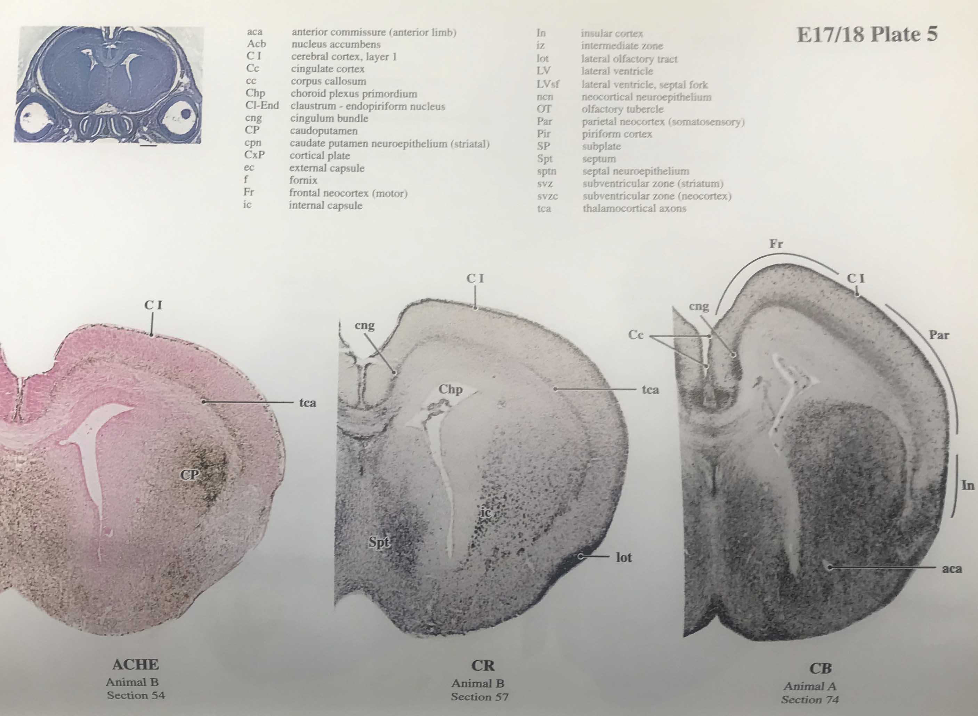

4) Authors may want to discuss if there is any advantage in using strategy B over double hemisphere electroporation at the same embryonic day E13.5.

It is known that callosal projection neurons are located in both upper and lower layers and that projections sent by these neurons innervate upper- and lower-layer neurons in the contralateral site. In this particular experiment we wanted to study specifically the contacts of a subpopulation of callosal projection neurons, those situated in upper layers, with targeted projection neurons located in both upper and lower layers of the contralateral cortex. Therefore, the main advantage of the double heterochronic electroporation versus double hemisphere electroporation is the possibility to target a subpopulation of callosal projection neurons, because E15.5 electroporation does not target lower layer callosal projection neurons. If we wanted to study callosal projections in general (from upper- and lower-layers projection neurons), double hemisphere electroporation at E13.5 could work. We have tried to further clarify these aspects on the manuscript (representative results section).
5) Authors may want to cite more recent reviews on neocortical development (e.g. Popovitchenko and Rasin, 2017) and possible advanced usage of in utero electroporation in the in vitro studies (e.g. Popovitchenk et al., 2016).
We kindly thank reviewer #2 suggestions about citation of reviews on cortical development and other uses of IUE technique. We have added new references related with these suggestions in the new version of the manuscript.

