Dear Editor,

RE Manuscript: JoVE61037

Title: Construction of an in vitro model of human cutaneous hypertrophic scar using macromolecular crowding

We thank you for arranging for our manuscript to be reviewed and we appreciate the valuable comments from the reviewers. In the following pages we address the comments raised by the reviewers point-by-point and we hope that this revised version of the manuscript is now suitable for publication in JoVE. We have tracked the changes within the revised manuscript to identify all of the edits.

Editorial comments:
General:
1. Please take this opportunity to thoroughly proofread the manuscript to ensure that there are no spelling or grammar issues.

The manuscript has been proofread by all the co-authors to make sure no spelling or grammar issues in the document.
2. Please ensure that the manuscript is formatted according to JoVE guidelines–letter (8.5” x 11”) page size, 1-inch margins, 12 pt Calibri font throughout, all text aligned to the left margin, single spacing within paragraphs, and spaces between all paragraphs and numbered protocol steps/substeps.

We have double-checked the format to make sure the page size is 8.5” x 11”; 1 inch margins; 12 pt Calibri (body) and all text aligned to the left. The paragraph line-spacing is single with a single line-space between paragraphs and numbered protocol steps/substeps.
3. Please define all abbreviations before use, e.g., FVO.

Definition of FVO has been added in line 229.
4. JoVE cannot publish manuscripts containing commercial language. This includes trademark symbols (™), registered symbols (®), and company names before an instrument or reagent. Please limit the use of commercial language from your manuscript and use generic terms instead. All commercial products should be sufficiently referenced in the Table of Materials and Reagents.
For example: Life Technologies, GE Healthcare, Wako, Ficoll, Sartorius, Sigma-Aldrich, Olympus IX-81 HCS, Merck, Bio-Rad, NuPAGE, Thermo Fisher Scientific, Odyssey, LI-COR Biosciences, QIAGEN, NanoDrop, iScript, SsoAdvanced
All the commercial language, symbols and descriptions have been replaced with generic terms in the manuscript.
Protocol:
1. There is a 10 page limit for the Protocol, but there is a 2.75 page limit for filmable content. If revisions cause the highlighted portion to be more than 2.75 pages, please highlight 2.75 pages or less of the Protocol (including headers and spacing) that identifies the essential steps of the protocol for the video, i.e., the steps that should be visualized to tell the most cohesive story of the Protocol.

The length of protocol is within 2 pages, which does not exceed the limit for filmable content.
2. For each protocol step/substep, please ensure you answer the “how” question, i.e., how is the step performed? Alternatively, add references to published material specifying how to perform the protocol action. If revisions cause a step to have more than 2-3 actions and 4 sentences per step, please split into separate steps or substeps.
Specific Protocol steps:
1. 6.5: The plates do not appear to be in the Table of Materials; neither do the PCR reagents.

The RT-PCR was performed using PrimePCR Assays. The 96-well assay plate is provided pre-coated with optimized primers; all that is required is to add assay samples and SYBR green. This has been clarified in the Table of Materials.

Other reagents such as RLT buffer used for RT-PCR are a provided component in the assay kit listed in Table of Materials.
2. 6.7: Should there be an extension step here?

The recommended protocol combines the Annealing and Extension steps into a single step (snapshot below, from SsoAdvanced Universal SYBR Green Supermix manual). This has been clarified in line 218.
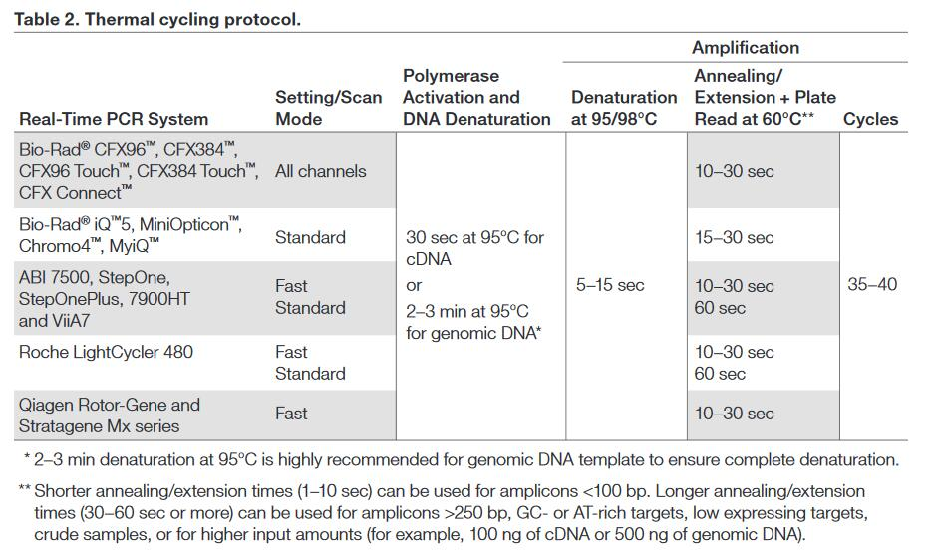

Figures:
1. Please obtain explicit copyright permission to reuse any figures from a previous publication. Explicit permission can be expressed in the form of a letter from the editor or a link to the editorial policy that allows re-prints. Please upload this information as a .doc or .docx file to your Editorial Manager account. The Figure must be cited appropriately in the Figure Legend, i.e. “This figure has been modified from [citation].”

Copyright has been obtained from the Elsevier.
2. Figure 1: Please combine all panels of this figure into one image file.
Figure 1 has been revised into one image.
Discussion:
1. Please revise the Discussion to explicitly cover the following in detail in 3–6 paragraphs with citations:
a) Critical steps within the protocol
b) Any modifications and troubleshooting of the technique
c) Any limitations of the technique
The discussion has been revised as follows:

The 1st paragraph provides an overall summary about the research and explained the modifications of this reported protocol compared to previous published method;

More details have been added in the 2nd paragraph to identify and discuss critical steps in the protocol, including (i) the selection of crowders and optimisation of FVOs; (ii) use of cells at low passage number; and (iii) supplementation with ascorbic acid; (iv) validation of primary antibodies before apply this protocol to other cell types.

The 3rd and 4th paragraphs remain unchanged. This text addresses the significance of this protocol against other existing models and the application and future direction of this protocol.

The last paragraph has been added to explain one of the limitations of this model.
References:
1. Please do not abbreviate journal titles.
All journal titles have been revised to full name.
Table of Materials:
1. Please ensure the Table of Materials has information on all materials and equipment used, especially those mentioned in the Protocol.
Missing information has been added in the revised Table of Materials (highlighted).
Reviewers' comments:
Reviewer #1:
Manuscript Summary:
This is an interesting and generally nicely written protocol that will be of interest to other scientists.
Major Concerns:
Although PVP data are used as a control, almost no information is present in this manuscript to justify why this is done. I understand that the focus of this protocol is on the utilization of Ficoll-based MMC system. I also understand that comparison of PVP- and Ficoll-based MMCs is given in the original research article (reference 11). In lines 88-90, the authors state: "Interestingly, several popular crowding agents, e.g. Ficoll, dextran, polyvinylpyrrolidone (PVP) and sodium 4-styrenesulfonate (PSS), are not equivalent when applied to different cell types, and when applied in different configurations". This is a very important observation that should be discussed in more detail instead of being mentioned in one sentence. I think that an extended discussion should be added here to emphasize an important observations that the effects of PVP- and Ficoll-based MMCs on HSFs are very different. This will provide a justification of the use of PVP-based MMC as a negative control.
More detail is now included with discussion of the effects of different crowders on cells from distinct sources in lines 100-105.
Minor Concerns:
1) Meaning of the abbreviation FVO should be added

Definition of FVO has been added in line 229.
2) Details of the source of PVP samples used in this protocol should be added
Source of PVP has been added in the revised Table of Materials.
Reviewer #2:
Manuscript Summary:
This submission reports the effects of macromolecular crowding (MMC), a cell culture additive approach, on collagen production and in primary hypertrophic scar-derived human skin fibroblasts (HSF). The authors assessed total and type 1 collagen deposition, the levels of a variety of wound healing related proteins, and the expression levels of a battery of wound healing and inflammation-associated genes with and without MMC treatments. Significant effects of MMC treatments were evident. While I have several suggestions to improve the readability of the document, these are interesting findings and they are worthy of publication.
Major Concerns:
The nomenclature used to describe the primary fibroblasts is very confusing. The authors abbreviate "primary hypertrophic scar derived human skin fibroblasts" as HSF. The normal dermal fibroblast controls are abbreviated nsHSF without providing an extended form, so this reviewer presumes "normal skin human skin fibroblasts"? "Normal skin human skin" is obviously clumsy and redundant, and easily confused with HSF for hypertrophic skin fibroblasts. This reviewer suggests the authors consider adopting abbreviations that are easier to interpret, such as hNSF (human normal skin fibroblasts) and hHSF (human hypertrophic scar fibroblasts) to avoid this problem.
The nomenclature for Human normal skin fibroblasts i.e. hNSF and human hypertrophic scar fibroblasts i.e. hHSF have been renamed, as suggested by the reviewer.
Minor Concerns:
Please include at least one full length description of fractional volume occupancy (FOV), as it is currently only used in the abbreviated form in the text.
Definition of FVO has been added in line 229.

Why was a FVOs of 72% assessed? Does that have any physiological relevance? If so, in what context?

The selection of FVOs was based on a previously published study¹. In vivo FVOs range from 9% to 54% depending upon the tissue and physiological state of the tissue. As shown in the below figure¹, Rashid et al. (2014) observed Ficoll at 9% and 18% FVO stimulate the proliferation of dermal fibroblasts equally. However, proliferation is dramatically reduced among cells cultured with Ficoll at 36% FVO, in contrast to that assayed at FVOs of 9% and 18%.

For PVP40, it is evident that when cultivated with PVP40 at FVOs of 9%, 18% and 36%, cell proliferation is significantly increases. However, when cells are cultivated with PVP at 18% FVO more collagen is deposited than is evident under other FVOs.

Cell proliferation is significantly enhanced under PVP360 at FVOs of 9%, 18%, 36% and 54%; however, PVP360 at 54% is the most effective condition for increasing collagen deposition. Effects of PVP at FVOs >54% are untested.

Based on these previously published data, we elected the evaluate Ficoll at 9% and 18% FVO, PVP40 at 18% FVO and PVP360 at 54% and 72% FVO in our study.

These have been briefly discussed in the revised discussion part in lines 308-315.
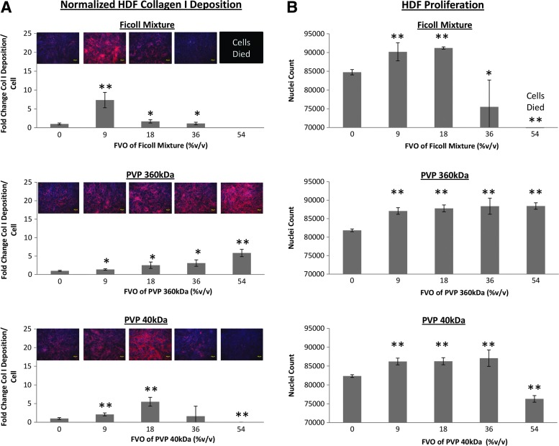
Rashid et al. (2014)
Reviewer #3:
Minor Concerns:
The manuscript is well written and clear. I have two suggestions
a) perhaps emphasise that it really makes sense to play with the Ficoll concentration. In this case authors managed a better collagen deposition with "half-strength" Ficoll MMC (9% v/v as opposed to the original publication in Chen et al al2011). This goes to show that the - Ficoll - system has to be adapted from time to time to a given cell type. This is a very nice working protocol , so people using it should be encouraged to try different strengths of macromolecular crowding. Its an empirical aspect, but as we can see here, it pays off.
We appreciate the reviewer agrees with our interpretation that when used as a macromolecular crowder, the FVO of Ficoll should be optimized for individual cell types. Clearly both the composition of the crowder and FVO thereof, elicit distinct responses from different cell populations.

This has been emphasized in the revised discussion in lines 308-315.
b) If the authors can squeeze in a sentence or two that ECM antibodies are not interchangeable, as many of them do not work as claimed in data sheets. Did the authors validate the antibody in a cyrosection of skin., or a cryo or paraffin section for a hypertrophic scar ?
It would be a good place to make the point that one needs to be absolutely sure that the antibody against a collagen works (Wblot vs IHC and all the usual issues). What I mean to say is that if this antibody from abcam does the job, than people adopting the protocol should stick to it, and not use another collagen antibody without validating it.
The selection of antibodies was based on protocols published by others, and subsequently optimized in our lab. We recommend other researchers use these antibody clones for hypertrophic scar fibroblasts, however, antibodies need to be validated if apply this protocol to other cell types (these have been explained in the revised discussion part in lines 319-321).

Here is one example from our data for the selection and optimization of antibodies to collagen I.

The collagen antibody ab6308 was validated and used by our colleagues for their previous study² (revised in the Table of Materials). Data from Figure 1.C demonstrates that ab6308works consistently in our study. However, we found that ab6308 did not work well in Western blotting, and therefore we evaluated 3 alternative antibodies to collagen I, as shown below:

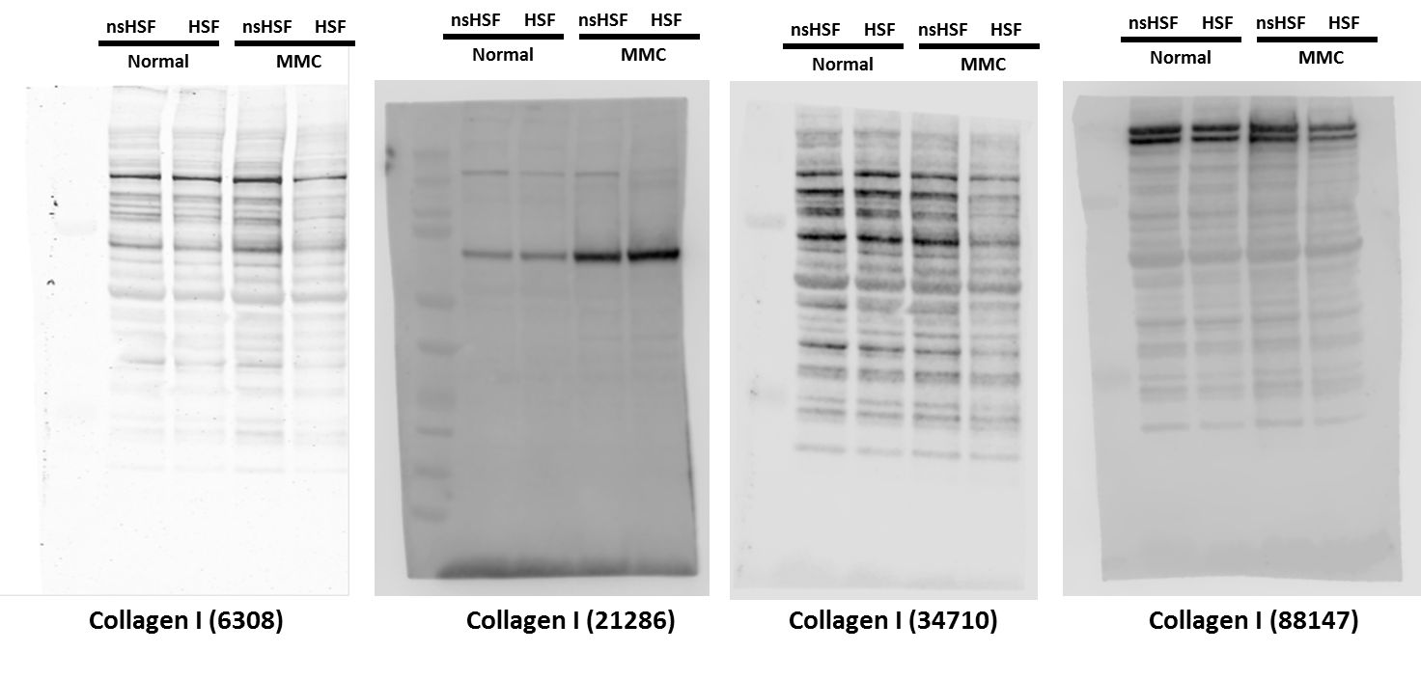

In our samples many non-specific species are recognised by ab6308, ab34710 and ab88147. Based on this analysis, we selected ab21286. By repeating the experiments using protein samples collected from 3 patients (below images), we consistently observed two reactive species: 100 kDa ~ 150 kDa, the predicted size for collagen I, although reactivity is weak. The second species ~ 50 kDa reacts more strongly.
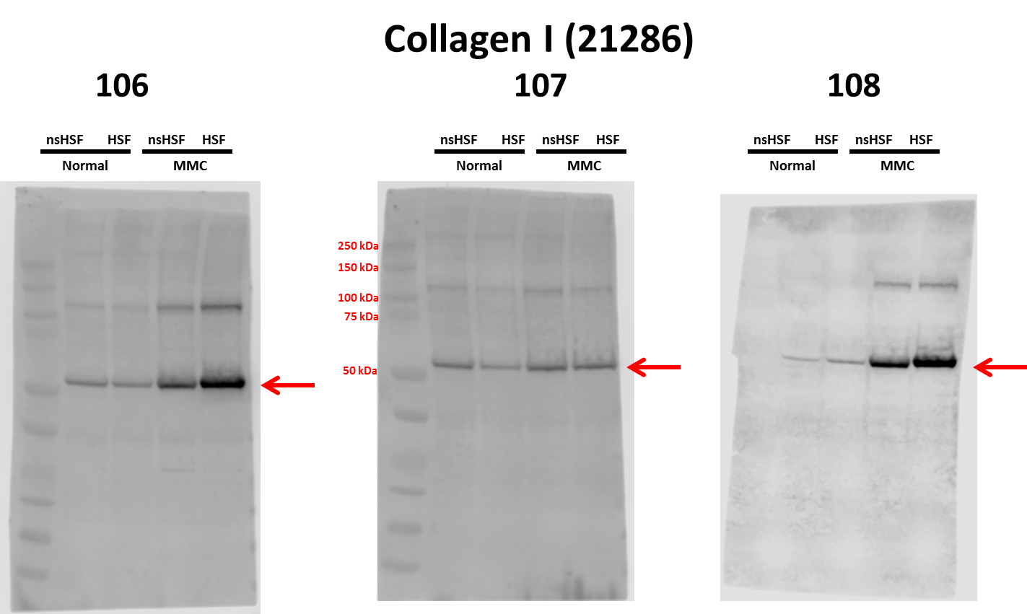

By checking the previously published work using ab21286, we noted that in most examples a single band is reported³⁻⁵, probably because the α1 and α2 migrate too closely to be resolved. One article reports the double-bands of collagen I⁶, suggesting that the expression of collagen I varies from different samples.

We interpret the 50 kDa band in our assays is degraded collagen I. Evidence suggested that the molecular weight of degraded collagen ranges from 70 to 20 kDa⁷. Due to the weak and differential expression of 100~150 kDa collagens, we interpreted our data based on degraded collagen I at 50 kDa.
Reviewer #4:
Manuscript Summary:
The authors used 'macromolecular crowding' to create "in vivo-like" human hypertrophic scar tissue in vitro. When cultivated in a crowded macromolecular environment, human skin fibroblasts exhibit a phenotype, biochemistry, physiology and functional characteristics resembling scar tissue, and conclude that the technique is useful for validating interventions intended to relieve the symptoms of scarring.
Minor Concerns:
The authors investigate the model for 1 week, does the fibroblast maintain the high activity in 2w,3w,and 4w.
We previously reported that cells cultivated under MMC conditions exhibit significantly improved ECM deposition after 1 week. For this study, we optimized culture conditions, including crowders, FVOs and duration, etc., using a different cell population. It is evident that 1 week of culture works well for scar-derived fibroblasts. We accept the reviewer’s comment, that it would be interesting to see the effects of MMC after longer exposure, for example: 2 weeks, 3 weeks, 4 weeks. This was not an objective of this study; we will share our findings in a subsequent report.

This has been added in the future direction in the revised discussion section in lines 351-352.
Reviewer #5:
Manuscript Summary:
In the manuscript entitled "Construction of an in vitro model of human cutaneous hypertrophic scar using macromolecular crowding", the authors have tried to exhibit the method of macromolecular crowding (MMC) technique to produce an in vitro model system for hypertrophic scar by adding crowders to the human fibroblast cells.
The findings of this manuscript are surely interesting and the use of the MMC technique is quite innovative for the generation of in vitro scar models. However, this manuscript needs some revision prior to publication.
Major Concerns:
1. Please elucidate whether the MMC addition strategy is able to mimic the complex hierarchical architecture and alignment of cells and ECM present in scar tissue?

There are many studies reporting that MMC addition strategy affects ECM architecture⁸, alignment of extracellular matrix fibers⁹ and cell orientation¹⁰. We are not aware of any study that has examined the hierarchical structure of scar tissue resulting from cultivation under MMC conditions. We believe that our study is the first to examine the MMC technique with hypertrophic scar derived fibroblasts, and thus similarities to the hierarchical architecture, alignment of cells and ECM in this model and scar tissue in vivo has yet to be examined.
We agree that such an examination is worthwhile, offering further evidence to support the authenticity of this tool of a model platform for the study of hypertrophic cutaneous scars. This has been mentioned in the future direction of the revised manuscript (lines 352-355).
2. The introduction can be elaborated by giving details of alpha smooth muscle actin (SMA) and TGF-beta which are the main contributors in scarring.

Roles of TGF-β1 and αSMA have been added in the revised manuscript lines 60-65.
3. The authors have not shown anywhere regarding the formation of collagen in single direction which is most important marker of skin scar tissue.

We agree with the reviewer that the orientation of collagen in scar tissue is an important parameter. In Figure 1.C, we noted that the collagen orientation in Ficoll at 9% FVO is different from other conditions. We found this interesting; however, we reserved our interpretation. We prefer to undertake further analyses, e.g. confocal microscopy, second harmonic microscopy, polarised birefringence, etc., before we claim fibril alignment. We have demonstrated the MMC strategy increases collagen deposition. We intend to characterise collagen orientation, among other parameters, in future. This has been added in the future direction in the revised discussion section (lines 352-355).
4. Mention the genes studied by RT-PCR in the protocol section.

Genes tested in RT-PCR have been added in lines 219-220.
5. Mention about the statistical analysis undertaken in the protocol

The statistical analysis section has been added in lines 223-226.
6. The discussion part needs to be elaborated
The discussion part has been revised as explained in above section (Editorial comments).
Minor Concerns:
1. In references somewhere DOI is mentioned, whereas it is missing from some portions

The reference showing DOI is a book chapter. To keep the format consistent, the book chapter has been replaced with a journal article reporting the same information.
2. Grammar correction should be taken care throughout the manuscript

The revised manuscript has been carefully proofread by all the co-authors.

References:

1 Rashid, R. et al. Novel use for polyvinylpyrrolidone as a macromolecular crowder for enhanced extracellular matrix deposition and cell proliferation. Tissue Engineering Part C: Methods. 20 (12), 994-1002, (2014).
2 Benny, P., Badowski, C., Lane, E. B. & Raghunath, M. Improving 2D and 3D Skin In Vitro Models Using Macromolecular Crowding. J Vis Exp. 10.3791/53642 (114), (2016).
3 Nakamichi, R. et al. Mohawk promotes the maintenance and regeneration of the outer annulus fibrosus of intervertebral discs. Nature Communications. 7 12503, (2016).
4 Yu, M.-L. et al. The Effects of TiO2 Nanodot Films with RGD Immobilization on Light-Induced Cell Sheet Technology. BioMed Research International. 2015 10, (2015).
5 Hilgendorff, A. et al. Lung matrix and vascular remodeling in mechanically ventilated elastin haploinsufficient newborn mice. Am J Physiol Lung Cell Mol Physiol. 308 (5), L464-478, (2015).
6 Maruyama, S. et al. Follistatin-like 1 promotes cardiac fibroblast activation and protects the heart from rupture. EMBO Mol Med. 8 (8), 949-966, (2016).
7 Jeevithan, E., Bao, B., Zhang, J., Hong, S. & Wu, W. Purification, characterization and antioxidant properties of low molecular weight collagenous polypeptide (37 kDa) prepared from whale shark cartilage (Rhincodon typus). J Food Sci Technol. 52 (10), 6312-6322, (2015).
8 Ng, W. L., Goh, M. H., Yeong, W. Y. & Naing, M. W. Applying macromolecular crowding to 3D bioprinting: fabrication of 3D hierarchical porous collagen-based hydrogel constructs. Biomaterials Science. 6 (3), 562-574, (2018).
9 Zeiger, A. S., Loe, F. C., Li, R., Raghunath, M. & Van Vliet, K. J. Macromolecular Crowding Directs Extracellular Matrix Organization and Mesenchymal Stem Cell Behavior. PloS one. 7 (5), e37904, (2012).
10 D., G. & D., Z. Macromolecular crowding and mechanical stimulation for tenogenic phenotype maintenance and differentiation/transdifferentiation. Orthopaedic Proceedings. 100-B (SUPP_3), 37-37, (2018).

