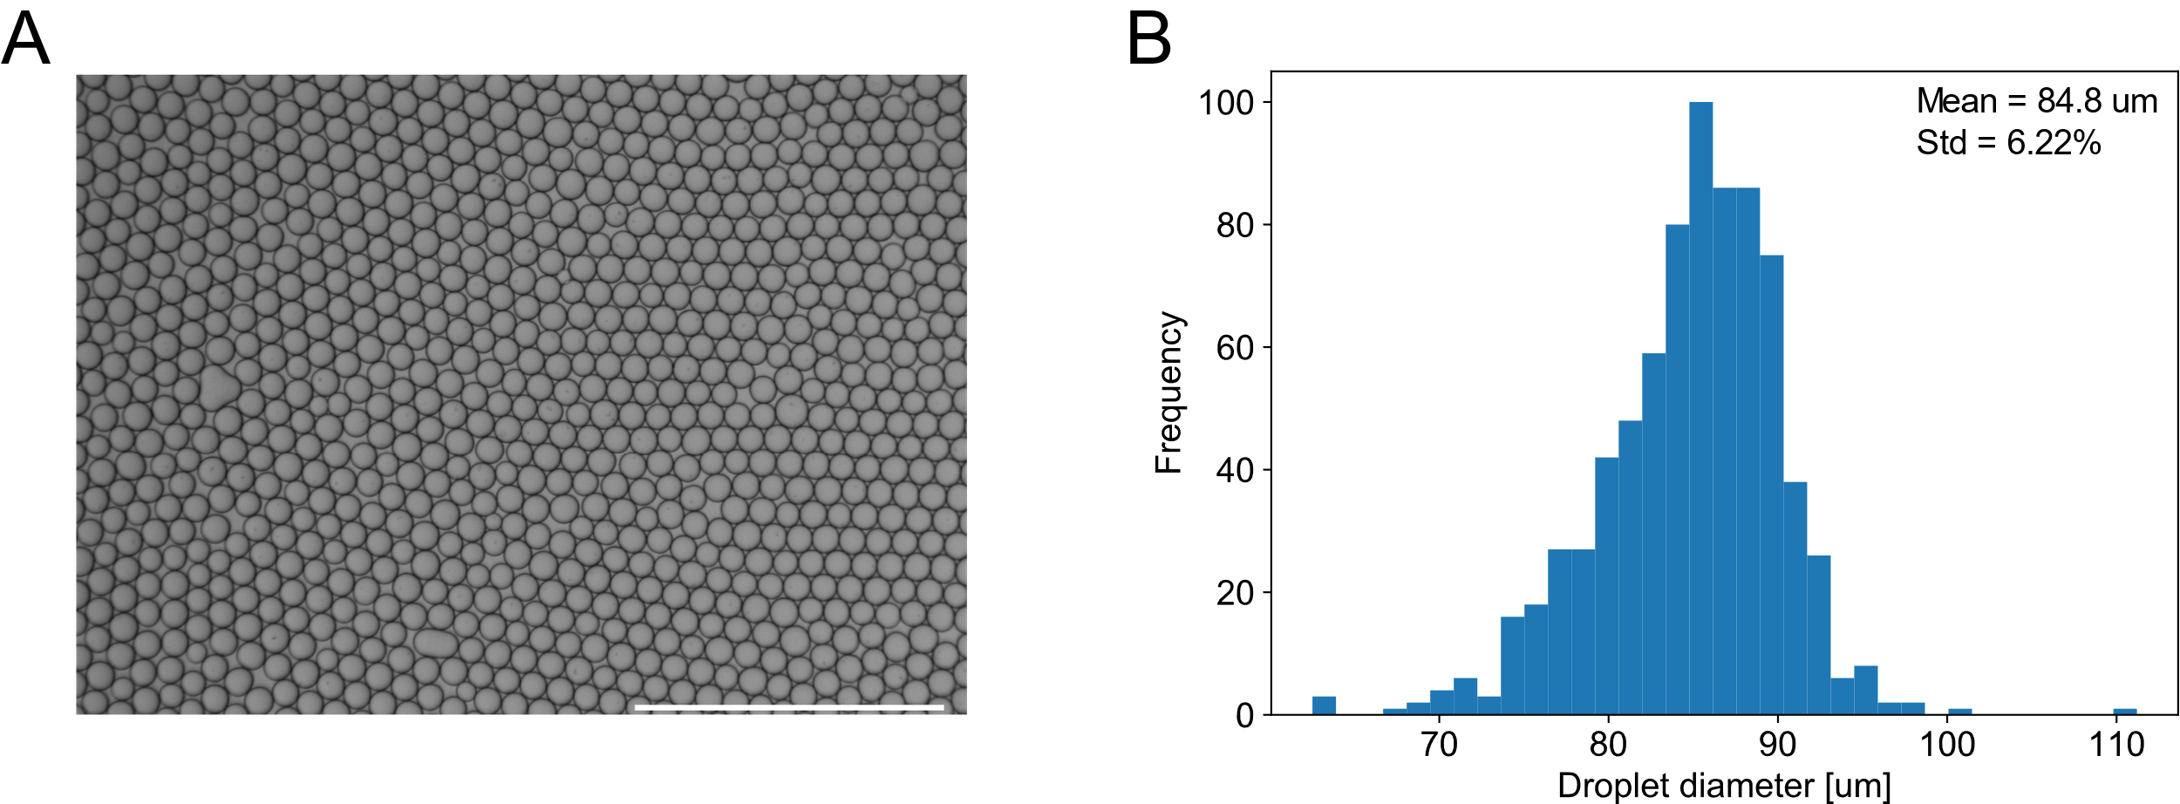
Supplemental Figure 1. Monodispersity characterization of drops produced by device A. (A) Representative micrograph of collected emulsion. Scale bar 1000 um. (B) Histogram of drop diameters based on drops shown in (A).

Supplemental Figure 2. Relationship between single and double encapsulation frequency for several different lambda values, given that bead loading into droplets follows Poisson statistics.

