We would like to thank the editor and the reviewers for the constructive comments on the manuscript and for providing timely reviews. Below is our point-by-point response to the concerns and suggestions raised. Changes are highlighted in the manuscript and reported here.
Editorial Comments:
• Please take this opportunity to thoroughly proofread the manuscript to ensure that there are no spelling or grammatical errors.
We made sure there are no spelling and grammatical errors in the manuscript.
• Protocol Language: Please ensure that ALL text in the protocol section is written in the imperative voice/tense as if you are telling someone how to do the technique (i.e. “Do this”, “Measure that” etc.) Any text that cannot be written in the imperative tense may be added as a “Note”, however, notes should be used sparingly, and actions should be described in the imperative tense wherever possible.
1) Examples NOT in imperative voice: 1.3, 1.5, 2.4
The text is now adjusted so that the imperative tense is used throughout the protocol. As suggested by the editor, we made changes for points 1.3, 1.5, and 2.4. Additionally, we modified the text for points 2.7, 3.1, 5.1, and 5.4. See changes underlined below:
Changes for 1.3:
  - Prepare 1 mg/mL of Endoxifen solution, diluted in 10% DMSO and backfill the syringe with the bent needle.

NOTE: We recommend administering 5 μl of the compound to ensure widespread exposure of meningeal cells in the adult C57Bl/6j mouse (ca. 25-30 g), although pilot experiments that test different concentrations and injection volumes may be necessary when treating animals of different ages and strains.

Changes for 1.5:
  - Adjust the mouse head holder so that the mouth piece is at approximately 30° from the surface of the surgical table.

NOTE: A stereotactic frame with three-point fixation (i.e., ears and mouth) can also be used for this procedure. In this case, however, the animal will only be fixed with the mouth piece, whereas ear bars can be extended under the animal’s forelimbs and be used to support the animal’s body during the procedure.

Changes for 2.4:
2.4. Deliver air at a rate of 400 ml/min.

Changes for 2.7:
  - Remove the animal from the chamber and check for suppression of the paw reflex by delicately pinching the hind paws.

NOTE: The reflex may still be present but delayed a couple of seconds. If that is the case, we recommend placing the animal back in the chamber until complete suppression of the paw reflex has been achieved.

Changes for 3.1:
  - Fix the animal’s head onto the head holder. To improve accessibility to the cisterna magna, position the animal’s body at approximately 30° from the surface of the table and the head titled downwards, to establish an angle of 120° with the rest of the body and extend the back of the neck to facilitate access to the cisterna magna (Figure 1A).

Changes for 5.1:
  - To gain access to the cisterna magna, identify the caudal end of the occipital bone and insert the needle that was previously bent immediately underneath.

NOTE: There will be a sudden drop in resistance as the dural membrane is punctured. However, the tip of the needle will only penetrate slightly underneath the meningeal surface, thanks to its hooked shape.

Changes for 5.4:
  - After the injection, let the needle rest in site for 1 min and carefully remove it. Use fine tip forceps to aid retraction of the needle from its hooked position.

NOTE: The use of a thin needle (e.g., 30G) does not lead to substantial damage of the meningeal membrane, and consequent outflow of the cerebrospinal fluid. If larger needle sizes are required, we recommend sealing the punctured site with cyanoacrylate adhesive following injection, to prevent extensive loss of fluid.
• Protocol Detail: Please note that your protocol will be used to generate the script for the video, and must contain everything that you would like shown in the video. Please add more specific details (e.g. button clicks for software actions, numerical values for settings, etc) to your protocol steps. There should be enough detail in each step to supplement the actions seen in the video so that viewers can easily replicate the protocol.
Find below the changes to the text, which are here underlined.
1) 2.6: Mention animal age, sex, weight, strain.
We are now reporting details for the animal used as a note in point 2.5:
NOTE: For the present experiments, we have used adult (>2 months old and approximately 30 g) male and female transgenic mice carrying Cx30-CreER and R26R-tdTomato, and bred on a C57Bl/6j background.
2) 3.2: Use of the term "tissues" can be confusing in this context, "paper towel" may be a suitable alternative.
We have now removed the term “tissues” and replaced it with “paper towels” in point 3.2.
3) 4.2: Mention surgical tools used.
We have specified to use surgical scissors to perform the incision:
  - Using surgical scissors, perform a midline incision (ca. 7 mm in length) starting at the level of the occipital bone and extending it posteriorly.
4) 5.1: Is this the needle from 1.1? How deep should you insert?
The needle mentioned in 5.1 is indeed the one that has been prepared in 1.1. We have specified this and added that the needle will only penetrate slightly under the dural surface due to its hooked shape. In 5.2 we then added that the whole tip of the bent needle shall be inserted through the meningeal layer, in order to hook it to the occipital bone.
  - To gain access to the cisterna magna, identify the caudal end of the occipital bone and insert the needle that was previously bent immediately underneath.

NOTE: There will be a sudden drop in resistance as the dural membrane is punctured. However, the tip of the needle will only penetrate slightly underneath the meningeal surface, thanks to its hooked shape.

  - Once the dura has been perforated, allow the bent tip of the needle to penetrate underneath the dural surface by gently pulling the syringe upwards and parallel to the animal’s body, in order to “hook” the needle to the skull (see Figure 1B). This will ensure better stability and will prevent the needle from penetrating deeper, thus avoiding the risk of damaging the underlying cerebellum or medulla.
5) 6.2: Mention suture material and pattern.
We now suggest suturing with absorbable sutures and interrupted stitches as an alternative to using skin glue.
  - Close the skin incision using a few drops of cyanoacrylate adhesive.

NOTE: Alternatively, use absorbable sutures (e.g., 5-0 vicryl sutures) and close the skin incision with interrupted stitches.
• Protocol Highlight: Please highlight ~2.5 pages or less of text (which includes headings and spaces) in yellow, to identify which steps should be visualized to tell the most cohesive story of your protocol steps.
1) The highlighting must include all relevant details that are required to perform the step. For example, if step 2.5 is highlighted for filming and the details of how to perform the step are given in steps 2.5.1 and 2.5.2, then the sub-steps where the details are provided must be included in the highlighting.
2) The highlighted steps should form a cohesive narrative, that is, there must be a logical flow from one highlighted step to the next.
3) Please highlight complete sentences (not parts of sentences). Include sub-headings and spaces when calculating the final highlighted length.
Please find in the text the parts highlighted in yellow. Altogether they make up 2.5 pages of text (incl. spaces and headings).
• Discussion: JoVE articles are focused on the methods and the protocol, thus the discussion should be similarly focused. Please ensure that the discussion covers the following in detail and in paragraph form (3-6 paragraphs): 1) modifications and troubleshooting, 2) limitations of the technique, 3) significance with respect to existing methods, 4) future applications and 5) critical steps within the protocol.
We have addressed the important points in the discussion: for instance, we highlight the importance of slow delivery of the compound to avoid increasing intracranial pressure, and suggest modifications in case the experiment requires administration of large volumes (e.g., assembling the injection syringe onto a micromanipulator to regulate delivery rate), we mention how our method builds on, and improves, current strategies for intracisternal injection with the use of a hooked needle that is safely secured to the skull. Furthermore, we list a few applications for which our method can be applied (e.g., for the study of leptomeningeal functioning at the brain-meninges barrier, or the tracking of cerebrospinal fluid).
• References: Please spell out journal names.
We are now using full names for the journal. Please see the reference section in the manuscript for the changes.
Comments from Peer-Reviewers:
Reviewer #1:
Manuscript Summary:
The manuscript entitled "Genetic modification of leptomeningeal cells via intracisternal injection" describes an intracisternal injection method which successfully injects solutions through the cisterna magna eliminating the risk of causing damage. The protocol is well-written with details that will ensure other researchers to perform the related experiment. In my opinion, there are some small additions to be made in order to improve the reading of the protocol.
We thank the reviewer for their positive feedback and address the minor concerns and suggestion raised below.
Major Concerns:
None
Minor Concerns:
Title
I suggest, to remove the word "Genetic" from the Title and modify the Title for example: "Induction of leptomeningeal cells modification via intracisternal injection".
We welcome the suggestion to revise our title and have changed it accordingly.
Introduction
In the introduction when the authors suggest that this method could be used to induce bacterial meningitis, references should be expanded (other references should be included such as: Colicchio et al., Infect Immun. 2019 Mar 25;87(4); Ricci et al., BMC Infect Dis. 2014 Dec 31;14:726; Zhang et al., J Vis Exp. 2018 Jul 1, 137).
We have now added references for the bacterial infection (see line 367). The following references were added:
15 Colicchio, R. et al. The meningococcal ABC-Type L-glutamate transporter GltT is necessary for the development of experimental meningitis in mice. Infection and Immununity. 77 (9), 3578-3587, (2009).
16 Ricci, S. et al. Inhibition of matrix metalloproteinases attenuates brain damage in experimental meningococcal meningitis. BMC Infectious Diseases. 14 726, (2014).
Protocol
In order to improve the impact of this research and help the reader to better understand the technique and how it differs from other methods, it would be useful to clarify for those who are not familiar with the terms to which they refer anatomically intracisternal and cisterna magna. Most readers may not be familiar with the details of the cranial anatomy, therefore a brief but more detailed explanation is recommended.
To aid identification of the anatomical landmarks, Figure 1B is now specifying where occipital bone and cisterna magna are located. See updated panel below.
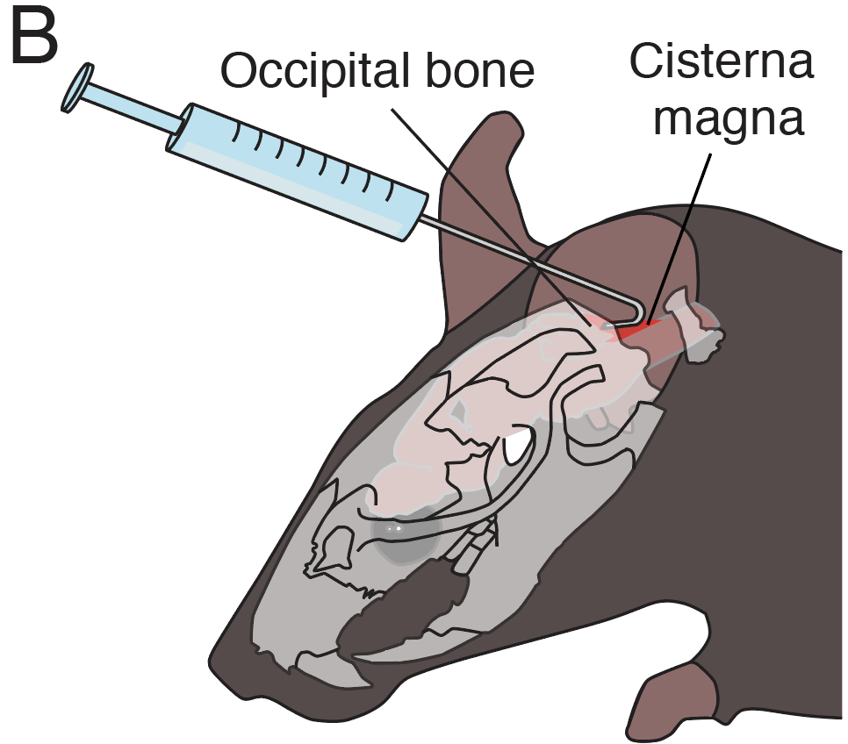
Discussion
The authors suggest that this protocol could be useful to study meningococcal meningitis and to understand the interactions between N. meningitidis and leptomeninges.
However, it should be clarified that in case of meningococcal manipulation some modifications should be made to the protocol, first of all on the safety for biological risk.
We welcome the suggestion and have now specified in the discussion (line 369-371) that researchers will need to consider additional ethical and safety measures when working with bacterial infections. See below:
Of note, the protocol hereby presented may require modifications to account for additional ethical and safety requirements necessary to carry out procedures that entail bacterial infections.
Reviewer #2:
Manuscript Summary:
This is a straightforward method paper that will benefit many. Overall, the manuscript is clear. I have just a few points;
We thank the reviewer for the positive feedback and address their comments below.
Major Concerns:
1. Page 3. Reference for expression of Cx30
Thank you for noticing we missed the reference. It is now added:
De Bock, M. et al. A new angle on blood-CNS interfaces: a role for connexins? FEBS Letters 588 (8), 1259-1270, (2014).
2. 3.2 indicate the exact tilting of the head that is optimal
We have now specified that the head should form an angle of 120° with the rest of the body, as shown in figure 1A, to facilitate access to the cisterna magna.
3. Illustration of the mice at the stereotaxic frame with the bended needled in place during the injection is a key: it cannot be visualized by the scheme how the needle is safely kept in place and the anterior to posterior orientation of the syringe seems a bit awkward to access the CM.
We have modified figure 1B so that the head of the mouse is tilted downwards, similar to the depiction in 1A. We, furthermore, edited orientation of the syringe and looks of the needle to resemble reality more closely. We believe these adjustments will make it easier for the readers to understand the injection strategy. See below the updated panel 1B.
4. The manuscript does not mention how the perforated area of the dura membrane is sealed after removing the needle. CSF leakage will lead to loss of the injected compound and pathological changes in CSF flow.
We do not seal the dural membrane after injection. In our experience, the use of a thin needle (e.g., 30G) only causes a small aperture in the meninges that does not allow substantial amounts of CSF to flow out. The small puncture will, furthermore, be tapped by the overlaying connective tissue and neck muscles, thus, further preventing fluid loss. We have added a note to highlight this point in the protocol (point 5.4).
5.4. After the injection, let the needle rest in site for 1 min and carefully remove it. Use fine tip forceps to aid retraction of the needle from its hooked position.

NOTE: The use of a thin needle (e.g., 30G) does not lead to substantial damage of the meningeal membrane, and consequent outflow of the cerebrospinal fluid. If larger needle sizes are required, we recommend sealing the punctured site with cyanoacrylate adhesive following injection, to prevent extensive loss of fluid.
Reviewer #3:
Manuscript Summary:
The manuscript describes a simple procedure for intra-cisterns saga injections of molecules into the CSF. This procedure appears to be more convenient with less risk of CNS tissue injury and erroneous injections.
We thank the reviewer for the comments and address the concerns below.
Minor Concerns:
The procedure could be commented on further with respect to frequency and numbers of injections allowed, and volume limits.
Per ethical permit, we are required to keep injection volumes < 10 ul. We have added a note at point 2.5 to recommend conducting pilot experiments to adjust for the optimal injection volume and concentration of the compound based on the details of the study.
NOTE: For the present experiments, we have used adult (>2 months old and approximately 30 g) male and female transgenic mice carrying Cx30-CreER and R26R-tdTomato, and bred on a C57Bl/6j background.
Furthermore, our ethical permit allows for a single intracranial injection, which prevents us from observing how well can the animal tolerate repeated treatment. A single administration of Endoxifen is however able to efficiently label cells from the leptomeninges, thus, not requiring the animal to undergo repeated surgeries. We have specified in the manuscript (at line 55) that the present protocol describes a single administration. We have, furthermore, added that one should consider revising ethical specification and the ability of the animal to withstand multiple surgeries in case the study requires repeated treatments (lines 340-344).
Line 55: The surgical procedure outlined below allows widespread and specific labelling of these meningeal cells via one-time delivery of Endoxifen into the cisterna magna of transgenic mice conditionally expressing tdTomato in Cx30⁺ cells.
Lines 340-344: Furthermore, the present protocol is designed to perform a single intracisternal injection, which efficiently labels leptomeningeal cells. We recommend considering ethical specifications, as well as the animal’s ability to withstand multiple surgical procedures, should the study require repeated administration of compounds.

Also, for some of the conclusions about the type of cell targeted by the Endoxifen molecule, the authors could show immunohistochemistry to back up their claims that it is the type of cell that they say. Many cells express the connexion gene that they are demonstrating activation of with their reporter.
We have now added panels G in Figure 1 to highlight Pdgfra reactivity of the tdTomato-labelled cells, suggesting they are indeed leptomeningeal cells, and demonstrated that the underlying astroglial cells (also expressing Cx30) are not recombined with the current procedure.
Panel G illustrates recombination of leptomeningeal cells (asterisk), identified through Pdgfra reactivity, after intracisternal injection. By contrast, surface (arrowhead) and parenchymal (arrow) astrocytes expressing Gfap remain unlabeled.
