Laboratoire de l’Angiogenèse et du Microenvironnement des Cancers
INSERM U 1029
Université Bordeaux
Allée Geoffroy St Hilaire, Pessac, France
Director: Prof Andreas Bikfalvi
E-Mail: andreas.bikfalvi@u-bordeaux.fr
Tél : (33) 5 40 00 87 03, Fax : (33) 5 40 00 87 05

Bordeaux, December 20 / 2019

JoVe revised article 60998_R1_111119

Dear Benjamin,
Please find attached our revised manuscript re-entitled “A reliable and easy-to-use 3D model for glioblastoma” and the response to reviewers in the next pages.

Sincerely yours,

Dr. Thomas Daubon, PhD Pr. Andreas Bikfalvi, MD PhD

Editorial comments:
General:
1. Please take this opportunity to thoroughly proofread the manuscript to ensure that there are no spelling or grammar issues.
2. Please ensure that the manuscript is formatted according to JoVE guidelines–letter (8.5” x 11”) page size, 1-inch margins, 12 pt Calibri font throughout, all text aligned to the left margin, single spacing within paragraphs, and spaces between all paragraphs and protocol steps/substeps.
3. Please include email addresses for all authors in the manuscript itself.
4. Please include at least 6 key words or phrases.
5. For in-text formatting, corresponding reference numbers should appear as numbered superscripts after the appropriate statement(s). Please number references according to their appearance in the manuscript.
6. JoVE cannot publish manuscripts containing commercial language. This includes trademark symbols (™), registered symbols (®), and company names before an instrument or reagent. Please limit the use of commercial language from your manuscript and use generic terms instead. All commercial products should be sufficiently referenced in the Table of Materials and Reagents.
For example: Accutase, Matrigel, Nikon, IRDye
Reply: This was checked.
Summary:
1. Please include a separate Summary section (before the Abstract) that clearly describes the protocol and its applications in complete sentences between 10¬ and 50 words, e.g., “Here, we present a protocol to …
Reply: This was added in the text.
Protocol:
1. There is a 10 page limit for the Protocol, but there is a 2.75 page limit for filmable content. Please highlight 2.75 pages or less of the Protocol (including headers and spacing) that identifies the essential steps of the protocol for the video, i.e., the steps that should be visualized to tell the most cohesive story of the Protocol. Remember that non-highlighted Protocol steps will remain in the manuscript, and therefore will still be available to the reader.
Reply: this was highlighted with a grey back-color.

2. For each protocol step/substep, please ensure you answer the “how” question, i.e., how is the step performed? Alternatively, add references to published material specifying how to perform the protocol action. If revisions cause a step to have more than 2-3 actions and 4 sentences per step, please split into separate steps or substeps.
Reply: This was checked.
Specific Protocol steps:
1. Glucose flux analysis, 1: ‘As described above’-which steps exactly?
Reply: this was removed from the text.

2. Fiji Macro: It may be best to include the macro itself as a supplemental file.
Reply: the macro was inserted in a supplemental file.
Figures:
1. Figure 2: Please include a space between numbers and units; e.g., ’24 h’ instead of ‘24h’ (see also Figure 4). Please also use ‘x’ for scientific notation instead of ‘.’.
Reply: We apologize for these mistakes. This was corrected in all Figures.
2. Please include a legend for Movie 1.
Reply: This was added in the text.
Discussion:
1. Please also include discussion of critical steps of the procedure and limitations here.
Reply: This was added to discussion.
Acknowledgment and Disclosures:
1. Please include a Disclosures section, providing information regarding the authors’ competing financial interests or other conflicts of interest. If authors have no competing financial interests, then a statement indicating no competing financial interests must be included.
Reply: This was added in the text.
References:
1. Please ensure that the references appear as the following: [Lastname, F.I., LastName, F.I., LastName, F.I. Article Title. Source. Volume (Issue), FirstPage – LastPage (YEAR).] For more than 6 authors, list only the first author then et al.
2. Please do not abbreviate journal titles.
Table of Materials:
1. Please remove trademark (™) and registered (®) symbols from the Table of Materials.
2. Please ensure the Table of Materials has information on all materials and equipment used, especially those mentioned in the Protocol.
Reviewers' comments:
Reviewer #1:
Manuscript Summary:
In the manuscript entitled: "A 3D spheroid model for studying glioblastoma development", Guyon et.al., describe a 3D culture protocol for human glioblastoma spheres that can be used for in vitro migration and invasion studies. The protocol is well written and explains the necessary steps in detail. I have two minor concerns:
Minor Concerns:
1. In Figure 4D, what is the staining? The authors should describe exactly what they are showing.
Reply: Cells were infected with lentivirus for expressing NLS:mCherry (nucleus are in orange) and with cytoplasmic-GFP (blue color). Details were added into the text and in the legends.
2. In Figure 1B, the authors are showing representative EM images of quiescence and proliferative zones of glioma spheres. Can they provide some detail on why they are showing the mitochondria and is the share of the mitochondria indicative of the cellular state or something else?
Reply: The EM images were shown to demonstrate cellular structures can be evidenced such as mitochondria which non-uniformly distributed in the core or the peripheral areas of these spheroids. This would indicate the oxidative state of the cells. The precise ultrastructure of the mitochondria is also indicative for this state.
Reviewer #2:
Manuscript Summary:
The manuscript "A 3D spheroid model for studying glioblastoma development" by Guyon et al presented a protocol to form a glioblastoma and characterize the invasion of the microtumor. In general, the authors introduced an interesting method for the microtumor fabrication. However, a number of issues should be clarified in the protocol.
Major Concerns:
1. The type of tumor cells used in the presented study should be introduced.
Reply: We used a patient-derived glioblastoma cell line, which exhibit a mesenchymal phenotype (Wang J et al, 2005; Bougnaud et al, 2016 ; Daubon et al, 2019).
2. In page 6, before the tumor cells are washed, the authors should clarify how the cells were cultured.
Reply: This information was added to the text in page 6.
3. Inhibitors and chemicals in page 6 should be clarified.
Reply: We have now added the sentences indicating potential inhibitors or chemicals which could be used in this assay.
4. Inhibitors or activators in page 7 should be clarified.
Reply: We have now added the sentences indicating potential inhibitors or activators which could be used in this assay.
5. What does cNBM stand for?
Reply: This stands for complete NeuroBasal Medium, as indicated in the text.
6. It is not clear how the recorded video was analyzed. The authors should clarify.
Reply: This was added into the movie and Figure 4 legends.
Reviewer #3:
Manuscript Summary:
The authors present methods for 3D spheroid modeling of glioblastoma invasion using collagen and Matrigel matrices. 2D culture systems lack many elements of the 3D microenvironment that dictate disease progression, and the authors report on an in vitro assay to observe more realistic tumor dynamics. However, there are some major and minor concerns regarding the manuscript content and discussion, as outlined below:
Major concerns:
1. The abstract is severely lacking in description of the context of this work and rationale, specifically with regards to why this platform is necessary for GBM culture specifically, considering how important invasion is to GBM tumor progression.
Reply: We have entirely revised the abstract and provide a rationale for the development of this assay.

2. The introduction is missing a review of other 3D invasion assays and why the authors' specific method is different or advantageous compared to other methods. A lot of sentences within lines 33-51 are also redundant and can be condensed. Ideally, more information on GBM modeling of tumor dynamics is necessary.
Reply: We have discussed other existing assays in the introduction section, as the reviewer requested.

3. The authors post that their first figure proves a difference in diffusion of oxygen and the presence of a hypoxic center, but there is not a robust characterization of hypoxia in these spheroids. A quantification of IR-labeled glycolysis across the spheroid bulk might be included here.
Reply: We have replaced the entire figure of a spheroid stained with calcein or IR-labeled 2-DG by a spheroid section depicting the internal cellular organization, and a staining with anti-carboxic anhydrase IX, as hypoxic marker.

4. The authors lack addressing in the Discussion section the contradictory nature of using matrices that do not mimic composition of brain tissue in GBM invasion assays.
Reply: We acknowledge that the matrix we are using does not fully represent the stroma found in glioblastoma. However, collagens are part of the brain matrix and we wanted to develop a ready- and easy-to-use assay which can run in any laboratory.

5. The proliferation experiment does not accurately represent 3D proliferation without also embedding it into a 3D matrix after spheroid formation.
Reply: Spheroid expansion is an indirect indicator of tumor cell proliferation, and this was measured in Figure 4A.
The authors also do not address why the difference in using collagen for invasion but Matrigel for migration.
Reply: We agree with the reviewer on this point. However, if the assay was performed on collagen I-coated plates, cells will not only migrate but also assemble into clusters (image below). This does not occur when this assay is performed on Matrigel (Figure 4C).
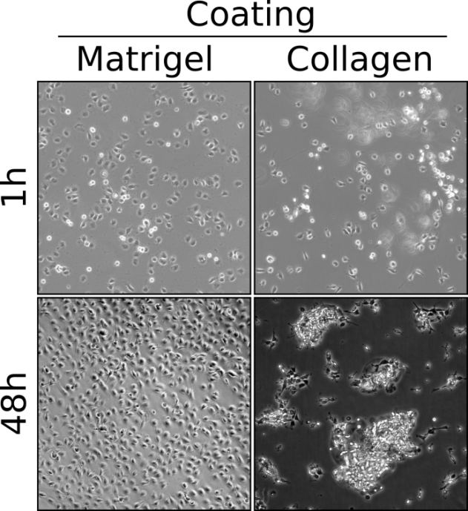
6. The images used for quantification are 2D representations of area, which seems a limited way to measure 3D tumor invasion, can they show quantifications of tumor expansion in terms of 3D volume using their z-stack images as shown in Figure 4d?
Reply: The pictures were taken in brightfield and not from fluorescence images. The quantification of the invasive area was done the median section of the spheroid, and we have validated the reproducibility of this approach in using knock-down for specific genes (Daubon et al, 2019 Nat Comm) or pharmacological inhibition (Daubon et al, 2019 Neuro-Oncology Advances). Z-stack does not add anything more to the quantification.

7. Discussion line 264: more description of the "micro-tumor" would be appreciated and discussed in the context of the assay.
Reply: Instead of micro-tumor, we now wrote invasive micro-tumor to underline the specific property studied in this assay. In the subsequent sentences, this was more discussed in detail.
8. More discussion on the limitations of this assay is missing, in addition to a lack of discussion on where this assay fits with the current standard of spheroid culture/invasion assays already used.
Reply: We wanted to setup an easy and reproducible assay that can be carried out in any laboratory. The theoretical limitation is, of course, that the quantification of invasion in the 3D structure is performed on the median section. However, we have validated the reproducibility of this approach in using knock-down for specific genes or pharmacological inhibition. Therefore, we consider our approach as sound.

When compared to similar assays published in JoVe (Berens et al, 2015 ; Vinci et al, 2015 ; Cavaco et al, 2019), our assay has the following advantages:
- our approach characterized specifically the invasive properties of stem-like cells derived from patients;
- we have developed a macro using FiJi software that allows rapid and easy quantification, and no specific equipment or other software is needed.
Minor concerns:
1. The title is misleading- spheroids are already formed when they are embedded and cultured, and the imaging/measurements are described for invasion, therefore invasion is a more apt description than "development."
Reply: We modified the title which is now “a reliable and easy-to-use 3D model for glioblastoma.”
2. Abstract line 29- definition of the acronym for GBM is missing.
Reply: The abstract was completely modified. By consequence, this is not appearing in the text.
3. Line 249- Sentence "Quantification of each assay is shown in Figure" seems unfinished.
Reply: This was modified in the text.
4. Line 256-257- Figure references are incomplete.
Reply: This was modified in the text.
5. Figure legend for Figure 1c and 1d are in incorrect order.
Reply: The Figure was modified, and the corresponding legend is in a correct order.

6. Discussion line 277: the transition to discussing the HCl acid treatment was abrupt and lacking the context of acid treatment and why that would stimulate invasion in your model.
Reply: This was completed into the discussion as “It is known that tumor acidosis activates a number of signaling pathways, including metabolic pathways (glycolysis), growth factors as TGFβ, and inhibits immune response”.
7. Line 278: "physiological environment" sounds awkward, is that supposed to read "physiologically relevant environment"?
Reply: we have changed this sentence.

8. The figure legends are lacking in description, particularly figures 2 and 3.
Reply: We have now described into details the figures.
9. There are other grammatical and typographical errors in this manuscript, please edit scrupulously.
Reply: this has been done.

