

November 28, 2019
RE: JoVE60996

Dear Dr. Cao,

We are pleased to submit our revised manuscript entitled “A Standardized Workflow for Drug Screening of Primary Patient Derived Tumor Xenografts in Zebrafish”, manuscript number JoVE60996.

We appreciated the reviewer’s positive comments and the thoughtful critiques and suggestions. We have revised the manuscript accordingly, as outlined in the reviewer response letter, and believe that the revisions have adequately addressed the issues raised by the reviewers. We have submitted two manuscript documents, a track changes version that is not final and the final, clean manuscript version. The track changes version has been submitted as a supplemental file. We hope the reviewers and you find the revised manuscript appropriate for publication with JoVE.
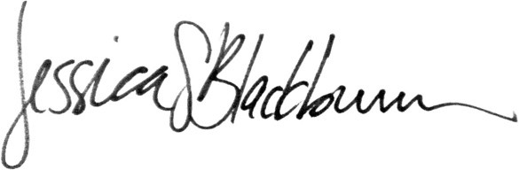

Jessica Blackburn, PhD
Sincerely,

Jessica Blackburn, PhD

