January 28, 2020

Xiaoyan Cao, Ph.D.
Review Editor
JoVE
1 Alewife Center Suite 200 Cambridge MA 02140

Dear Dr Xiaoyan Cao,

Please find enclosed our invited article (manuscript and video), revised for a second time according to the requirements of the Editors, entitled: Murine Precision-Cut Liver Slices as an Ex Vivo Model of Liver Biology by Pearen, Lim et. al., for consideration for publication in JoVE. The manuscript contains red highlighted text to indicate the final edits made to the original version.

Also enclosed is a point-by-point response addressing all of the Editorial comments, The revised video has not been uploaded to the JoVE manuscript submission website, rather, a high-resolution version of our revised video has been uploaded to the following site, as requested:
https://www.dropbox.com/request/2LWM9MUdVaaaqkn7mtvd?oref=e

We sincerely hope that you will now find this revised article and video suitable for publication in JoVE and look forward to your response.

Yours sincerely,
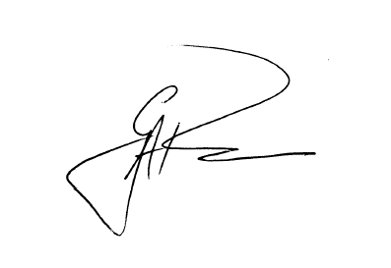
Professor Grant A. Ramm,
Head of Department – Cell and Molecular Biology,
Group Leader – Hepatic Fibrosis and
Principal Research Fellow
QIMR Berghofer Medical Research Institute,
PO Royal Brisbane and Women’s Hospital,
Brisbane, QLD., 4029, AUSTRALIA.
Ph: +61-7-3362 0177
E-Mail: Grant.Ramm@qimrberghofer.edu.au

