
DYSON COLLEGE OF ARTS & SCIENCES
Department of Biology
861 Bedford Road
Pleasantville, NY 10570
(914) 773-3587

February 4, 2020

Dr. Kyle Jewhurst
Journal of Visualized Experiments
1 Alewife Center, Suite 200
Cambridge, MA 02140

Dear Dr. Jewhurst, Dr. Bajaj, and Editorial Staff,

Please find attached our resubmission of the manuscript, “A confocal microscope-based laser ablation and regeneration assay for zebrafish interneuromast cells,” JoVE 60966. We appreciate the editorial comments and valuable feedback from the reviewers, and feel that this review process has allowed us to considerably strengthen our manuscript. We have addressed to the best of our ability the concerns raised by reviewers, as detailed below.
Editorial comments:
- We have thoroughly proofread the manuscript to ensure that there are no typographical or grammatical errors.
- We have removed commercial language from the protocol, relegating all such information to the revised Table of Materials.
- We have changed the text of the protocol to use the imperative tense in each step.
- We have removed personal pronouns from the protocol; some personal pronouns remain in the Results and Discussion sections, but presumably this is not an issue.
- We have broken down some of the longer steps into simpler, 2-3 step procedures.
- We believe that we have been explicit in describing how each step is performed.
- In step 5.1, we have added that the fish are anesthetized for this step.
- We have broken down steps 5.4, 6.4, and 6.5 into sub-steps for simplicity.
- We have not broken down step 7 into individual mouse clicks because these are commonly used tools in confocal microscopy, and entering each mouse click would surely make the protocol well over the ten page limit. We feel that we have provided enough detail for the casual confocal microscope user to follow. If the editors feel that these still need to be broken down further, we will do so at the expense of brevity.
- We have highlighted approximately 2.75 pages of the protocol, but are happy to reduce the highlighted portion further if we have inadvertently included too many steps for filming.
- None of our figures have been previously published in any form.
- The figure legends each include a title and a short description of the data included therein.

Reviewer 1:
Major concerns: None
Minor concerns:
- We have included a new figure demonstrating cell death after laser irradiation (Figure 2) and have added step 8.2 to ensure that the cell is no longer fluorescing after ablation.
- We have added a figure (Figure 3) to demonstrate that nearby tissues, namely the lateral line nerve, are unaffected by focused laser ablation. We have further added a section in the representative results section (lines 344-348) detailing the photobleaching and survival of periderm cells.
- We have added the specifications of the 405 nm laser to both the protocol (Step 7.1) and the Table of Materials.
- The reason for using high zoom rather than a region of interest for ablation is now included in Step 7.2 (lines 255-256).
- We have modified our protocol to use the freely-available FIJI software package for analyzing gap size, eliminating the costly Imaris software (section 9).
- We have removed the term “failed experiments” from our manuscript (lines 375-378).
- We have completed both incomplete sentences pointed out by the Reviewer (Steps 6.1 and 7.3, formerly step 7.2).

Reviewer 2:
Major concerns:
- Figure 1, referred to as not “particularly useful or interesting,” has been replaced.
- Figure 3 has also been replaced.
- We have provided data showing that the targeted cells die (Figure 2) and that the ablation is selective (Figure 3).
- We have included data on the reproducibility of the results and the likelihood of gap closure (lines366 and 375, Figure 5) as well as evidence of cell death (Figure 2).
- We have addressed the question regarding the advantage of our technique over electroablation (greater selectivity) and the observation of new neuromast formation in a previous study (lines 454-459).
- We have removed the steps in which larvae are rinsed with E3 medium as suggested.
- We have provided additional details on the imaging setup, including the pinhole size (step 6.5.3) and numerical aperture of the objective (step 6.1 and Table of Materials). We have also explained why we use high zoom for ablations (step 7.2).
- As described above, we have switched out the costly Imaris software for FIJI in our image analysis section (section 9).
- We have provided results for 50 trials (30% closure rate) and the correlation between gap size and likelihood of gap closure (Figure 5) as evidence of reproducibility.
- We now make reference to additional previous studies in our Discussion section (line 426, 427, 457, 459).
Minor concerns:
- We have completed the two incomplete sentences noted by the Reviewer (Steps 6.1 and 7.3, formerly step 7.2).

Reviewer 3:
Major concerns:
- We have demonstrated hair cell ablation as an additional application of our technique (Figure 4).
- We are uncertain what is meant by “the legal implications of the work.” Does this refer to animal care and use? As mentioned on lines 99-100, all animal work was approved by the Institutional Animal Care and Use Committee. This would presumably vary from institution to institution, but we have no knowledge of how such experiments would be considered by different committees, nor in different countries.
Minor concerns:
- Figure 1 has been replaced.

Reviewer 4:
Major concerns:
- We have now included a figure showing that the ablated cell is dying, and that apparent macrophages are recruited to remove the cellular debris (Figure 2).
Minor concerns:
- We have added a period to the sentence cited on line 112.
- We have removed the E3 rinses from our protocol.
- The sentence cited as line 192 has been completed.
- The positions option (lines 216-216) will vary depending upon the software in use; however, it is impossible to address what this option may be called in all possible software packages. We do refer to the specific software used to perform this protocol in the Table of Materials.
- We have completed the sentence formerly on line 240, now line 253.
- We were unable to identify the font change mentioned; we believe that the entire manuscript is in the correct font.
- As described above, we have added a period to the offending sentence.
- We have replaced the word “removed” with “destroyed” on line 442.
- It is unclear what is meant by “what the differences are” between neuromasts in figure 2. These are simply the common annotations for sequential neuromasts along the lateral line.
- The mesh wells for transferring zebrafish larvae are listed in the Table of Materials and will appear in the accompanying video.

This revision was developed in consultation with all coauthors, each of whom has approved of this final version. Please let us know if you have any remaining questions or concerns regarding our resubmitted manuscript.

Best Regards,
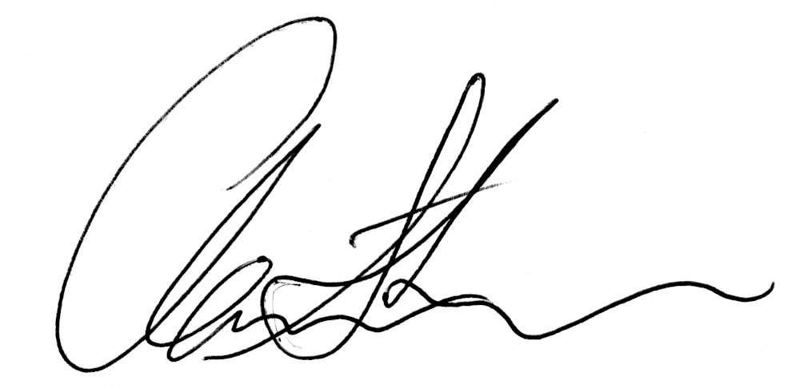

Aaron B. Steiner, Ph.D.
asteiner@pace.edu

