Copyright Permission from Journals/Publisher to Reuse Previously Published Work.

Permission/Policy from APS journals:
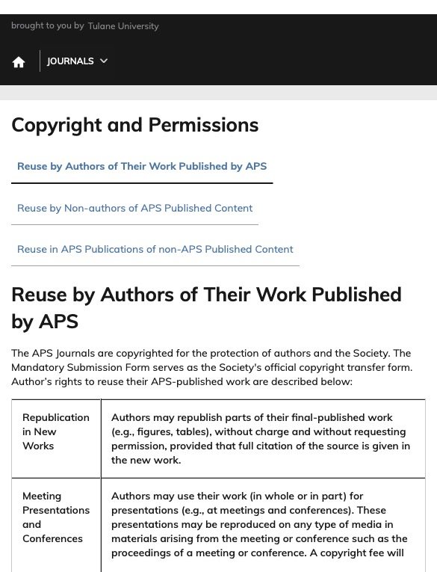

Permission from Springer Nature: pertaining to the previously published work in the Methods in Molecular Biology Journal.

Permission from AHA Journals:

