

Dr. Nam Nguyen December 22nd, 2019
JoVE

JoVE60931

Dear Dr. Nguyen,

We appreciate the preferable considerations on our manuscript entitled “A rabbit venous interpose model to assess intimal hyperplasia under arterial blood pressure mimicking revascularization surgery using vein grafts” for publication in JoVE. According to valuable comments from the reviewers, we revised the manuscript.

We believe that we could sufficiently revised the manuscript for the publication in JoVE and we look forward to receiving your positive reply.

Please address all correspondence to:
Hidetoshi Masumoto, MD, PhD
Department of Cardiovascular Surgery,
Graduate School of Medicine, Kyoto University
54 Shogoin Kawahara-cho, Sakyo-ku, Kyoto 606-8507, Japan
TEL: +81-75-751-3784 / FAX: +81-75-751-4960
masumoto@kuhp.kyoto-u.ac.jp

Sincerely,

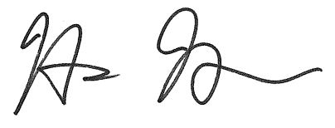
Hidetoshi Masumoto, MD, PhD

