Submission ID #: 60888

Scriptwriter Name: Susan Timberlake

Project Page Link: http://www.jove.com/files_upload.php?src=18570888

Title: Simple Lithography-Free Single Cell Micropatterning Using Laser-Cut Stencils

Authors and Affiliations:
Soah Lee^{1,2,3,}*, Huaxiao Yang^{1,2,3,}*, Caressa Chen^{1,2,3,}*, Sneha Venkatraman^{1,2,3}, Adrija Darsha^{1,2,3}, Sean M. Wu^{1,2,3}, Joseph C. Wu^{1,2,3}, Timon Seeger^{1,2,3,4}

¹Stanford Cardiovascular Institute, Stanford University School of Medicine, Stanford, CA, USA
²Department of Medicine, Division of Cardiovascular Medicine, Stanford University, Stanford, CA, USA

³Institute for Stem Cell Biology and Regenerative Medicine, Stanford University, Stanford, CA, USA
⁴Department of Medicine III, University Hospital Heidelberg, Heidelberg, Germany

Corresponding Authors:
Timon Seeger (timon.seeger@med.uni-heidelberg.de)

Email Addresses for Co-authors:
Soah Lee (soahlee@stanford.edu)
Huaxiao Yang (huaxiao@stanford.edu)
Caressa Chen (caressa.chen@gmail.com)
Sneha Venkatraman (sneha.v987@gmail.com)
Adrija Darsha (adrija.k.darsha@gmail.com)
Sean M. Wu (smwu@stanford.edu)
Joseph C. Wu (joewu@stanford.edu)

Author Questionnaire

1. Microscopy: Does your protocol involve video microscopy, such as filming a complex dissection or microinjection technique? Yes

If Yes, can you record movies/images using your own microscope camera? No

If No, JoVE will need to record the microscope images using our scope kit (through a camera port or one of the oculars). Please list the make and model of your microscope.
Zeiss Primo Vert
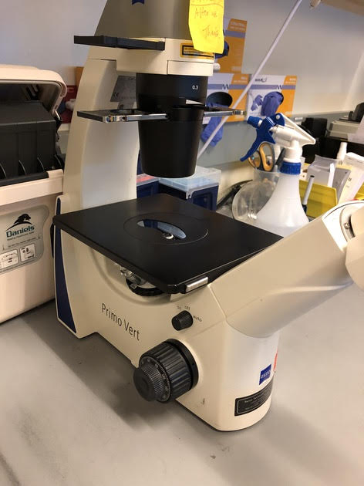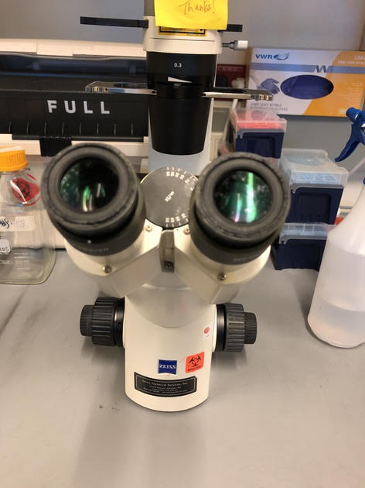
2. Software: Does the part of your protocol being filmed include software usage? No

3. Filming location: Will the filming need to take place in multiple locations? No

Script – Introduction
- Introductory Interview Statements
- Huaxiao Yang: We describe a stencil-based, lithography-free single-cell micropatterning method that overcomes many of the obstacles associated with photolithography and soft lithography. The stencils are reusable and the process is inexpensive and customizable. [1].
    - INTERVIEW: Named author says the statement above in an interview-style statement while looking slightly off-camera.
- Soah Lee: This method can open a new avenue for non-engineer researchers to study cell shape- and area-induced mechanotransduction in various physiological and pathological contexts. Furthermore, this protocol allows for micropatterning of thousands of cells, which can be utilized for high-throughput disease modeling and drug screening in a dish [1].
    - INTERVIEW: Named author says the statement above in an interview-style statement while looking slightly off-camera.
- Huaxiao Yang: Visual demonstration will facilitate implementation of two crucial steps: detaching one coverslip from the hydrogel, and drying the hydrogels sufficiently before placing the stencil. [1].
    - INTERVIEW: Named author says the statement above in an interview-style statement while looking slightly off-camera.

Script - Protocol
- Solution Preparation
  - Prepare the polyacrylamide hydrogel solution in a new 50-milliliter polypropylene centrifuge tube, as described in the manuscript [1-TXT].
    - Establishing shot of talent at laboratory bench. TEXT: See manuscript for details on altering the stiffness of the hydrogel by changing the ratio of acrylamide to bis-acrylamide.
  - Next, to prepare the 5-percent photoinitiator solution, dissolve the ingredients in 700 microliters of 100-percent ethanol [1-TXT]. The ingredients are not water-soluble, so be sure to fully dissolve by vortexing [2]. Add 300 microliters of PBS, for a final volume of 1 milliliter [3].
    - Talent prepares photoinitiator solution. TEXT: The photoinitiator solution is good for 4 weeks, if stored in foil at 4 °C. Videographer: It is not necessary to show the entire process of making the solution.
    - Talent vortexes centrifuge tube.
    - Talent adds PBS.
  - [1-TXT].
    - Talent prepares basement membrane matrix protein solution. TEXT: When working with basement membrane matrix, work on ice and use ice-cold solutions and chilled pipette tips and tubes.
  - Working on ice, dilute basement membrane matrix protein stock solution with ice-cold DMEM/F12 media or 1x PBS to the optimized dilution ratio [1]. Keep on ice for later use. When working with basement membrane matrix, make sure to always work on ice and use ice-cold solutions and chilled pipette tips and tubes [2].
    - Talent dilutes basement membrane matrix protein stock solution. (Author Comment: During filming, 2.4.1 was labeled and filmed as 2.3.1)
    - Talent places solution on ice.
- Hydrogel Fabrication
  - Place a UV bench lamp in a biological safety hood [1-TXT].
    - Talent places bench lamp in hood. TEXT: Lamp: 365 nm, 4 mW/cm²
  - Next, examine the sterilized and dried paraffin films prepared previously [1]. If the paraffin films are not completely dry, use a vacuum aspiration system to remove any residual liquid [2].
    - Talent sets Petri dishes containing paraffin films in safety hood places the paraffin films in a Petri dish, and then uses a roller to flatten them out.
    - Talent uses aspiration system.
  - Using autoclaved forceps, place six autoclaved coverslips on the paraffin film, six in each Petri dish [1].
    - Talent places coverslips on films.
  - To prepare the UV-crosslinkable polyacrylamide final solution, dilute the photoinitiator solution with the polyacrylamide hydrogel precursor solution [1-TXT]. Sterilize the solution using a 50-milliliter filter unit with a 0.22-micrometer pore size [2].
    - Talent prepares UV-crosslinkable solution. TEXT: NOTE: Always prepare fresh solution.
    - Talent sterilizes solution.
  - Then, dispense 200 microliters of UV-crosslinkable polyacrylamide final solution onto each of the 6 glass coverslips in the Petri dishes [1-TXT]. Using autoclaved forceps, carefully cover each coverslip with a second coverslip, trapping a layer of the solution between the two coverslips [2].
    - Talent dispenses solution onto each glass coverslip. TEXT: Note: Paraffin film is used to avoid spilling and to confine the precursor solution between the coverslips.
    - Talent covers each coverslip with a second coverslip.
  - Place the Petri dishes containing the coverslips under the UV bench lamp with the lid unclosed [1]. For protection from UV radiation, cover the lamp with aluminum foil [2]. Photopolymerize the polyacrylamide hydrogels for 5 minutes [3-TXT].
    - Talent places Petri dishes under UV bench lamp.
    - Talent covers lamp with aluminum foil.
    - Talent turns on bench lamp. TEXT: Wear UV-protection goggles.
  - Use a razor blade to carefully separate each pair of coverslips [1-TXT]. Videographer: Author has indicated this is one of the most important steps for viewers to see.
    - Talent uses razor blade to separate coverslips and place the coverslip with hydrogel in a disposable polypropylene reservoir. TEXT: NOTE: The hydrogel will usually stick to the top coverslip. Be careful when detaching the coverslip from the hydrogel, because it is likely to break.
  - Fill the reservoir containing the six coverslips with PBS [1]. [2]. After rinsing for 5 minutes, return the hydrogel-coverslip composites to the paraffin film in the Petri dish [3].
    - Talent fills reservoir with PBS.
    - Talent transfers coverslips to reservoir. (Author we included this action in step 3.81)
    - Talent places hydrogel constructs back on the paraffin films in the Petri dishes.
- Protein Conjugation
  - Obtain a tube of sulfo-SANPAH from storage at minus 80 degrees Celsius [1-TXT]. Add 1,200 microliters of pre-chilled PBS to the tube, and mix by pipetting up and down [2].
    - Talent removes a vial from freezer. TEXT: Thaw sulfo-SANPAH immediately before use. Do not reuse or refreeze leftovers.
    - Talent adds PBS to the tube and mixes by pipetting.
  - Dispense 200 microliters of the diluted sulfo-SANPAH onto the paraffin film in the Petri dish [1]. Place a hydrogel-coverslip composite over the sulfo-SANPAH, with the hydrogel contacting the sulfo-SANPAH [2-TXT].
    - Talent dispenses sulfo-SANPAH.
    - Talent places hydrogel construct over sulfo-SANPAH. TEXT: Repeat for each hydrogel-coverslip composite.
  - Next, place the hydrogel-coverslip composites under the UV lamp and expose them for 5 min, to activate the sulfo-SANPAH [1-TXT].
    - Talent places composites under lamp. TEXT: UV lamp: 365 nm, 4 mW/cm²
  - If the sulfo-SANPAH turns from orange to brown, indicating successful activation and incorporation, proceed to the next steps within 10 minutes [1].
    - CU: Hydrogel-coverslip composite, showing brown color.
  - Replenish the disposable polypropylene reservoir with fresh PBS [1]. Transfer the activated hydrogel-coverslip composites to the reservoir and rinse them briefly to remove unbound sulfo-SANPAH [2-TXT].
    - Talent replenishes the reservoir.
    - Talent rinses composites in reservoir. TEXT: Note: Washing > 5 minutes can result in low protein-conjugation efficiency.
  - Place the hydrogel-coverslip composites on the paraffin film in the Petri dishes [1] and carefully dab them with sterile lint-free wipes [2-TXT].
    - Talent places the hydrogel composites on the paraffin film.
    - Talent dabs the composites with sterile wipes. TEXT: Important: Do not overdry or leave excess moisture.
  - Place a stencil on top of each hydrogel-coverslip composite [1-TXT]. To ensure a tight seal between the stencil and the composite, remove excess moisture by dabbing with autoclaved lint-free wipes [2]. Videographer: Author has indicated this is one of the most important steps for viewers to see.
    - Talent confirms the front side of a stencil and places the front side of a stencil facing up on top of each composite. TEXT: The front side of a stencil is determined by a chiral letter when it’s readable.
    - Talent dabs with lint-free wipes. Videographer: Author has indicated this is the most difficult step of the procedure.
  - Carefully dispense the diluted basement membrane matrix protein solution, placing 200 microliters on top of each hydrogel-coverslip composite [1]. Incubate the constructs overnight at 37 degrees Celsius [2]. Videographer: Author has indicated this is one of the most important steps for viewers to see.
    - Talent dispenses basement membrane matrix protein solution.
    - Talent places hydrogel composite in incubator.
  - The next day, transfer the composites to a 6-well plate [1]. Videographer: Author has indicated this is one of the most important steps for viewers to see.
    - Talent transfers constructs to 6-well plate.
  - Soah Lee: A tight seal between hydrogel and stencil can be easily validated by observing whether the matrix protein solution has been retained on top of the stencil. Failure to form a tight seal leads to quick leakage of the protein solution through the holes [1].
    - INTERVIEW: Named author says the statement above in an interview-style statement while looking slightly off-camera.
  - Fully immerse the composites in PBS [1-TXT]. Using autoclaved tweezers, carefully detach the stencils from the hydrogels, without tearing the hydrogels [2]. Remove the PBS from the wells, and refill the wells with DMEM [3]. Incubate the plate overnight at 37 degrees Celsius [4].
    - Talent adds PBS to wells. TEXT: Immersion helps prevent sticking and tearing during stencil removal. Video editor: Keep text on screen for 4.12.1 and 4.12.2.
    - Talent detatches stencils.
    - Talent removes PBS and refills wells with DMEM.
    - Talent places 6-well plate in incubator.
  - After removing the plate from the incubator, examine the DMEM [1]. If the DMEM is not cloudy, the hydrogel-coverslip composites are ready to be used for cell plating [2].
    - Talent removes 6-well plate from incubator.
    - 6-well plate on laboratory bench, with color of fluid in wells visible.

Script – Results
- Results: Micropatterning of Cells
  - Stencils were fabricated containing arrays of squares and rectangles [1]. Micropatterned hydrogel substrates were created from the stencils, and islands of matrix protein were obtained [2]. Cell islands were also obtained, for example, islands of human induced pluripotent stem cell-derived cardiomyocytes [3].
    - LAB MEDIA: Figure 4. Video editor, please focus on Figure 4A.
    - LAB MEDIA: Figure 4. Video editor, please focus on Figure 4B.
    - LAB MEDIA: Figure 4: Video editor, please focus on Figure 4C.
  - Matrix protein concentration played an essential role in generating proper patterns [1]. An optimal concentration led to a homogenous distribution of proteins [2]. Suboptimal matrix protein solution concentrations led to suboptimal patterning [3]
    - LAB MEDIA: Figure 5.
    - LAB MEDIA: Figure 5. Video editor, please focus on Figure 5A.
    - LAB MEDIA: Figure 5: Video editor, please focus on Figure 5B.
  - It is critical to use the front side of the stencil [1]. If the back side of the stencil is used, the size of the matrix protein islands increases due to the direction of the laser cutting [2]. While using the back side of the stencil did not significantly affect the width of the rectangular patterns [3], the height significantly increased, leading to a reduction in the intended aspect ratio [4].
    - LAB MEDIA: Figure 6. Video editor, please focus on Figure 6A and Figure 6B.
    - LAB MEDIA: Figure 6: Video editor, please focus on 6B.
    - LAB MEDIA: Figure 6. Video editor, please focus on 6C.
    - LAB MEDIA: Figure 6. Video editor, please focus on 6D and 6E.
  - Stencil-based patterning was applied to silicon elastomer substrates [1]. The patterned cardiomyocytes on silicon elastomer substrates were visualized by immunocytochemistry of cardiac troponin T at low magnification [2] and by sarcomeric protein ⍺-actinin at high magnification [3].
    - LAB MEDIA: Figure 7.
    - LAB MEDIA: Figure 7. Video editor, please focus on 7A.
    - LAB MEDIA: Figure 7. Video editor, please focus on 7B.
  - The stencil-based patterning was also applied to pattern two cardiomyocytes side-by-side on hydrogels with different stiffnesses [1].
    - LAB MEDIA: Figure 8.

Script - Conclusion
- Conclusion Interview Statements
  - Huaxiao Yang: The discovery of human induced pluripotent stem cells (hiPSCs) and corresponding differentiation protocols has made it an ideal in vitro human model for studying organogenesis and pathogenesis. However, a major limitation using the iPSC system is the absence of a structured microenvironment, which has the particular biochemical composition and stiffness to interact with cells [1].
    - INTERVIEW: Named author says the statement above in an interview-style statement while looking slightly off-camera.
  - Huaxiao Yang: Analysis of iPSC-derived cell types, in our case cardiomyocytes, in a more physiological morphology opens opportunities to study challenging cardiomyopathies in a culture dish [1].
    - INTERVIEW: Named author says the statement above in an interview-style statement while looking slightly off-camera.
  - Soah Lee: The patterning can be combined with traction force microscopy and immunocytochemistry assays to characterize structure and function of the cardiomyocytes [1].
    - INTERVIEW: Named author says the statement above in an interview-style statement while looking slightly off-camera.
  - Huaxiao Yang: This technique can be applied to many other systems, such as microfluidic chips and high-content screening plates. The shape and the substrate can also be readily adjusted according to the application [1].
    - INTERVIEW: Named author says the statement above in an interview-style statement while looking slightly off-camera.

