Athens, November 25th, 2019

Phillip Steindel, Ph.D., Review Editor

Dear Dr. Steindel,

Please find enclosed our revised manuscript entitled ” Efficient Differentiation of Postganglionic Sympathetic Neurons Using Human Pluripotent Stem Cells under Feeder-free and Chemically Defined Culture Conditions” by Hsueh Fu Wu and Nadja Zeltner. We have now revised the manuscript, we adressed the editorial and reviewers comments to the best of our capabilities. We apologize for the delayed submission.

Our manuscript is not under submission in any other journal and all authors agreed to the final version of the manuscript. There are no conflicts of interest for any authors.

Thank you for your consideration of the manuscript and please do not hesitate to contact me with additional questions.

Sincerely,
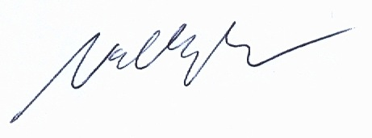

Nadja Zeltner, PhD

