
Administrative Offices
2130 Taubman Health Center
1500 E. Medical Center Drive
Ann Arbor, MI 48109-5340
Phone (734) 936-5895
Fax (734) 763-5354

Chief
Paul S. Cederna, MD

Section Administrator
Nadine Lewis, MHSA

Adult Appointments:
Phone (734) 998-6022
Fax (734) 998-6696

Pediatric and Craniofacial Appointments:
Phone (734) 763-8063
Fax (734) 232-6973

Plastic Surgeons
David L. Brown, MD
Steven R. Buchman, MD
Paul S. Cederna, MD
Kevin C. Chung, MD, MS
Robert H. Gilman, MD, DMD
Steven C. Haase, MD
Steven J. Kasten, MD, MHPE
Jeffrey H. Kozlow, MD, MS
Theodore Kung, MD
William M. Kuzon, MD, PhD
Benjamin Levi, MD
Adeyiza O. Momoh, MD
Erika D. Sears, MD, MS
Christian J. Vercler, MD, MA
Jennifer F. Waljee, MD, MPH, MS
Edwin G. Wilkins, MD, MS

Research Faculty
Dennis R. Claflin, PhD
Stephen W.P. Kemp, PhD
Shuli Li, PhD
Elham Mahmoudi, PhD

Emeritus Faculty
Cynthia L. Marcelo, PhD
M. Haskell Newman, MD
Riley S. Rees, MD
Melanie G. Urbanchek, MS, PhD

Website:
www.uofmplasticsurgery.com

K.

November 21, 2019
Kyle Jewhurst, PhD
Science Editor
JoVE

Dear Dr. Jewhurst,

Thank you very much for your letter regarding our submission to JoVE entitled “Fabrication of the Composite Regenerative Peripheral Nerve Interface (C-RPNI) in the Adult Rat”. We are also very appreciative of the reviewer’s very constructive and insightful comments regarding our manuscript, and we believe that these changes have strengthened our paper. We believe that we have addressed all of the reviewer’s concerns, and we have subsequently incorporated these changes into a revised manuscript (changes are displayed in red and underlined in the revised manuscript). In our Response to Reviewers, we have set out a point-by-point list that highlights the changes that we have made with respect to each reviewer’s comments. We look forward to the review of the revised manuscript, and if you have any further questions or require any additional information or clarification, please don’t hesitate to contact me.

All authors of this paper have read and approved the revised version submitted. We look forward to hearing from you. Thank you very much for the opportunity to submit our revised manuscript for consideration for publication in JoVE.
Sincerely yours,
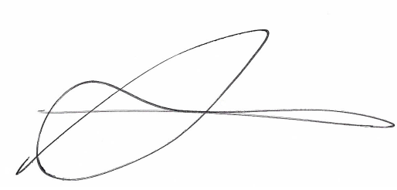

Stephen W.P. Kemp, Ph.D
Director, Neuromuscular Lab
Assistant Research Professor
University of Michigan, Section of Plastic Surgery
Department of Biomedical Engineering
1150 W Medical Center Drive
MSRB II, A570 Ann Arbor, MI, 48109-5456
P: (734) 615-2598
swpkemp@med.umich.edu

