December 14, 2019

To: Nam Nguyen, Ph.D, Manager of Review, JoVE
From: Avi Schroeder, PhD, Department of Chemical Engineering
Technion – Israel Institute of Technology, Haifa 32000, Israel
avids@technion.ac.il

Re: "A Simple Protocol for Preparing Protein Producing Synthetic Cells and Cell-Free Bacterial Extracts using Liposomes and Emulsion Transfer"
Manuscript number: JoVE60829R1

Dear Dr. Nguyen,

Please allow us to thank you for the comments regarding our manuscript. We corrected the typos and performed additional editing of the text. All the materials and equipment (with the catalog numbers) are now described in Table of Materials. Following yours instructions we reduced the attached tables and the remaining describe compositions of the solutions used in the article.
Attached please find a 'track changes' copy of the revised manuscript.
We hope you find this version of the revised paper suitable for publication in this journal.

Warmly yours,
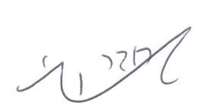

Avi Schroeder, PhD
Department of Chemical Engineering
Technion – Israel Institute of Technology, Haifa 32000, Israel

