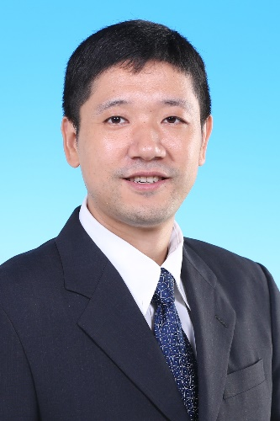
Biography:
Prof. Jie Yuan (M06-SM12) received his Ph.D in Electrical Engineering from University of Pennsylvania, Philadelphia, in 2006. He received his B.S in Electrical Engineering from Tsinghua University in 2000. Since 2006, Prof. Yuan has been a faculty member of the Electronic & Computer Engineering Department in Hong Kong University of Science & Technology. Currently, he is an Associate Professor at HKUST.
Prof. Yuan’s research expertise is on sensory IC design. His research group has made contributions to the fields of ADC, CMOS imaging sensor, bio-cellular recording systems, human body communication, energy harvesting etc.
Prof. Yuan is currently the chair of the Analog Signal Processing Technical Committee of IEEE CAS society. He served as the chair of the Biomedical Circuits and Systems Technical Committee of IEEE CAS 2012-2014. He served as the Technical Program Committee Co-Chair of IEEE Biomedical Circuits and Systems Conference in 2009. He is an Associate Editor of the IEEE Transactions on Biomedical Circuits and Systems. Prof. Yuan was an Associate Editor of the IEEE Transactions on Circuits and Systems II: Express Briefs, and a guest editor of the IEEE Transactions on Circuits and Systems I: Regular Papers.

