Point by point response to reviewers and editorial comments

Reviewer #1:

Manuscript Summary:
The manuscript by Sharma and Wright describes the deployment of genome-scale CRISPR/Cas9 screens in the identification of cell surface receptors using an oligomerized streptavidin-PE recombinant ectodomain probe; hence permitting the identification of receptor-ligand interactions. While comprehensive and clearly within the scope of the journal, certain sections require further clarification to maximize adoption of this approach in a more general setting:

Major Concerns:
Line 63: Here the authors state that overexpression of cDNAs to screen for a phenotype of interest can be used to identify new protein-protein interactions. Within this section (or later on in the discussion if more appropriate), authors should also discuss the pitfalls of relying on protein overexpression and how this can lead to an increased risk of false positives, particularly if the native binding avidity of the receptor is also altered. In particular, how a CRISPR/Cas9 based approach overcomes this problem should also be discussed.

We thank the reviewer for this comment. The CRISPR/Cas9 based loss-of-function based screening approach described here identifies the interactions mediated by cell surface molecules natively displayed on cell surfaces and does not, by contrast to cDNA expression cloning methods, depend on the over-expression of receptors. This also makes this genetic screening approach suitable to study interactions mediated by all types of cell surface molecules regardless of their biological properties.

To highlight this, we have now changed the discussion section:

‘However, one major advantage of this approach is that it is applicable to interactions mediated by surface molecules natively displayed on the cell and does not depend on the over-expression of receptors, which can influence the binding avidity of the receptor. Unlike other methods, therefore, this technique makes no assumptions regarding the biochemical nature or cell biology of the receptors and provides an opportunity to study interactions mediated by proteins that are normally difficult to study using biochemical approaches; for example, very large proteins, or those that traverse the membrane multiple times or form complexes with other proteins, and molecules than proteins such as glycans, glycolipids and phospholipids.’

Line 269: If an EDTA-based cell detachment method is favored, why is FBS-containing media required for neutralization and washing of the cells? Can the cells not directly be resuspended in wash buffer (PBS/1%BSA)?

We thank the reviewer for pointing this out. We have found that if EDTA-based cell detachment buffer is used, the cells can be directly resuspended in wash buffer. We have now added this point to the protocol.

Line 289: What does "…step 5.12…" refer to?
Thank you for pointing out the typo. This has now been corrected.

Line 300: "…ideally over 80 % of the cells…" How did the authors determine that this value (and not lower) is appropriate for identification of a positive binding cell line? Why would a cell line that demonstrates <80% binding not be considered a positive line? Based on the previous gating steps if less than 1% is set at the positive gate then anything higher should be considered a positive result?

The 80% cut-off is based on our experience of performing genetic screens, but we agree that the way it is written here could be construed as an absolute cut off, which is not the case. Because we are using a single stringent sorting approach for performing genetic screens (1-5% of non-binding population), if the binding population is very low, the signal to noise ratio will be very low and the screen might not be successful.

We have reworded this and added the following sentence as a note:

“[Note: Cell lines that display a higher binding population are desired for genetic screens, as they have a higher signal to noise ratio. Ideally over 80 % of the cells should fall within this gate.]”

Line 316: It is unclear to me what is exactly meant by "Binding to HS on the cell surface is not necessarily 'non-specific' but rather a property of the protein." Given the authors' experiences with this phenomenon during their screening assays, can they give further comment as to how this HS binding property varies between cell lines that indicate positive binding to the probe? Does the additive binding interfere with the sensitivity of the assay?

Following this point, a large section appears to be devoted in discussing practical ways around the HS binding issues, which suggests that it has a significant impact on the deployment of the assay. It would therefore be helpful if the authors detail all the cell lines they have tested that have this property and provide some statistical analysis demonstrating the magnitude of the additive binding and how the proposed genetic targeting approaches targeting the HS/GAG biosynthesis pathways improves the assay sensitivity. Additionally, the impact of interference of HS/GAG biosynthesis on the biological properties of the cells (and indeed any impact on receptor-ligand interactions or screening) need to be discussed further.

In the cell binding assay designed here, we have generally found that the contribution of HS towards binding is additive rather than co-dependent on other receptors (Sharma et al. 2018). Also, if a protein has HS-binding property, it should, in principle, bind to all cell lines that display HS molecules. Pragmatically, it also means that if the protein has HS-binding properties, it will likely bind to any HS-expressing cell surface, even in the absence of another receptor. The initial HS-binding test is to aid the understanding of the biochemical properties of the recombinant protein. If a complete loss of binding is observed in this heparin blocking experiment, it is likely that the genes identified in the full genetic screen would be dominated by those involved in HS biosynthesis. We have shown this to be a case in both P. falciparum and mammalian proteins (in at least 6 cases) (Sharma 2018).

We have tested a number of cell lines originating from different tissue types and have noticed that some cell lines tend to bind to proteins in a HS-dependent manner more than others, presumably due to higher cell surface levels of HS. We have observed a greater number of proteins binding to cell lines such as HEK293, NCI-SNU1, NCI-SNU-16, COLO-320-HSR, and HepG2. Cell lines originating from the haematopoietic lineage such as HEL, HL-60 generally bind to fewer proteins which are not dependent on HS. One of our observations from CRISPR activation based experiments has been that upregulations of syndecans (proteoglycans that display HS at the cell surface) in cell lines lead to increased binding of proteins that have HS-binding properties (Chong et al. 2018). We have also found that expression of syndecans tend to be higher in the cell lines in which we tend to see more HS-dependent binding (figure 1). We have, however, not performed a comprehensive analysis to study the binding behavior of different cell lines so we would be cautious in confidently providing the identity of the cell lines that express differential binding behavior.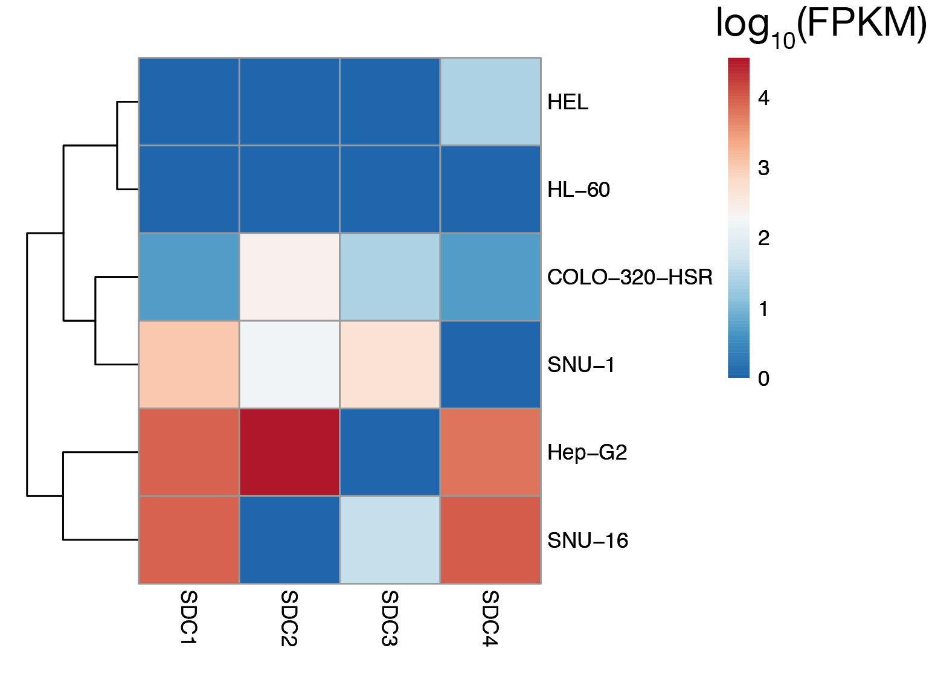
Figure 1: Expression levels of syndecan family member proteins in different cell lines. Normalized FPKM values for each cell line was obtained from RNA-seq expression analysis from cell model passport.

However, we have found that the additive binding of HS does not interfere with the binding to a specific receptor: if a protein has a HS-binding property but also binds to a second receptor, the protein will continue to bind to cells in the absence of HS on the surface of the cells. Heparin blocking experiments in such cases will reveal residual binding. We have illustrated this in figure 3 of the manuscript. In genetic screens, we have been able to identify both the receptor and the HS biosynthesis pathway (also see figure 3). We have dedicated a substantial section in our original paper to describe this phenomenon using the example of interaction mediated by the P. falciparum invasion ligand RH5. We therefore believe that it would be more suitable to point the readers to that section of the original paper rather than rewrite the whole section again.

To address these points, we have included this in the discussion section :

One of the major limitations of this method when using it to identify the receptor of an orphan protein is the initial requirement to first identify a cell line that binds to the protein. This is not always easy, and identifying a cell line that displays a binding phenotype which is also permissive to genetic screens, can be the time-limiting step for deploying this assay. We have also noticed that some cell lines tend to bind to more proteins than others. This is especially relevant for proteins that have a HS-binding property, because these proteins tend to bind to any cell line that displays HS side chains, irrespective of the native binding context. Additionally, we have observed that upregulations of syndecans (proteoglycans that contain HS) in cell lines leads to increased binding of HS-binding proteins (Chong et al, 2018). This could be a factor to take into consideration when selecting the cell line for screening. However, also important to note is that the additive binding of HS does not interfere with the binding to a specific receptor. Because a number of proteins are known to bind to HS and the binding mediated by HS in this assay is additive rather than co-dependent, in a practical sense, it means that if a binding is observed, it is possible that it is mediated solely by HS. In such a scenario, the heparin blocking approach that we have described can identify such behaviors without having the need to perform a full genetic screen.

Line 498: The basis of 30% transduction efficiency is based on the Poisson probability distribution that ensures each cell receives a single gRNA, ensuring that the resultant phenotype is linked to a specific knockout. This point should be included in the section as to make it clear to a novice reader.
We thank the reviewer for this comment. We have now added this point in the figure legend of figure 1.

Given that the control population has not undergone the same processing through FACS the sorted BFP+ population, would the assay not benefit from additionally analysing the BFP+/PE+ population that currently does not get sorted? This may give some insight as to any FACS-related or other technical related loss of gRNA when compared to the control population as gRNA(control) = gRNA(BFP+/PE+) + gRNA(BFP+/PE-). This may additionally inform on any biological response illicited by probe binding that could alter gRNA distributions. Furthermore, some exemplary FACS plots showing a real distribution of the fluorescent populations would be informative, are the populations clearly defined so the gating is straightforward or is the distribution broader?

During the development of this method, we tried a number of different approaches including the one where we compared gRNA(BFP+/PE+) with gRNA(BFP+/PE-) as suggested by the reviewer. We found it technically difficult to perform a two-way sort because 94-99% of the cells were being sorted into the (BFP+/PE+) tube and the smaller number of (BFP+/PE-) cells in the other. Technically, this resulted in cell “spraying” contaminating the smaller fraction. We observed that the “single sort” approach could overcome this technical limitation. For one-way sorting to work efficiently, we tend to keep the binding population be as high as 80% such that the signal to noise ratio is high. We have now included an example of what we consider to be an ideal binding profile. Gating for these samples is very straightforward as seen from the figure 2. We have added this figure in supplementary figure 1 and referred in text in section 8.10 of the revised manuscript:

“An example of a sorting gate is provided in supplementary figure 1.”

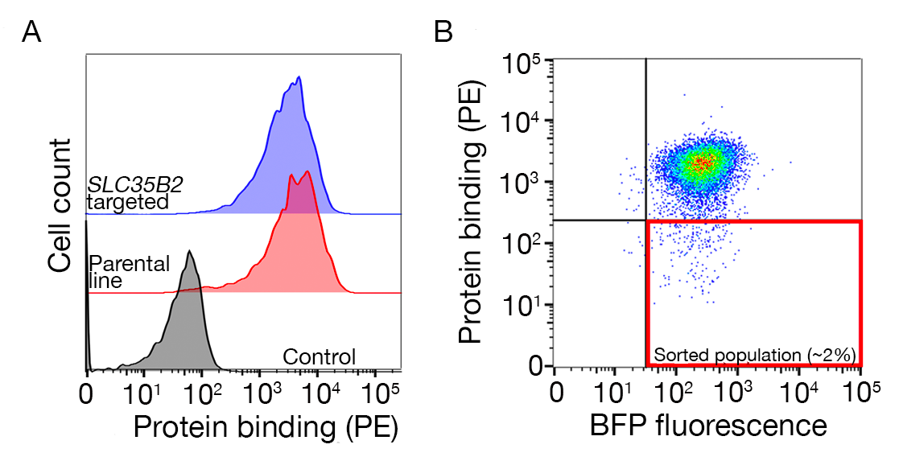
Figure 2: A guide to drawing gates for sorting the non-binding population. A. An ideal protein candidate for screening should have a clear shift of binding population compared to the control population and the binding should be retained on cells lacking machinery for HS biosynthesis. A heparin blocking experiment can be used in place of testing on SLC35B2 targeted cell lines. B. Cells lacking the surface staining from the protein ectodomain but expressing BFP fluorescence (from lentiviral transduction) were collected. The cells displayed are from a screen for the identification of receptor for GABBR2 (figure 2A modified from Sharma et al. 2018).

The readout of the assay depends on the loss of the streptavidin-PE probe from the cell, however loss of binding may also be induced gRNA targeting general cellular processes such as receptor trafficking to the plasma membrane or receptor protein folding within the ER, which may not be necessarily lethal and thus not classed as an essential gene. Does the scoring and ranking take this into consideration?

The reviewer is correct in recognition that the loss of binding can be due to indirect non-lethal processes and this is something we initially considered. However, as we started performing these types of genetic screens, it became less of a concern for us because it was evident that the gRNAs targeting the receptor usually dominate the screen. For the ~10 antibody screens and 9 recombinant protein screens that we have reported to date, we have always identified the receptor within FDR of 0.05 and usually ranked 1. Therefore, we think that it is not crucial to have an additional scoring system for the identification of the receptor itself. We have now added this sentence in the discussion section to make this clear.

“When using this approach to identify the interaction partner, one should therefore expect the receptor and the factors contributing to its presentation on the surface to be identified with a high statistical confidence.”

Minor Concerns:
Although obvious, "D10 media" needs to be formally defined.
This is defined in table 2.

Reviewer #2:
Manuscript Summary:
Manuscript describes application of GeCKO library screening using fluorescent avid protein probes and negative FACS-sorting procedure. The manuscript is well written and protocol is clear and can be recommended for acceptance without a major revision.

We thank the reviewer for the positive feedback.

Minor Concerns:
1. Protocol #1. In my opinion, the brief description of principles how proteins expressed from vectors are biotinylated, and major advantages or disadvantages, using different multimerization motifs (leucin zippers, COMP and so on) would be very informative. As an option, schematic illustration of this can increase the perception of multimer formation and process understanding.

We thank the reviewer and we agree that that would be very useful for the readers. We have previously reviewed the concepts of multimerization and different multimerization techniques so we believe it would be more useful to point the readers to the review for a more comprehensive understanding (Wright 2009). We have now done this in the introduction section.

2. Previous works on affinity reagents (mAbs and others) screenings using GeCKO library should be cited (J Immunol Methods. 2016 Dec;439:8-14, Cell Rep. 2018 Apr 10;23(2):596-607, others)

Citations for studies that use high-affinity ligands and reviews on pooled genetic screens for the purposes of studying a range of biological processes such as cell signaling and virus-host interactions have now been added in the introduction section.

Reviewer #3:
Manuscript Summary:
In the present manuscript, Sharma et al. describe a genome-scale CRISPR/Cas9 knockout genetic screening approach to identify receptors and cellular pathways required for specific cell surface recognition events. Overall, the manuscript is well written and provides detailed information about the methodology and associated protocols.

We thank the reviewer for the positive feedback.

Major Concerns:
Thorough discussion of the methodology's limitations is missing. The authors may consider highlighting more the biological and technical drawbacks in order to provide the reader with realistic expectations on the success of the screening.

We thank the reviewer for this comment. A similar point was raised by reviewer #1 so we will reiterate the point we made before:

The major limitation of this approach is the initial screening required to identify a screen-permissive cell line that interacts with the protein. This is not always straightforward. This is additionally complicated for proteins that have HS-binding property. This is because, such a protein, in principle, binds to all cell lines that display HS molecules. Pragmatically, it also means that if the protein has HS-binding properties, it will likely bind to any HS-expressing cell surface, even in the absence of another receptor. We have included an initial HS-binding test is to aid the understanding of the biochemical properties of the recombinant protein. If a complete loss of binding is observed in this heparin blocking experiment, it is likely that the genes identified in the full genetic screen would be dominated by those involved in HS biosynthesis. As per the technical aspect of the screens, we have found the CRISPR/Cas9 screening system itself to be very robust. We have always identified the screen among the highest ranking genes and usually on position 1.

Addressing both reviewers, we have now added the following paragraph in the discussion section to address this comment.

One of the major limitations of this method when using it to identify the receptor of an orphan protein is the initial requirement to first identify a cell line that binds to the protein. This is not always easy, and identifying a cell line that displays a binding phenotype which is also permissive to genetic screens, can be the time-limiting step for deploying this assay. We have also noticed that some cell lines tend to bind to more proteins than others. This is especially relevant for proteins that have a HS-binding property, because these proteins tend to bind to any cell line that displays HS side chains, irrespective of the native binding context. Additionally, we have observed that upregulations of Syndecans (proteoglycans that contain HS) in cell lines leads to increased binding of HS-binding proteins (Chong et al, 2018). This could be a factor to take into consideration when selecting the cell line for screening. However, also important to note is that the additive binding of HS does not interfere with the binding to a specific receptor. Because a number of proteins are known to bind to HS and the binding mediated by HS in this assay is additive rather than co-dependent, in a practical sense, it means that if a binding is observed, it is possible that it is mediated solely by HS. In such a scenario, the heparin blocking approach that we have described can identify such behaviors without having the need to perform a full genetic screen.

Minor Concerns:
Some minor questions/comments regarding the experimental procedure are listed below:
Overall: the authors could consider to include timelines in each section to facilitate planning and provide a rough idea regarding the duration of the experiment.

We have now added a timeline in the schematic in figure 1. We have highlights the sections in the protocol that require considerable time (more than 1 week) and planning.

Line223: transfer the total volume of the sample?

This refers to transferring the total of 200 μL from the dilution plate to the streptavidin plate. We have changed this to the following:

“Transfer total volume (200 uL) from dilution plates to individual wells of the streptavidin-coated plates and incubate for 1 hour at room temperature (RT).

Line226: what is the volume of the washing buffer?
It should be 200 μL, we have now added this.

Line289. step 5.12 does not exist; probable typo
Yes, we have corrected it.

Line295:could be useful to elaborate more on what a control probe is.
Control probe is protein that contains the same tags as a recombinant protein of interest. We include a control protein to ensure that the observed binding is not mediated by the tags. We have defined this in section 3.2. In the edited manuscript this is in section 2.2.

Section 5: could be useful to provide a control graph.
The control graphs are demonstrated in figure 3. We have now also added a representative graph that showcases an ideal sorting gate.

“An example of a sorting gate is provided in supplementary figure 1.”

Figure 2: A guide to drawing gates for sorting the non-binding population. A. An ideal protein candidate for screening should have a clear shift of binding population compared to the control population and the binding should be retained on cells lacking machinery for HS biosynthesis. A heparin blocking experiment can be used in place of testing on SLC35B2 targeted cell lines. B. Cells lacking the surface staining from the protein ectodomain but expressing BFP fluorescence (from lentiviral transduction) were collected. The cells displayed are from a screen for the identification of receptor for GABBR2 (figure 2A modified from Sharma et al. 2018).

Line527: please indicate the unit (9-16 days?)
We have changed it to 9-16 days.

Reviewer #4:

In this protocol, authors have described the steps to employ the CRISPR screen to identify genes that directly and indirectly interfere with the binding of the proteins (of choice) on the cell membranes' array of receptors. The protein of choice is oligomerized on a streptavidin-PE. The oligomerized protein is then subjected to the cell culture. The oligomerized protein molecules will bind the receptors on the cell membrane. The cell culture (expressing Cas9) is pre-subjected to a library of gRNAs, in amounts such that each cell will undergo genetic disruption in roughly one gene only. The cells of the culture, are then FACS sorted according to the fluorescence of the PE (which would be bound to the cell membrane via the protein molecules oligomerized over streptavidin-EP). Further sequencing of such cells and their comparisons with a control population will reveal the genes that play important roles in mediating the binding of the protein of choice onto the cell membrane's receptors. The CRISPR screens are now being widely used to uncover the genetic networks of many biological interactions. This protocol is a timely, elegant and well-detailed adaptation of the CRISPR screen to uncover the genetic networks of protein-membrane receptor interactions.

The protocol is extremely long and well-detailed. I applaud the authors for including these many details. The manuscript should be published. Although I think the current version protocol is not the easiest of the read and it may be taxing for new readers. I would suggest that the protocol be made a little tighter. The protocol must not be stripped of details, as I strongly feel that they are keys to a good protocol. But following (or related) changes can be made to make the protocol a little tighter, without compromising on necessary details:

1. The protocol has too many abbreviations. I would suggest removing abbreviations for terms that are not even germane to the manuscript. A simple example: Mass spectrometry (MS). Also remove abbreviations for some other terms and feel free to use the full term instead of abbreviations in the rest of the manuscript.
We thank the reviewer for this comment. We have removed a number of abbreviations as suggested by the reviewer. Examples include: Mass spectrometry (MS), monoclonal antibodies (mAbs), over-night (O/N).

2. The protocol needs a figure flowchart in figure 1, describing all the keys steps.

Thank you for this comment. We have taken this into consideration and changed the figure to make it clear how the individual steps in the protocol relate to the three key parts of the protocol.

Modified figure 1:
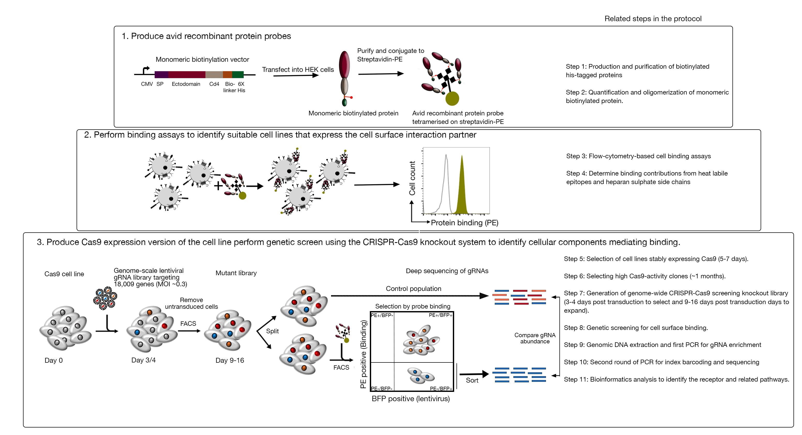

3. The abbreviation PE has never been defined in the manuscript. Please define it as Phycoerythrin. Authors also need to specify that the PE is fluorescent and its emission wavelength etc.
Thank you - we have now added this in the introduction section as follows.

The protocol here will describe the steps for generating fluorescent avid probes from monomeric biotinylated proteins by conjugating them to streptavidin conjugated to a fluorochrome (e.g Phycoerythrin (PE)), which can be used directly in cell-based binding assays and has the advantage of not requiring a secondary antibody for detection.

The emission wavelength and the detection lasers are mentioned in the protocol section 3.8.

4. All the sections are not necessarily in order of the workflow. E.g., Ways of determining specificity is not necessarily a direct part of the workflow. Is there a way to present these sections separately? I understand that JOVE has a particular format. But if possible, authors may consider highlighting the necessary sections of the workflow, a little separately than the other indirect sections.
We thank the reviewer for this comment. It is true that specificity is not directly related but we have found it to be a very important check that must be performed before proceeding with the screen. That said, we note that we have spent a very long section on this point, which can be distracting. We have considerably trimmed this section to make clearer. Section 4 of the protocol is the new revised section.

5. CRISPR screens are becoming increasingly common, but the protocol assumes that the reader would know about the idea and concept of the CRISPR screen already. I would add a few more details about the idea behind the CRISPR screen.
We agree that it would be useful to have background on CRISPR screens but because of space limitations we are unable to do this in the main text. We have added more details on the concept of CRISPR screen in figure 1.

6. In the introduction, the authors mention that the assay consists of three major steps. But then those three major steps are broken into many sections. A better synergy is needed between the introduction and the sections of the protocol. Perhaps the author can mention that the first step includes section 1 to m or something similar.
We have edited the schematic figure to indicate which section refer to which three steps of the protocol. Hopefully this will make the protocol easier to follow.

7. In data analysis section, It would be better if terms like RRA score & Cumulative distribution function plots are explained in one or two sentences. I understand that readers must look to other manuscripts for details about the analysis and interpretation of the sequencing data. But at the same time, it may be better to ensure that any specialized/uncommon technical terms like RRA, etc are given some context/explanation in the protocol.
We have added more details on specialized terms in the results section. Due to space limitations, we were not able to provide details in the protocol section, but we have included the concepts in the discussion and figure legends. Here are some examples:

The RRA-score in MAGeCK provides a measure of which gRNAs are ranked consistently higher than expected.—discussion section.

For any given number, cumulative density function reports percent of datapoints that are below that threshold.- Figure 5A legend.

Editorial comments:
Changes to be made by the Author(s):
1. Please take this opportunity to thoroughly proofread the manuscript to ensure that there are no spelling or grammar issues. The JoVE editor will not copy-edit your manuscript and any errors in the submitted revision may be present in the published version. Please use American English throughout.
Thanks you, this has been done.

2. Please provide at least 6 keywords or phrases.
Keywords are :CRISPR/Cas9, recombinant proteins, cell adhesion, cell surface receptor, genome-scale screening, extracellular protein interactions.

3. Please ensure that the long Abstract is within 150-300-word limit and clearly states the goal of the protocol.
The current abstract length is 150 words.

4. Please remove all commercial language from your manuscript and use generic terms instead. All commercial products should be sufficiently referenced in the Table of Materials and Reagents.
For example: Addgene, Opti-MEM, Lipofectamine, polybrene, Falcon tube, AMPure XP paramagnetic beads, Illumina NGS, iPCR-11mer tags, etc.
This has now been done.

5. Please ensure that all text in the protocol section is written in the imperative tense as if telling someone how to do the technique (e.g., “Do this,” “Ensure that,” etc.). The actions should be described in the imperative tense in complete sentences wherever possible. Avoid usage of phrases such as “could be,” “should be,” and “would be” throughout the Protocol. Any text that cannot be written in the imperative tense may be added as a “Note.”
The manuscript has been edited to ensure this.

6. The Protocol should contain only action items that direct the reader to do something. Please move the discussion about the protocol to the Discussion.
This has now been done.

7. The Protocol should be made up almost entirely of discrete steps without large paragraphs of text between sections.
Given the complexity of the protocol, we have included a section head for some of the steps so that anyone reading the protocol is able to understand why a certain step is being performed. Large text from protocol itself has now been moved as a NOTE.

8. Please ensure that individual steps of the protocol should only contain 2-3 actions per step.
This has now been done.

9. Please revise the protocol text to avoid the use of any personal pronouns in the protocol (e.g., "we", "you", "our" etc.).
This is has now been except in [Tip] sections.

10. Please add more details to your protocol steps. Please ensure you answer the “how” question, i.e., how is the step performed?
We have tried to edit the manuscript to include as much information as possible for how the step should be performed.

11. 1.1 and 1.2: Please explain how this is done, else please consider moving this section to the introduction as well.
We have moved this to the introduction section.

12. 4: This section doesn’t describe the action in the protocol, this can be moved to the discussion instead.
We have moved this section to the discussion section.

13. 5.1: Please include the cell line used in your example experiment.
HEK293 and NCI-SNU-1 cell was used in the example experiments. However, it is not necessary to use these cell lines. The identity of these cell lines are provided in the representative result section. We would prefer not to provide the identity in the protocol section as it might imply that these cell lines must be used.

14. Lines 197-204, 683-685: Only numbered steps describing the action can be filmed. If this need filming, please convert to numbered action step in imperative tense. Else please move some of the details to discussion. Sentences which directly are relevant with the protocol can stay as a NOTE. In the JoVE Protocol format, “Notes” should be concise and used sparingly. They should only be used to provide extraneous details, optional steps, or recommendations that are not critical to a step. Any text that provides details about how to perform a particular step should either be included in the step itself or added as a sub-step.
Lines 197-204 have been moved. Lines 683-683 includes steps from another published protocol. This has now been referred and the action steps have been changed to imperative tense.

15. 6, 7.1, 9, 10, 12.1: Please consider making action steps describing the actual action being performed in your experiment and move the other details to the discussion section.
These have now been addressed as suggested.

16. Please add more specific details for the software steps (e.g. button clicks for software actions, numerical values for settings, etc.).
For MAGeCK, a separate protocol for installation has already been published. We have referred to that publication as it is a method of its own. For other analysis steps, we have now included the column header from the output of MAGeCK software that are relevant for this study.

17. There is a 10-page limit for the Protocol (including headings and spacings), but there is a 2.75-page limit for filmable content (including headings and spacings). Please highlight 2.75 pages or less of the Protocol (including headings and spacing) that identifies the essential steps of the protocol for the video, i.e., the steps that should be visualized to tell the most cohesive story of the Protocol. Presently the protocol length is more than 10 pages.
The protocol is within 10 pages now.

18. Please obtain explicit copyright permission to reuse any figures from a previous publication. Explicit permission can be expressed in the form of a letter from the editor or a link to the editorial policy that allows re-prints. Please upload this information as a .doc or .docx file to your Editorial Manager account. The Figure must be cited appropriately in the Figure Legend, i.e. “This figure has been modified from [citation].”
All the modified figures have been published under creative common’s license. We have included the original paper where the license is printed.

19. As we are a methods journal, please ensure that the Discussion explicitly covers the following in detail in 3-6 paragraphs with citations:
a) Critical steps within the protocol
b) Any modifications and troubleshooting of the technique
c) Any limitations of the technique
d) The significance with respect to existing methods
e) Any future applications of the technique
The discussion section has been edited to address these points.

20. JoVE manuscripts do not have a separate conclusion section. Please combine the conclusions with the discussion.
This has now been done.
21. Please do not abbreviate the journal titles in the references section.
This has now been done.
22. Please remove all the commercial terms referred to in the tables/figures. Please use the generic term instead. All commercial terms can be referred to in the table of materials instead.
This has now been done.
23. Please sort the materials table in alphabetical order.
This has now been done.

Chong, Zheng-Shan, Shuhei Ohnishi, Kosuke Yusa, and Gavin J. Wright. 2018. “Pooled Extracellular Receptor-Ligand Interaction Screening Using CRISPR Activation.” Genome Biology. https://doi.org/10.1186/s13059-018-1581-3.
Sharma, Sumana. 2018. “Genome-Scale Identification of Cellular Pathways Required for Cell Surface Recognition.” University of Cambridge. https://doi.org/10.17863/CAM.18823.
Sharma, Sumana, S. Josefin Bartholdson, Amalie C. M. Couch, Kosuke Yusa, and Gavin J. Wright. 2018. “Genome-Scale Identification of Cellular Pathways Required for Cell Surface Recognition.” Genome Research 28 (9): 1372–82.
Wright, Gavin J. 2009. “Signal Initiation in Biological Systems: The Properties and Detection of Transient Extracellular Protein Interactions.” Molecular bioSystems 5 (12): 1405–12.

