
Sophie Astrof, Ph.D.
Associate Professor of Cell Biology
Rutgers University
Rutgers Biomedical and Health Sciences
Department of Cell Biology and Molecular Medicine
185 South Orange Ave, I-518
Newark, NJ 07103

Dear Nam,

We are submitting the revised manuscript entitled “Visualization and analysis of Pharyngeal Arch Arteries using Whole-mount Immunohistochemistry and 3D Reconstruction.” We have made the majority of the changes. However, some changes we could not make since they would render our protocol non-sensical. Our protocol is designed to use Fast Well spacers. If we remove that name, it will make no sense. So we will leave it as is. We added a note that non-commercial spacers could be used instead.

Similarly, if we remove the name Imaris, the procedure that we developed to quantify endothelial cell populations will be non-sensical. I am not aware of any non-commercial or commercial software that can be used here. If you want us to delete the Imaris part, we will have to delete the Analysis sections (section 7) and Figure 3, both of which are essential to the protocol we developed.

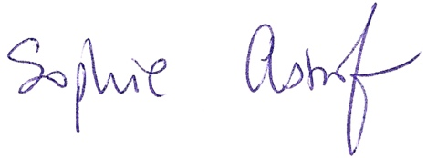
Best regards,

Sophie Astrof

