Vineeta Bajaj, Ph.D.
Review Editor
Journal of Visualized Experiments
1 Alewife Center, Suite 200
Cambridge, MA 02140

Re: Revision after Editorial Review
December 7, 2019

Dear Dr. Bajaj,

I am writing to re-submit the revised version of our manuscript with the new title “Simultaneous Affinity Enrichment of Two Post-Translational Modifications for Quantification and Site Localization ”, addressing comments that emerged during the editorial review.
I believe I thoroughly addressed all comments made and all points that were mentioned, which improved the manuscript significantly.
I have also uploaded a detailed rebuttal letter, the manuscript with tracking changes as requested; and a manuscript version where I have accepted the tracking changes, and taken out the comments.

Please let me know if you have any further questions.

Sincerely,
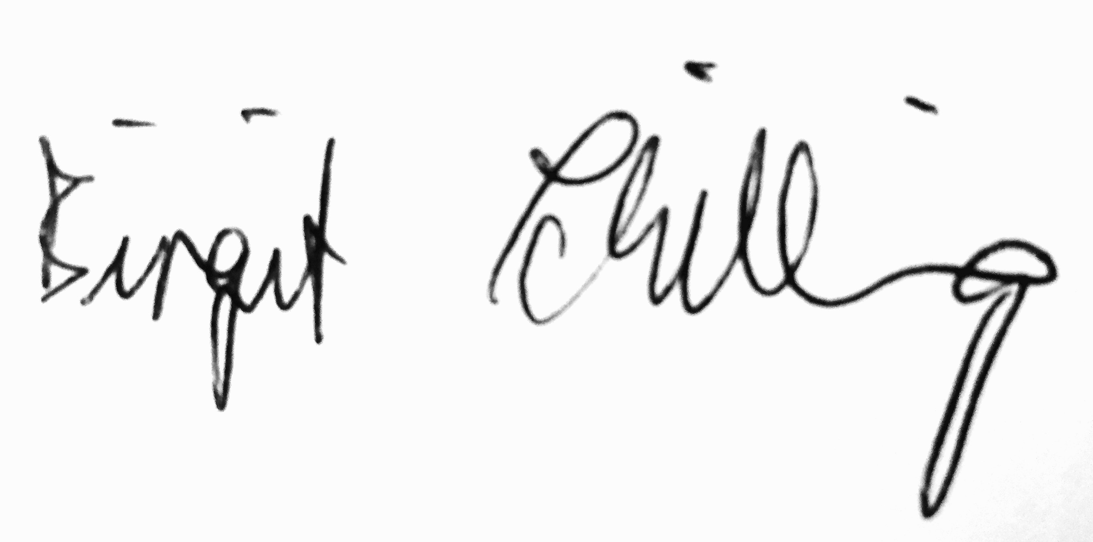
Birgit Schilling, Ph.D.
Assistant Professor
Buck Institute for Research on Aging

