
The University of Auckland
Private Bag 92019
Auckland 1142
New Zealand

Email: g.willmott@auckland.ac.nz
Phone: (64) (0)9 9737599
Fax: (64) (0)9 3737445

10 October 2019

The Editors and Referees, Journal of Visualized Experiments (JoVE)

Dear Editors and Referees,

We are resubmitting our original protocol, “Method for high throughput analysis of liquid droplet impacts” to JoVE. We have revised the manuscript according the editor and reviewers’ comments, and we have responded to these comments in a separate document included in this submission. We thank the reviewers for their efforts, and particularly note their comments that “this manuscript is well written” and that there are a “large number of people working on this subject”.
The original submission followed an invitation, and following discussions, with your Science Editor Dr Jialan Zhang. We have selected the options for a ‘JoVE Produced Video’, and for open access to the work. Thank you for your consideration of our work.

Best regards,

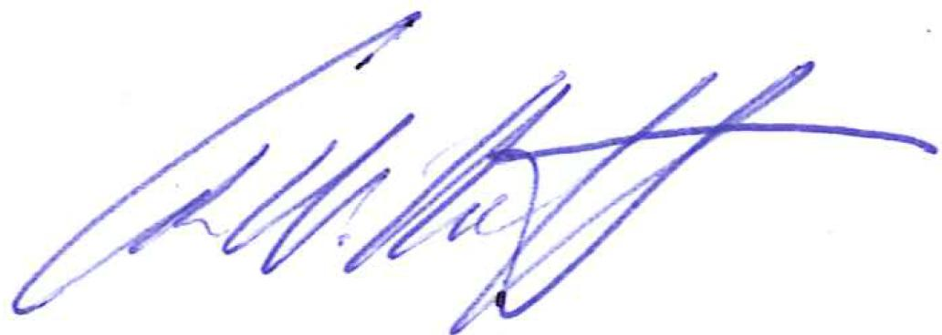

Dr Geoff Willmott
(On behalf of the authors)

The Departments of Physics and Chemistry
The University of Auckland, New Zealand
Ph: +64 9 923 9998
g.willmott@auckland.ac.nz

This document lists our responses (in blue) to the comments of the editor and reviewers (in black). References to the text (e.g. line numbers) refer to the revised manuscript.

Editorial comments:
1. Please take this opportunity to thoroughly proofread the manuscript to ensure that there are no spelling or grammar issues. The JoVE editor will not copy-edit your manuscript and any errors in the submitted revision may be present in the published version.

This has been checked
2. Please revise the Protocol text to avoid the use of personal pronouns (e.g., I, you, your, we, our) or colloquial phrases.

Line 52: changed ‘Our lab has an interest in’ to ‘The protocol described here was developed to study’
Line 85: removed ‘we’
Line 119: changed ‘in our lab’ to ‘to obtain the Representative Results’
Line 122: changed ‘description of our method’ to ‘method description’
Line 123: removed ‘our lab’, now ‘It is possible to investigate …’ with added citation to Refs 13, 14.
Line 245: removed ‘your’
3. 1.1.1: Please specify the dimension of the alignment marker used here.

Line 138 stated that the software expects a 4 mm length square; the clarified text now includes: “in this protocol, a 4 mm side length marker was used with the image analysis code provided”.
4. 1.2.1.4: Please specify the fluid used here.

Line 173, added: “(here, water was used)”

5. 1.2.1.5: Please specify the settings used.

Added text: “For the Representative Results, the average droplet diameter was 2.6 mm using a dispense rate of 0.5 ml/min and a dispensed volume of 11 μL.”

The protocol is not confined to this specific syringe pump setting. We have clarified this in the Introduction; on line 115, changed “It is also assumed that for the production of individual droplets³⁵ the user has access to a programmable syringe pump” to “It is also assumed that the user has access to a syringe pump which they can programme to produce individual droplets of desired volume when connected to a particular needle³⁵.”

6. 1.2.2: Please specify the sample used in this case.

Added text: “For the Representative Results, the sample is flat polydimethylsiloxane (PDMS).” The PDMS source has also been added to the materials list.

Regarding points 4-6 above, the aim here is to demonstrate a versatile method that can be applied to a variety of experimental configurations. We have added a clarifying comment in the Introduction (line 90): “The protocol is directly applicable for any basic droplet parameters (including liquid, size, and impact velocity), substrate material, or environmental conditions.”
7. After you have made all the recommended changes to your protocol section (listed above), please highlight in yellow up to 2.75 pages (no less than 1 page) of protocol text (including headers and spacing) to be featured in the video. Bear in mind the goal of the protocol and highlight the critical steps to be filmed. Our scriptwriters will derive the video script directly from the highlighted text.

This has been checked.
8. Please highlight complete sentences (not parts of sentences). Please ensure that the highlighted steps form a cohesive narrative with a logical flow from one highlighted step to the next. The highlighted text must include at least one action that is written in the imperative voice per step. Notes cannot usually be filmed and should be excluded from the highlighting.

This has been checked.
9. Please include all relevant details that are required to perform the step in the highlighting. For example: If step 2.5 is highlighted for filming and the details of how to perform the step are given in steps 2.5.1 and 2.5.2, then the sub-steps where the details are provided must be highlighted.

This has been checked.
10. Table of Materials: Please ensure that it has information on all relevant supplies, reagents, equipment and software used, especially those mentioned in the Protocol. Please sort the materials alphabetically by material name.

This has been checked and alphabetically ordered.

Reviewers' comments:
Reviewer #1:

It is unclear to me from the current state of the manuscript what the authors aim at doing exactly. What could come out of the data analysis? There are generic things one could analyze such as the maximum drop diameter; this should be easy to get from the videos. However there are less trivial things such as the drop splashing mentioned by the authors that are much harder to analyze.

This information appears in the Summary, Abstract, and paragraph 5 of the Introduction. We have revised some text in paragraph 5 for clarity:

“This paper describes a standardized method for capture and analysis of drop impact movies which enables efficient collection of large data sets.”
Changed to:
“This paper describes a standardized method for capture and analysis of drop impact movies. The primary aim is to enable efficient collection of large data sets, which should be generally useful for the wide variety of drop impact studies described above.”

“Using this method, the time-resolved, digitized outline of an impacting drop (which allows calculation of spreading diameter, for example) may be obtained for ~100 experiments a day.”
Changed to:
“Using this method, the time-resolved, digitized outline of an impacting drop may be obtained for ~100 experiments a day. The analysis automatically calculates the droplet impact parameters (size, velocity, Weber and Reynolds numbers) and the maximum spreading diameter.”

In the Discussion, final paragraph, we also added the sentence: “With relatively minor alterations to the analysis code, it could be extended to provide further data (e.g. time dependence and splashing profiles) or to study different impact geometries.”

I think the proposed methodology only makes sense if software or for instance Matlab routines are developed that analyses the data; in this case it should be specified what the analysis will yield.

A Matlab Supplementary Coding File was included with the submission and referred to extensively throughout the manuscript. The data yielded are described in the note following step 2.4.4 of the protocol, and in step 3. In the revised manuscript, the note following step 3.3 has been edited so that these outputs are more specifically described.
Reviewer #2:
This manuscript proposed a standard protocol to visualize droplet impact problem. The target is the impact of droplets falling under gravity against boundaries. The system is assumed to be under the standard room conditions (i.e., the atmosphere). In some droplet-impact-related problems, the surrounding pressure is reduced or vapor-rich (not the standard air). For studies of Leidenfrost drops, hot plates are used.

Here the reviewer correctly identifies some of the possibilities for this protocol.

Overall, this manuscript is well written, but before publication the authors had better explain the target problem setup for further clarity.

See above for changes which clarify the aim, data outcomes and scope of this protocol.

