
The University of Auckland
Private Bag 92019
Auckland 1142
New Zealand

Email: g.willmott@auckland.ac.nz
Phone: (64) (0)9 9737599
Fax: (64) (0)9 3737445

11 September 2019

The Editors and Referees, Journal of Visualized Experiments (JoVE)

Dear Editors and Referees,

We are submitting an original protocol, “Method for high throughput analysis of liquid droplet impacts”, for consideration as a Methods Article in JoVE. This follows the invitation to submit such an article, and following discussions, with your Science Editor Dr Jialan Zhang. We have selected the options for a ‘JoVE Produced Video’, and for open access to the work.
The protocol is appropriate for JoVE because it describes a method which can be of wide benefit to researchers studying dynamic interactions using high-speed photography, in cases where many experimental variables are relevant. Specifically, our method has been developed for research into drop impacts on solid surfaces, where there is a requirement to scan through variations in the properties of the liquid, solid, and impact conditions. This situation is relevant to our own published research, along with many other recent, high-impact papers relating to drop impact.
The method is useful and advantageous because it describes a streamlined experimental setup and workflow that can greatly increase the efficiency of experimentation. Image analysis of high-speed movies is carried out in organised batches. The efficiency gains should enable research of broader scope and greater experimental resolution than is typically reported in the literature.
Thank you for your consideration of our work.

Best regards,

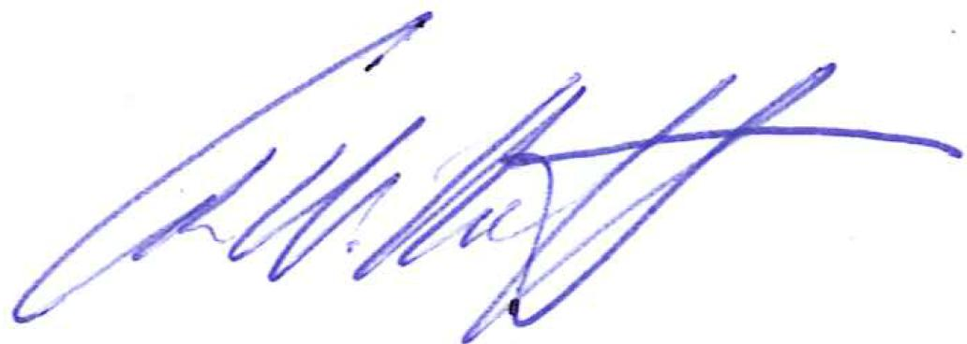

Dr Geoff Willmott
(On behalf of the authors)

The Departments of Physics and Chemistry
The University of Auckland, New Zealand
Ph: +64 9 923 9998
g.willmott@auckland.ac.nz

