Dear Author(s),
This document is divided into a number of sections in which you can add your comments to the video, voiceover, and online text/PDF. Please be aware that our policy is to do a single complimentary revision, so it is critical that all participants in this project offer their comments collectively. In addition, please make sure that your comments are easily interpreted and transparent.
Have fun!
Protocol Name: JoVE Protocol 60750: Time-Lapse Imaging of Mouse Macrophage Chemotaxis
Date: February 19, 2020

Authors and Affiliations
Please fill in any missing author information not included in the video.
Order | Author | Affiliation | Email

Video Comments
Please fill in any comments you wish to make using the table below using the example as a guide. If you need more space to write, please do so below the table. DO NOT ADD CORRECTIONS TO THE NARRATION HERE. PLEASE DO THIS IN THE AUDIO COMMENTS SECTION.
 | Time code | Comment | Requested Change
Example | 2:52 | Onscreen text says use 0.25 mM Fluo-4 | Text should say use 0.50 mM Fluo-4
1. | 00:07 | The address under the author names should not have a ‟V” at the end. | Text should say ZELLBIOLOGIE instead of ZELLBIOLOGIEV
2. | 00:14 | Is there another/better take with less blinking? Otherwise it’s fine.
3. | 00:29 | Is there another/better take from MARKUS HORSTHEMKE (incorrectly referred to as STEFAN WALBAUM in the video – see below) with less swaying?
4. | 00:30 | The name should be MARKUS HORSTHEMKE (he stood in for Stefan Walbaum, who was unwell on the day of shooting). | Use text MARKUS HORSTHEMKE instead of STEFAN WALBAUM
5. | 00:44 | Is there another/better take from ANNE BACHG in which she appears less serious? Otherwise it’s fine.
6. | 00:56 |  | Second to last line: Add ‟THE” between AT and INSTITUT
7. | 01:52 |  | At this point, it would be helpful to superimpose the image shown on the left at time 07:56 to highlight the port numbering system
8. | 03:06 |  | A movie clip showing medium being aspirated/sucked from an inverted (tilted downwards) 14 mL plastic tube via a glass pipette should accompany the line, “Discard the supernatant …”
9. | 09:13 | The Velocity (µm/min) graph at the top of the screen is wrong (see below; this also applies to the figure in the revised manuscript – we will submit a corrected version). The revised figure was not correctly converted from Origin (OriginLab) to Adobe Illustrator) | Please take the image at 09:13 from the corrected Figure 4 (see figure below), which will be supplied
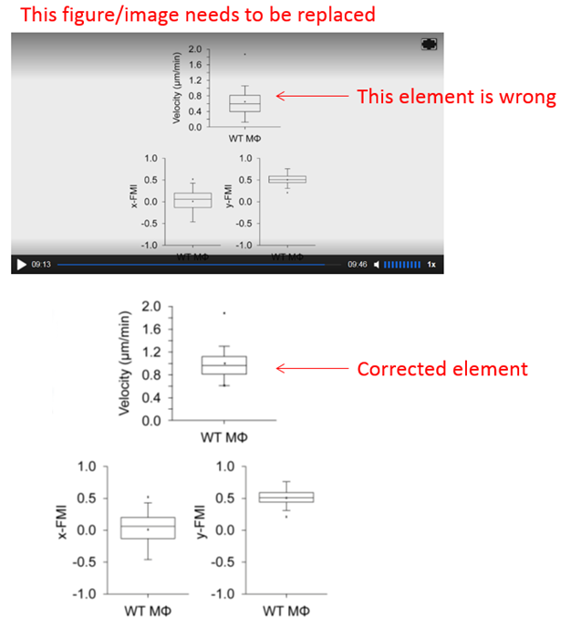
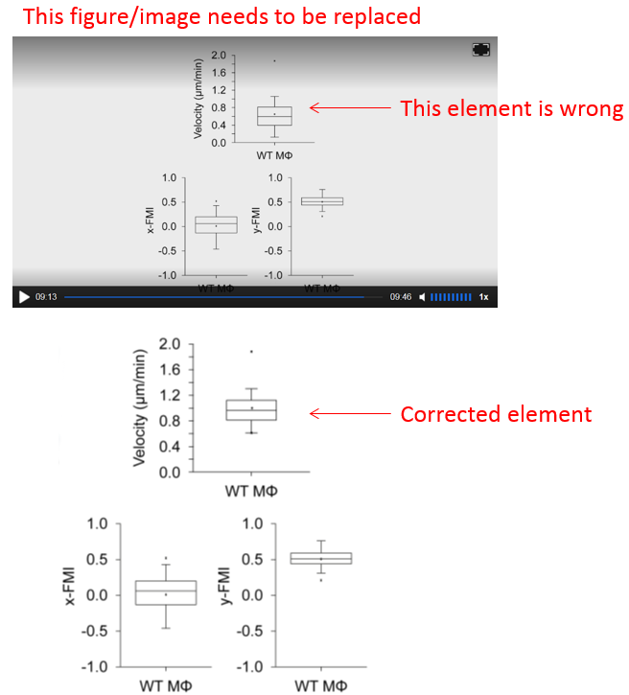

Audio Comments
This section is used to specify the changes that need to be made to the narration. Please follow the example below as a guide to list your changes. If there is a pronunciation change, please provide a phonetic pronunciation key.

 | Time code | Comment | Step(s) in Shotlist | Rewritten Text or Corrected Pronunciation (highlight in bold)
Example | 1:49 | Original Script Text:  “Then, show the participant their electromyography, or EMG patterns, which correspond to eight specific and unique polar plots.” | 2.2 | Rewritten Script Text:  “Then, show the participant the unique and specific polar plots, which correspond to their electromyography, or EMG (pronounced E-M-G) patterns.”
1. | 01:12 |  |  | In the line, ‟… modified RPMI 1640 Hepes medium …” Hepes should be pronounced, ‟He-Peas”
2. | 01:44 |  |  | Same as above: Hepes should be pronounced, ‟He-Peas”
3. | 02:35 |  |  | Should be, ‟… sacrificed 3-4 month old …”, NOT ‟3-4 week old …”
4.
5.
6.
7.
8.
9.
10.
11.
12.
13.
14.
15.
16.
17.
18.
19.
20.

Online Text/PDF Protocol
Please use this table to address changes that need to be made to the online text/PDF document. Both the online text and PDF are generated from the HTML template of your article. Since the PDF is generated from the HTML by our conversion software, it may contain formatting errors. For major structural changes or more than 10 spelling or grammatical mistakes, we will require re-upload of the entire document.

 | Protocol Step | Comment | Requested Change (highlight in bold)
Example | 1.1 | Step says “Centrifuge lysate at 2,000 x g.” | Please correct to “Centrifuge lysate at 4,000 x g.”
1.
2.
3.
4.
5.
6.
7.
8.
9.
10.
11.
12.

