

Stead Family Department of Pediatrics
Patrick L. Sinn, PhD

Carver College of Medicine
Pulmonary Medicine, Allergy and Immunology
169 Newton Rd, 6318 PBDB
Iowa City, IA 52242
319-335-8190 Tel
patrick-sinn@uiowa.edu
medicine.uiowa.edu/pediatrics
medicine.uiowa.edu/vectorcore
sinn.lab.uiowa.edu

August 29, 2019

Dear Editors,

Enclosed is our manuscript reporting a method for achieving widespread viral vector distribution in a large animal model. Specifically, we describe a detailed method for aerosolizing viral vector delivery to the airways of newborn pigs. Efficient lung gene transfer could be beneficial for a broad range of applications, even beyond gene therapy. We believe these findings would be of significant interest to the readers of the Journal of Visualized Experiments.

Sincerely,

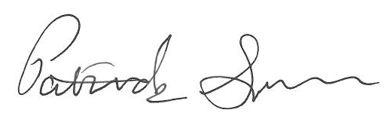

Patrick L Sinn, PhD
Associate Professor of Pediatrics
Associate Professor of Microbiology and Immunology
Director, University of Iowa Viral Vector Core

