Dear Editor-in-Chief:

Thank for your careful review and correction. We have tried our best to correct these errors. Previous figure 3 and 4 also missed the item numbers and we re-upload the merge figures. We really learn a lot from your comments. Feel free to let me know if any other mistake needed to be corrected. Thank you again.
We have uploaded the necessary files through dropbox on May,26, 2020 but it seemed failed to complete the revision process. You may check it in the dropbox and now I upload again. Thank you anyway.
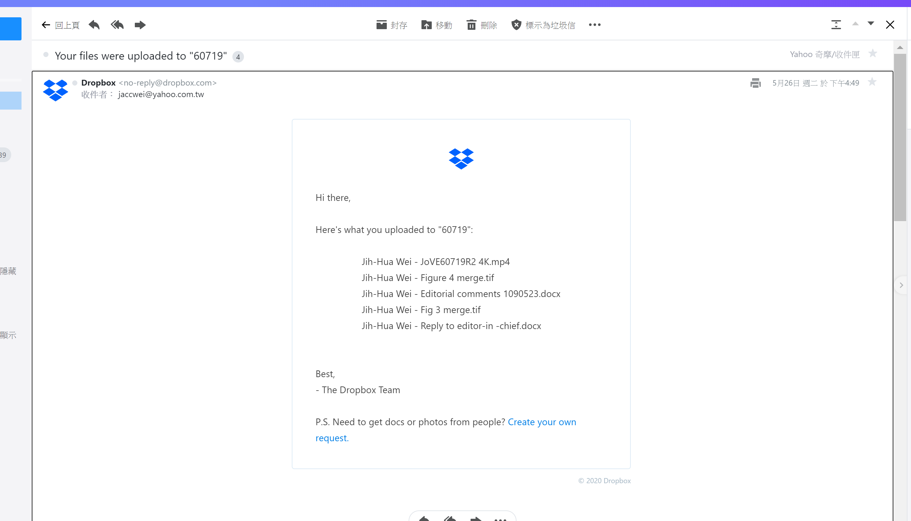
Best regards
Jih-Hua Wei, M.D., Ph.D.

