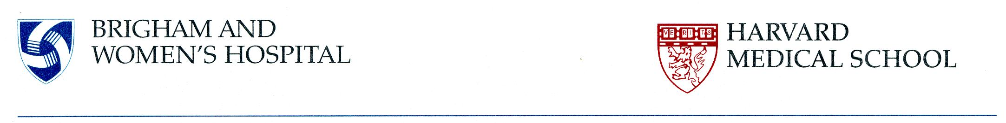
Su Ryon Shin, Ph.D.
Assistant Professor of Medicine, Division of Engineering in Medicine, Brigham and Women’s Hospital, Harvard Medical School
65 Landsdowne Street, Rm. 252
Cambridge, MA, 02139
Office: (617) 835-1164
Fax: (617) 768-8477
Email: sshin4@bwh.harvard.edu, shin.lotus@gmail.com

October 18, 2019

Subject: Revised manuscript based on reviewers’ comments

Dear Alisha DSouza,

We would like to thank you and the reviewers for the comments and the enthusiasm for the submitted manuscript. Please find the attached response letter including the specific comments from the reviewers and yourself along with our explanation and corrected statements. All the changes are tracked within the revised version of the manuscript to show all the edits. We believe that after the revisions made while to addressing the comments of the reviewers, our manuscript has been significantly improved in quality and scope. We hope you will find the manuscript suitable for publication in Jove.
We appreciate your consideration for the publication of this work. If you have any questions, please feel free to contact me at sshin4@bwh.harvard.edu or (617) 835-1164.

Respectfully yours,

Su Ryon Shin, Ph.D.

Response to the referees’ comments
We thank the editors and reviewers for their time and their valuable feedback on our manuscript. We have revised the manuscript in accordance with their suggestions. Please find the reviewers’ comments in blue and our response in black.

Editorial Comments:
• Textual Overlap: Significant portions show significant overlap with previously published work. Please re-write lines … avoid this overlap.
Answer: We have checked duplication of our manuscript using an ithentication program. The similarity index is around 6%. We couldn’t find any similar sentences in the results. We have attached the ithentication result.

• Protocol Detail: Please note that your protocol will be used to generate the script for the video and must contain everything that you would like shown in the video. Please add more specific details (e.g. button clicks for software actions, numerical values for settings, etc) to your protocol steps. There should be enough detail in each step to supplement the actions seen in the video so that viewers can easily replicate the protocol. Some examples:
Answer: We have added more specific details to our protocol steps. We hope the protocol contain enough detail in each step to supplement the actions seen in the video so that viewers can easily replicate the protocol. The modified parts were highlighted with pink color.
1) 3.2: Mention frequency (Hz) and amplitude (in Watt): 0.66Hz and 100 Watt were added.
2) 6.1, 7.1: provide the CAD file as a supplementary file. What are the specifications? We provided three CAD files.
3) 6.5: How is the Au layer deposited? Mention all settings: Au layer was deposited by using E-bean evaporator (Denton EE-4, Vacuum (Torr): 10⁻⁶, Power (%): 2.6, Rate (Å/sec): 2)
4) 7.6: mention temperature: The temperature as 37 ºC was added.
5) Please include an ethics statement before your numbered protocol steps indicating that the protocol follows the animal care guidelines of your institution.: We have added the ethics statement on pages 5 and 6.
“This study was carried out in strict accordance with the recommendations in the Guide for the Care and Use of Laboratory Animals of the National Institutes of Health. The protocol was approved by the institutional Animal Care and Use Committee (IACUC) of the Brigham and Women’s Hospital.”
6) 10.1.1: mention magnification and other settings. We have added the magnification in the section.

• Protocol Highlight: After you have made all of the recommended changes to your protocol (listed above), please re-evaluate the length of your protocol section. There is a 10-page limit for the protocol text, and a 3- page limit for filmable content. If your protocol is longer than 3 pages, please highlight ~2.5 pages or less of text (which includes headings and spaces) in yellow, to identify which steps should be visualized to tell the most cohesive story of your protocol steps.
1) The highlighting must include all relevant details that are required to perform the step. For example, if step 2.5 is highlighted for filming and the details of how to perform the step are given in steps 2.5.1 and 2.5.2, then the sub-steps where the details are provided must be included in the highlighting.
2) The highlighted steps should form a cohesive narrative, that is, there must be a logical flow from one highlighted step to the next.
3) Please highlight complete sentences (not parts of sentences). Include sub-headings and spaces when calculating the final highlighted length.
4) Notes cannot be filmed and should be excluded from highlighting.
Answer: We have highlighted the steps with yellow color that should be visualized.

• Discussion: JoVE articles are focused on the methods and the protocol, thus the discussion should be similarly focused. Please ensure that the discussion covers the following in detail and in paragraph form (3-6 paragraphs): 1) modifications and troubleshooting, 2) limitations of the technique, 3) significance with respect to existing methods, 4) future applications and 5) critical steps within the protocol.
Answer: We have modified the content of discussion to meet the requirements of Jove that were highlighted with green color on page 13.
“This method could not only overcome the limitations of existing optogenetic techniques, such as complicated fabrication processes, long fabrication times and potential toxicity of optogenetic tools, but also strongly enhance the performances of cell-based actuators leading to real-time stimulation using low-cost and easy-to handle techniques. Although the design of our current bioinspired actuators could not generate forward propulsion, its encouragement in the field of autonomous cell-based robots could attract a lot of interest.”

• Commercial Language: JoVE is unable to publish manuscripts containing commercial sounding language, including trademark or registered trademark symbols (TM/R) and the mention of company brand names before an instrument or reagent. Examples of commercial sounding language in your manuscript are MINI MICRO STENCIL INC. (USA)., CAD/Art Services, Inc, falcon tube, etc.
1) Please use MS Word’s find function (Ctrl+F), to locate and replace all commercial sounding language in your manuscript with generic names that are not company-specific. All commercial products should be sufficiently referenced in the table of materials/reagents. You may use the generic term followed by “(see table of materials)” to draw the readers’ attention to specific commercial names.
Answer: We have replaced all commercial sounding language in our manuscript with generic names that were highlighted with sky color.

• If your figures and tables are original and not published previously or you have already obtained figure permissions, please ignore this comment. If you are re-using figures from a previous publication, you must obtain explicit permission to re-use the figure from the previous publisher (this can be in the form of a letter from an editor or a link to the editorial policies that allows you to re-publish the figure). Please upload the text of the re-print permission (may be copied and pasted from an email/website) as a Word document to the Editorial Manager site in the "Supplemental files (as requested by JoVE)" section. Please also cite the figure appropriately in the figure legend, i.e. "This figure has been modified from [citation].
Answer: We reused figure 2e and figure 5f from our previous publication. We have obtained explicit permission to reuse the figures from the previous publisher. We have provided the permission on supplementary documents and we have also cited the figures appropriately in the figure legend.
Comments of Reviewers
We would like to thank the reviewers for their comments. As follows, we will answer each question about the experimental protocol one by one.

Reviewers #1:
1. 6.4: How is the tape placed on the glass substrates exactly?
Response: The position of double sided tape does not matter as long as the tape does not block the space for the micropatterned Au electrode. The two pieces of tape were placed manually on the support at a distance short enough to host the glass, and large enough to fit the entire pattern. We also modified the content in 6.4 to provide readers with a more precise description. (page: 4: highlighted in green).
“The two pieces of tape were placed manually on the support at a distance short enough to host the glass, and large enough to fit the entire pattern.”

2. 6.5: What sizes are the microelectrodes cut to?
Response: The size of cut electrodes is 7.376mm x 8.9mm x 200nm, which was added in 6.5. (page: 5: highlighted in purple).

3. 7.2: What is used to cover the glass slides? There seems to be more than 1 task in this step and unclear is the reference to glass slide is the same as the TMSPMA coated glass slide.
Response: We apologize for the confusing description of the fabrication process. Here, we will explain the procedure more in detail and will provide a schematic diagram to show the process more clearly. First, we added 15μL of PEGDA pre-polymer solution on top of the Au microelectrode. Second, we put a TMSPMA coated glass slide above the PEGDA pre-polymer solution. Third, we put 1st photomask (micropatterned PEGDA) above the TMSPMA coated glass slide. Finally, we exposed whole construct to UV light to obtain the micropatterned PEG hydrogel with the Au microelectrode. We have modified the procedure in 7.2 and modified the schematic diagram in Figure 1. (pages 5 and 11: highlighted with grey color).
“Pour 15 μL of 20% PEGDMA pre-polymer solution on top of the Au microelectrode, then cover with the TMSPMA coated glass slide. Place the 1st photomask for the glass slide (micropatterned PEGDA) on top of the TMSPMA coated glass slide and expose whole construct to UV light (200-Watt mercury vapor short arc lamp with 320-390 nm filter) at 800 mW of intensity and 8 cm distance for 110 s.”
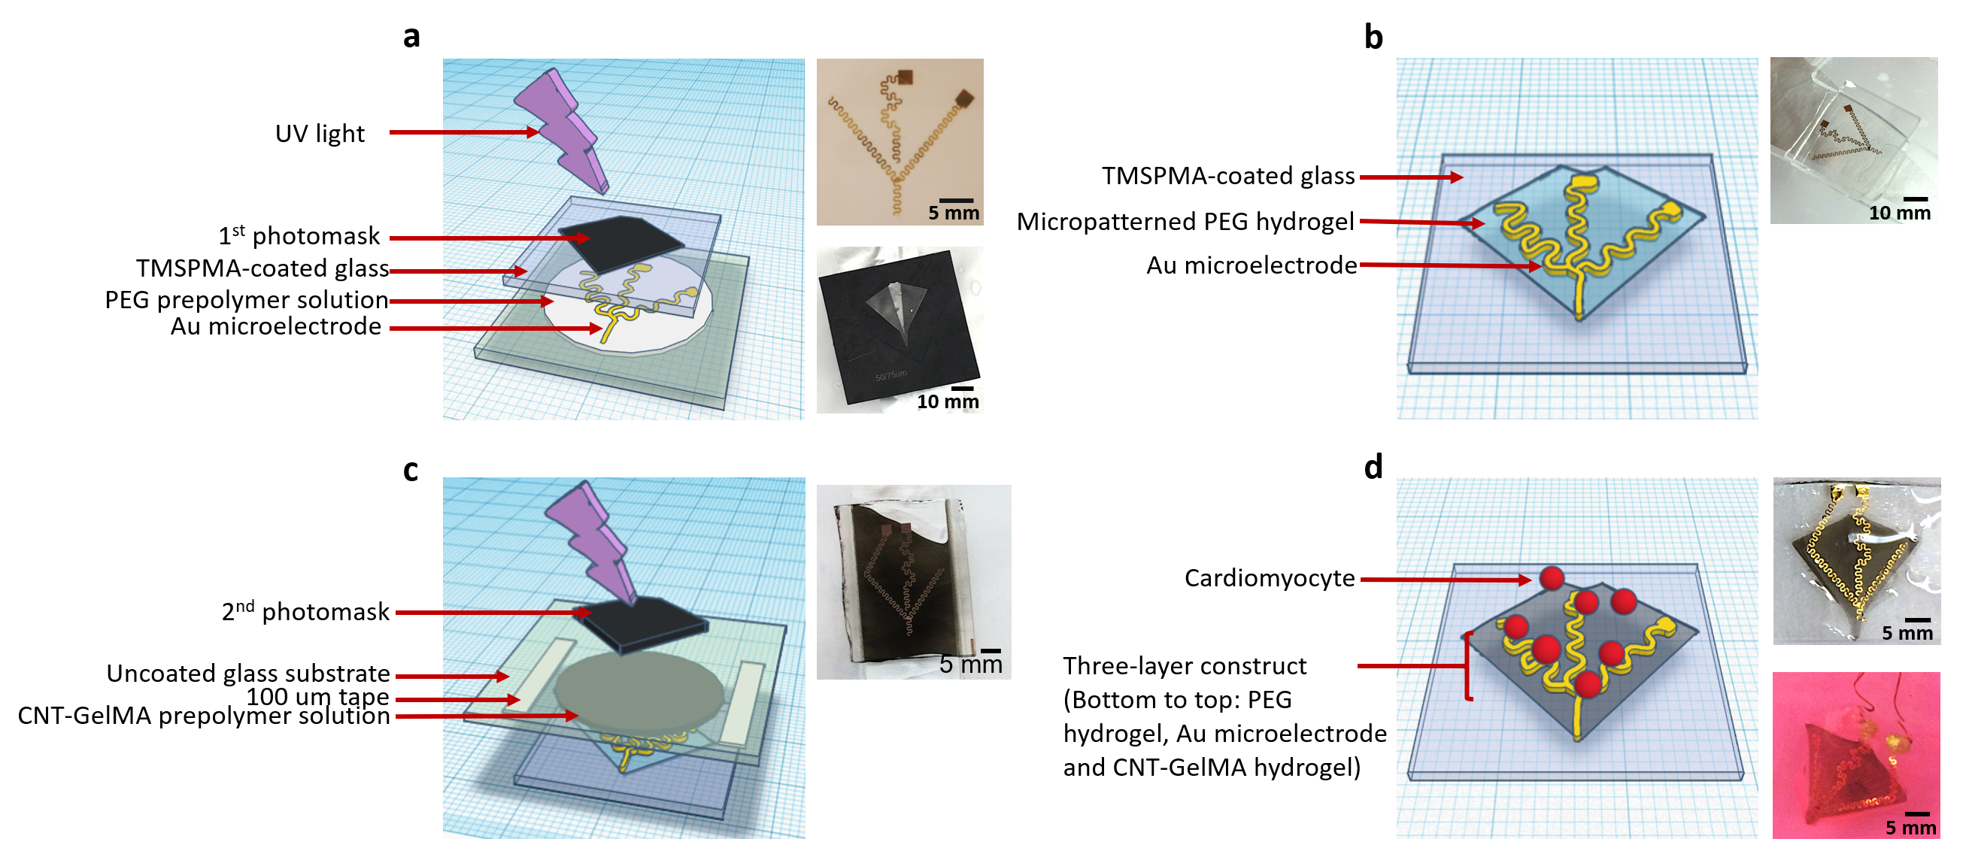

Figure 1: Schematic diagram and actual images depicting the fabrication process of the bio-inspired multilayered soft robot which is electrically controlled by electrical signal via the integration of a flexible Au microelectrode. (a) Patterning and crosslinking of the PEGDA hydrogel using the 1st photomask. (b) Micropatterned PEGDA hydrogel with encapsulated Au microelectrode on the TMSPMA glass obtained after step (a). (c) Crosslinking of the CNT-GelMA patterned hydrogel using the 2nd photomask. (d) Seeding of the cardiomyocytes on the multi-layered construct.
4. 7.3: Need to specify what is being detached and from what?
Response: During crosslinking, we micropatterned the PEGDA hydrogel by using a photomask on top of the Au microelectrode substrate. A TMSPMA-coated glass slide was placed between the photomask and the PEGDA hydrogel to control the final thickness thanks to the tape spacers. Then, we detached the micropatterned PEGDA hydrogel together with the Au microelectrode from the uncoated glass substrate (shown in the above schematic diagram). Due to the TMSPMA coating, the construct was transferred from the uncoated glass substrate to the TMSPMA-coated one. Hence, after this step, we obtained a TMSPMA coated glass slide on which the micropatterned PEGDA hydrogel and the Au microelectrode were placed (shown in the below schematic diagram). We added the explanation of the procedure in 7.3 and modified the schematic diagram in Figure 1. (page 5: highlighted with green color; page 11: heighted with grey color).
“Add DPBS to surround the glass slide and detach the micropatterned PEGDA hydrogel together with the Au microelectrode from the uncoated glass substrate carefully after 5 to 10 min to obtain the glass slide that has the micropatterned PEGDA hydrogel with the Au microelectrode.
Note: Look at Figure 1b. Due to the TMSPMA coating, the construct is transferred from the uncoated glass substrate to the TMSPMA-coated one…”
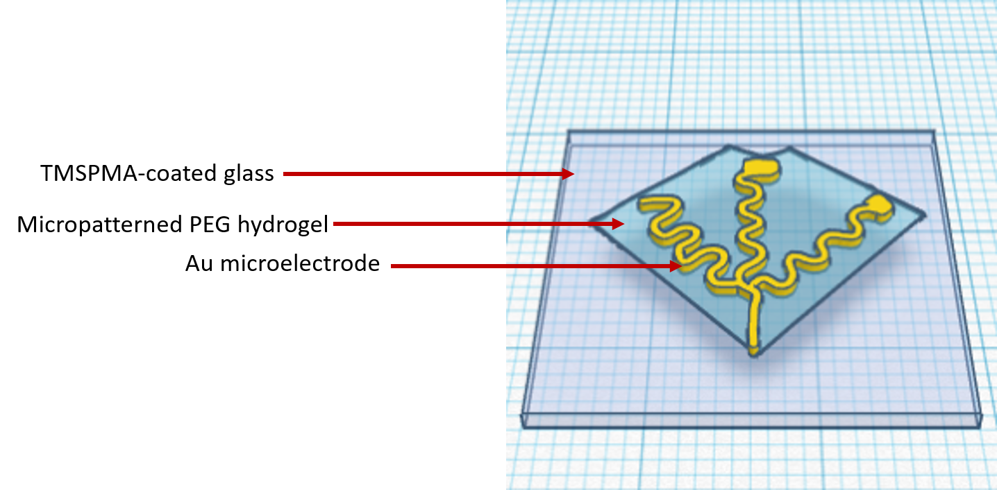

Reviewer #2:
1. The clear description of the figures and caption. More detailed sub-caption should be added. it is good for readers to follow the work. The protocol should be well connected with the equipment in text
Response: We thank the reviewer for pointing this out. We have modified the content of Representative results (pages: 8, 9 and 10: highlighted in grey) and added sub-captions to provide clear descriptions of the figures (pages: 8, 9 and 10: highlighted in grey).) We also modified the schematic diagram (Figure 1) of the fabrication process to make this protocol easy to understand. In addition, we modified the equipment text in Table of Material to make this protocol more reproducible.
“…. Briefly, there are three main fabrication steps for the bioinspired soft robot with an embedded Au microelectrode. First, a micropatterned PEGDA hydrogel with an incorporated Au microelectrode was obtained by UV crosslinking using the 1st photomask (Figure 1a and b). Second, a multilayered construct composed of the Au microelectrode, the micropatterned CNT-GelMA and the PEGDA hydrogels was fabricated by UV crosslinking using the 2nd photomask (Figure 1c). Finally, cardiomyocytes were seeded on the fabricated three-layer construct to provide actuation to the soft robot (Figure 1d).”
“1. Flow diagram schematizing the main steps for developing the Au microelectrode incorporated bioinspired soft robot….
2. Different designs of the soft robot….
3. The challenge of embedding the Au microelectrode between CNT-GelMA and PEGDA hydrogels….
4. The optimization of spacing between hydrogel micropatterns….
5. The analysis of movement of the cardiac tissue on micropatterned PEGDA- and CNT-GelMA hydrogels….
6. The characterization of the cardiomyocytes on the multi-layered soft robot and control of beating behavior by electrical stimulation….”
Figure 1: Schematic diagram and actual images depicting the fabrication process of the bio-inspired multilayered soft robot which is electrically controlled by electrical signal via the integration of a flexible Au microelectrode. (a) Patterning and crosslinking of the PEGDA hydrogel using the 1st photomask. (b) Micropatterned PEGDA hydrogel with encapsulated Au microelectrode on the TMSPMA glass obtained after step (a). (c) Crosslinking of the CNT-GelMA patterned hydrogel using the 2nd photomask. (d) Seeding of the cardiomyocytes on the multi-layered construct.

Reviewer #3:
1. The article needs of a flow diagram schematizing the main steps for developing the soft robot. The current images, contained in the Figures, presented by the authors are not quite effective in depicting the fabrication of the device
Response: We thank the reviewer for pointing this out. We have modified the content of Representative results (pages: 8, 9 and 10: highlighted in grey) and added sub-captions, as well as the schematic diagram of the fabrication process (Figure 1) to provide the readers with a clearer description of the fabrication procedure. We hope that our protocol, together with the new flow diagram, will improve the readers’ understanding of the protocol.
“1. Flow diagram schematizing the main steps for developing the Au microelectrode incorporated bioinspired soft robot
…. Briefly, there are three main fabrication steps for the bioinspired soft robot with an embedded Au microelectrode. First, a micropatterned PEGDA hydrogel with an incorporated Au microelectrode was obtained by UV crosslinking using the 1st photomask (Figure 1a and b). Second, a multilayered construct composed of the Au microelectrode, the micropatterned CNT-GelMA and the PEGDA hydrogels was fabricated by UV crosslinking using the 2nd photomask (Figure 1c). Finally, cardiomyocytes were seeded on the fabricated three-layer construct to provide actuation to the soft robot (Figure 1d).”
Figure 1: Schematic diagram and actual images depicting the fabrication process of the bio-inspired multilayered soft robot which is electrically controlled by electrical signal via the integration of a flexible Au microelectrode. (a) Patterning and crosslinking of the PEGDA hydrogel using the 1st photomask. (b) Micropatterned PEGDA hydrogel with encapsulated Au microelectrode on the TMSPMA glass obtained after step (a). (c) Crosslinking of the CNT-GelMA patterned hydrogel using the 2nd photomask. (d) Seeding of the cardiomyocytes on the multi-layered construct.

2. The authors should make available the CAD blueprints/renders, as with no access to those files it will be practically impossible to reproduce the robots.
Response: Thank you very much for your comment. We have provided our CAD files of the Au microelectrode, the PEGDA micropattern mask and the CNT-GelMA micropattern mask as supplementary documents.

3. Images depicting the actual setup used for fabricating the device are required. Particularly for the "photo-curing" part of the work.
Response: Thank you very much for your suggestion. Based on your comment, we modified the images depicting the actual setup (Figure 1) and added a detailed description of these images in Representative results to show the fabrication process more clearly. We added the explanation of the procedure on page 9 and new schematic diagram in Figure 1. (page: 9: highlighted in grey).

“…. Briefly, there are three main fabrication steps for the bioinspired soft robot with an embedded Au microelectrode. First, a micropatterned PEGDA hydrogel with an incorporated Au microelectrode was obtained by UV crosslinking using the 1st photomask (Figure 1a and b). Second, a multilayered construct composed of the Au microelectrode, the micropatterned CNT-GelMA and the PEGDA hydrogels was fabricated by UV crosslinking using the 2nd photomask (Figure 1c). Finally, cardiomyocytes were seeded on the fabricated three-layer construct to provide actuation to the soft robot (Figure 1d).”

4. Clarify what type of UV-lamp used and the reactor/irradiation system they used.
Response: A 200-Watt mercury vapor short arc lamp was used. A mercury-vapor lamp is a gas discharge lamp that uses an electric arc through vaporized mercury to produce light. When electricity is applied to the lamp, this mercury is “excited” and emits UV light. The exact wavelengths emitted depend on the vacuum pressure within the lamp tube itself. Here, the lamp uses high pressure to obtain 320-390nm UV light with filters (OmniCure, S2000). We added the explanation of the UV-lamp on page 5. (page: 5: highlighted in grey).
“…Place the 1st photomask the glass slide (micropatterned PEGDA) on top of the TMSPMA coated glass slide and exposed whole construct to UV light (200-Watt mercury vapor short arc lamp with 320-390 nm filter) at 800 mW of intensity and 8 cm distance for 110 s.”

5. Point 7.4 is confusedly written, please revise the verbal tenses and reduce length. Again, a schematic diagram depicting the main/key steps will be of great help in this section.
Response: Thank you very much for your idea. We have revised the content. We hope the modified content and the new schematic diagram will be helpful for readers to understand and to reproduce the soft robot. Here, the modified protocol and corresponding schematic diagram are attached (Figure 1c) to provide additional information. We modified the explanation of the procedure on page 5 and the schematic diagram in Figure 1. (page: 5: highlighted in dark yellow).
“7.4 Place 100 μm spacers made by stacking two layers of commercial invisible tape (thickness: 50 µm) on the bottom of a petri dish. Deposit a drop of 20 μL CNT-GelMA pre-polymer solution between the spacers and then flip the glass slide obtained in 7.3 and fix it onto the dish with adhesive tape. Then, rotate the device upside-down and place the 2nd photomask on the top of the glass slide, and expose under UV light at 800 mW of intensity and 8 cm distance for 200 s.”
