August 28, 2019
Editor
JoVE

Dear Dr. Jewhurst,

We are submitting to you our manuscript titled “Retrograde tracing of Drosophila embryonic motor neurons using lipophilic fluorescent dyes.” In this manuscript, we describe a method for retrograde tracing of the Drosophila embryonic motor neurons using lipophilic fluorescent dyes. By using this technique, we previously unraveled the molecular mechanisms that drive the initiation of motor dendrite connectivity (Kamiyama et al., Science, 2009; Kamiyama et al., Developmental Cell, 2015). This technique is highly adaptable for the phenotypic analysis of embryonic motoneurons, enhancing our ability to provide novel insight into the functional architecture of the Drosophila nervous system. Given the general use for motor neuron labeling, we expect it would be a great asset of JoVE’s Developmental Biology section.

Our suggested reviewers include Dr. Hiroshi Kohsaka at the University of Tokyo (kohsaka@neuro.k.u-tokyo.ac.jp) an expert on Drosophila embryonic neuromuscular junction development, Dr. Edward Giniger at the National Institutes of Health (ginigere@ninds.nih.gov), an expert on Drosophila motor neuron development, and Dr. Thomas Kidd at the University of Nevada, Reno (tkidd@unr.edu), an expert on Drosophila central nervous system development.

We hope this manuscript will receive your favorable consideration.

Sincerely yours,
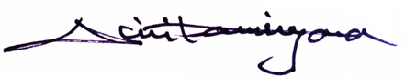
Daichi Kamiyama, Ph.D.

