Dear Dr DSouza

Thank you for the opportunity to revise this manuscript. The reviewer and editorial comments were very helpful, and we have responded by making substantial changes as outlined in the attached document. In particular, we have adjusted the wording of the protocol to meet the journal requirements.

In response to reviewer comments, we have also modified the protocol, representative results and discussion to focus on how to conduct transcranial magnetic stimulation with patients post-stroke in the acute hospital setting. We think this has addressed the reviewer and editorial comments and produced a much clearer report.

We look forward to further feedback.

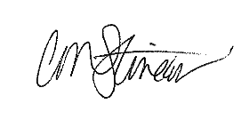
Sincerely,

Cathy Stinear, PhD
Professor, Clinical Neuroscience
Department of Medicine

