REBUTTAL LETTER FOR SUBMISSION OF MANUSCRIPT

Dr Miltiadis Fiorentzis, MD, FEBO, FICO
Department of Ophthalmology,
University Hospital Halle (Saale),
Martin-Luther University Halle-Wittenberg,
06120 Halle (Saale), Germany
Email: Miltiadis.Fiorentzis@gmail.com
Tel: +49 (0) 345-557 1878

30.10.2019

Dear Editor,

We wish to submit a revised manuscript entitled “Electrochemotherapy of ocular melanoma cell-seeded 3D spheroids” for consideration by the JoVE. Thank you very much for your comments and recommendations. We worked on all the suggested points and revised the manuscript accordingly.

We confirm that this work is original and has not been published elsewhere nor is it currently under consideration for publication elsewhere. All authors of this paper have read and approved the final version submitted.

Conflict of interest: There is no conflict of interest. I confirm that no connections exist with a company, whose product is mentioned in the article or sells a competing product. The presentation of the topic is neutral independent of the contents of the product.

Please address all correspondence concerning this manuscript to me at the address above.

Thank you for your consideration of this manuscript.
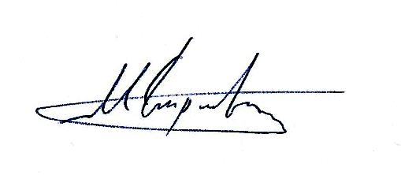
Sincerely,
Miltiadis Fiorentzis, MD, FEBO, FICO

