Answer to the reviewers

Dr Miltiadis Fiorentzis, MD, FEBO, FICO
Department of Ophthalmology,
University Hospital Essen,
Duisburg Essen University,
Hufelandstraße 55
45147 Essen
Telephone: +49 201 723 2900

02.01.2020

Dear Dr Steindel,
Thank you for your email and the reviewers’ comments. We carefully proofread the manuscript once more and corrected some spelling errors.

Thank you once more for your help,
M. Fiorentzis

Editorial comments:
No editorial concerns, although proofreading is always welcome.
Answer: Thank you for the positive review. We proofread the manuscript once more.

Reviewers' comments:
Reviewer #2:
Manuscript Summary:
In this manuscript, the authors describe their protocol for electrochemotherapy of ocular melanoma spheroids using their customized electrodes directly in the wells where spheroids are cultured.
In the revised version, the authors followed most of my suggestions and corrections. The title and abstract were changed significantly. The authors also added the protocol and changed many segment in the introduction and discussion. Therefore, I believe that the manuscript is now suitable for publication
Answer: Thank you for the positive review. We proofread the manuscript once more.

Reviewer #3:
Manuscript Summary:
The revised manuscript now reflects the work conducted by the authors and includes a detailed and accurate description of the protocol followed to develop the method for electrochemotherapy of cancer spheroids. All previous questions and suggestions have been addressed and the authors have significantly improved the content of the manuscript. There are no major concerns. The authors should perform a final review of the manuscript to ensure the correction of any language or grammar issues.
Answer: Thank you for the positive review. We proofread the manuscript once more.

Please address all correspondence concerning this manuscript to me at the address above.

Thank you for your consideration of this manuscript.
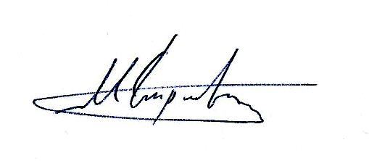
Sincerely,
Miltiadis Fiorentzis, MD, FEBO, FICO

