Based on the editorial`s and reviewers’ helpful comments, we revised the manuscript and figure and addressed the reviewers’ concerns.
Editorial comments:
General:
1. Please take this opportunity to thoroughly proofread the manuscript to ensure that there are no spelling or grammar issues.
2. Please use ‘mL’ and ‘µL’ instead of ‘ml’ and ‘µl’, including in figures. Please ensure there is a space between numbers and corresponding units (except %).
3. JoVE cannot publish manuscripts containing commercial language. This includes trademark symbols (™), registered symbols (®), and company names before an instrument or reagent. Please limit the use of commercial language from your manuscript and use generic terms instead. All commercial products should be sufficiently referenced in the Table of Materials and Reagents.
For example: Falcon, Miltenyi Biotec, Thermo Fisher Scientific, eBioscience, BD®, FACS Canto II, abcam®, Flowjo BD

We appreciate these helpful comments. We edited and corrected all relevant units and symbols.
Protocol:
1. Please include an ethics statement before the numbered protocol steps, indicating that the protocol follows the guidelines of your institution’s human research ethics committee.
2. For each protocol step, please ensure you answer the “how” question, i.e., how is the step performed? Alternatively, add references to published material specifying how to perform the protocol action. If revisions cause a step to have more than 2-3 actions and 4 sentences per step, please split into separate steps or substeps.
Thank you for these comments. We added an ethics statement and revised protocols.
Figures and Tables:
1. Please remove the embedded figures and tables from the manuscript.
2. Please upload Table 1 as an .xls/.xlsx file in your Editorial Manager account.
3. Please upload one file per figure (2 in total). Please remove ‘Figure 1’ and ‘Figure 2’ from the figures themselves.
4. Figure 2B: Please use ‘weeks’ instead of ‘w’.
In accordance with your comment, we edited the figures and manuscripts.
References:
1. Please do not abbreviate journal titles.
Thank you for this comment. We applied the JoVE EndNote style for references.
Table of Materials:
1. Please ensure the Table of Materials has information on all materials and equipment used, especially those mentioned in the Protocol.
2. Please remove trademark (™) and registered (®) symbols from the Table of Materials.
We edited the Table of Materials according to the editor’s comment.
Reviewers' comments:
Reviewer #1:
JoVE60608
Summary:
In this manuscript the authors describe a simple method to identify immune related adverse events after anti-PD-1 therapy. This assay identifies the binding of PD-1 antibody to T cells and can performed using peripheral blood and as simple as glucose test. This assay is advantageous than measuring antibody concentrations as once can visualize the binding of the antibody to T cells and also can further measure other immune-related markers using flow cytometry. Overall this manuscript is a very interesting and timely. However, the following comments need to be addressed to improve the overall quality of the manuscript.
Specific comments:
1. A Lancet and lancet device for blood collection would be simpler than using a needle. 100-200 ul of blood can be obtained using a lancet.

We appreciate this helpful comment. We replaced the glucose test needle with a blood lancet.
2. Why does the authors perform FCR blocking prior to the RBC lysis?

Thank you for this helpful comment. We used eBioscience 10XRBC Lysis Buffer (Catalog Number: 00-4300). According to manufacturer’s protocol, we originally performed Fc blocking and cell surface marker staining before RBC lysis. However, we found that this RBC lysis step quenched PE-conjugated anti-IgG4 antibody HP6025 from Abcam (ab99825). Therefore, we performed Fc blocking before RBC lysis, and surface staining after RBC lysis. We describe this in the discussion section.

3. The authors need to cite a study or perform experiments to confirm that therapeutic PD-1 antibodies block the EH12.1 PD-1 antibody binding
We cited “Zelba H et al Cancer Immunol Immunother. 2018 Dec;67(12):1845-1851” as reference 11.

4. The authors need to describe adequately that the they are measuring anti-PD-1 antibody binding based on no binding of PD-1 antibody. While this is acceptable, this is indirect way.
We appreciate this helpful comment. We added the following sentence to the representative results section: “This means that we are indirectly measuring the therapeutic binding of PD-1–blocking antibody based on the lack of binding of PD-1–detecting antibody.”

5. Does this method work with all annti-PD-1 antibodies in the market.
We appreciate this helpful comment. We confirmed that PD-1 on T cells showed competitive binding with EH12.1 and both nivolumab and pembrolizumab, the latter of which are clinically available for lung cancer patients in Japan. Another study (reference 11) demonstrated that other commercially available PD-1–detecting antibodies also bind PD-1 competitively with nivolumab and pembrolizumab.

6. The authors need to cite studies which describe multicolor flowcytometry in detail (Bommareddy PK et al J Biol Methods. 2019;6(2)
We cited “Bommareddy PK et al J Biol Methods. 2019;6(2)” in the protocol section as reference 9.
Overall the manuscript is well written and interesting, these comments need to be addressed to improve the quality of the manuscript.
Reviewer #2:
Manuscript Summary:
Immune checkpoint inhibitors, including PD-1 blocking antibodies, are now widely used as immunotheraputics for multiple types of cancer because they have been show to be highly effective at improving outcomes. Blocking the PD-1 pathway has been shown to increase the function and killing capacity of tumor specific T cells leading to enhanced clearance of cancer cells. However, the use of checkpoint inhibitors, including anti PD-1, are also associated with immune related adverse events and it has been shown that T cells bound to PD-1 blocking antibodies play an important role in the onset of these immune-related adverse events so determining the level of PD-1 on cell after blocking antibodies are given is potentially a way to facilitate the early diagnosis of irAEs and help determine the appropriate dosing of of anti PD-1 antibodies. This manuscript details a method to assess the level of anti PD-1 on T cell in the blood. It was designed as a screening test to determine the level of anti PD-1 binding in subject receiving PD-1 blocking antibodies as part of immunotherapy for various types of cancer in hopes that it will help predict irAEs. A rapid assay like this could be useful in may clinical setting.
Major Concerns:
Why use only 20 uls of blood? Is this representative and are the numbers of T cell analyzed sufficient to accurately determine the level of PD-1 binding. Using more blood would potentially make the assay more rigorous. Conversely shown data that larger volumes of blood provide the same information that 20uls does would be helpful. Only 10,000 events are collected which is fairly low for a flow cytometry-based assay.
We appreciate this very helpful comment. It is true that larger volumes and cell counts can potentially make the assay more rigorous. Originally we evaluated 100 µL blood samples according to the protocol of eBioscience 10XRBC Lysis Buffer (Catalog Number: 00-4300). However, titration assays confirmed that the frequency of antibody binding was no different between 20 µL and 100 µL. We also focused on reasonable antibody volumes and RBC lysis efficiency to simplify the assay while still retaining good accuracy.

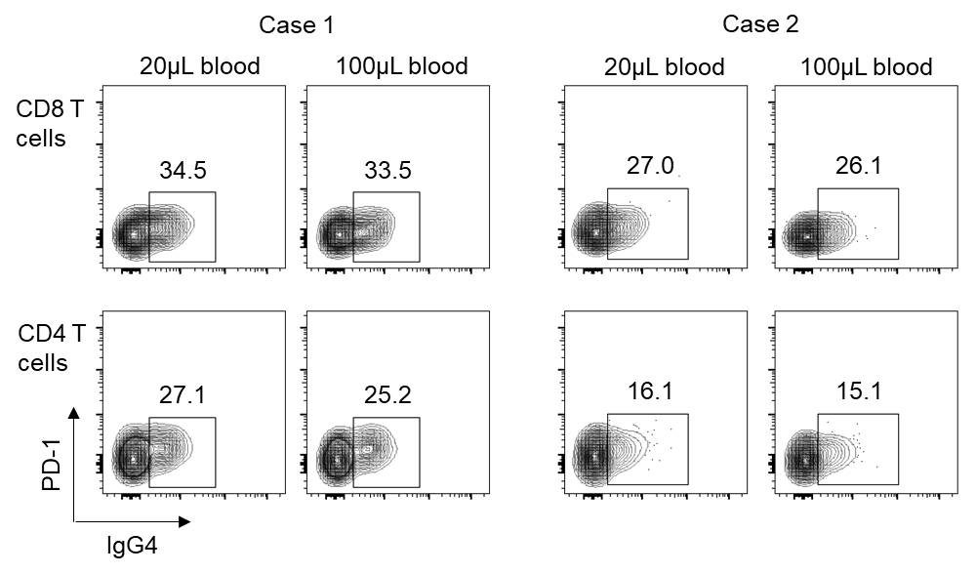

How well does PD-1 binding in the blood reflect PD-1 of T cells in tissues. All the irAEs occur in tissues and thus it is the most important site to assay.

Thank you for this comment. In cases of irAEs, specific types of tissues can be collected if biopsies can be performed. Although we do not have data from isolated biopsy samples, we were able to confirm antibody binding to T cells in bronchoalveolar lavage and cerebrospinal fluid from patients who developed interstitial lung disease and aseptic meningitis, respectively (data shown below). Because it is very important to explore this issue, future experiments will focus on biopsy samples.

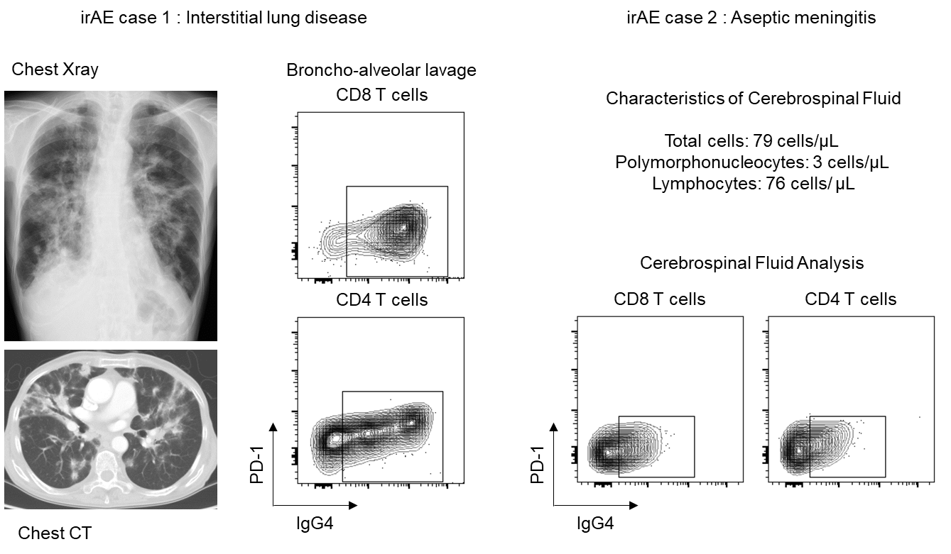
The authors mention that the RBC lysis set is critical and that if not done properly the result are suspect. Including a control to ensure that the RBC lysis work appropriately would strengthen the test.

We appreciate this helpful comment. Basically, it is important to check if the macroscopic appearance of the solution is clear before staining. As long as an isotype control is established for each assay to determine the gate of the IgG4-positive cluster, the frequency is not affected. However, using this protocol, if RBC lysis is insufficient there may be reductions both in the T cell count in the lymphocyte gate and in the intensity of each surface marker. We included this explanation in the manuscript.
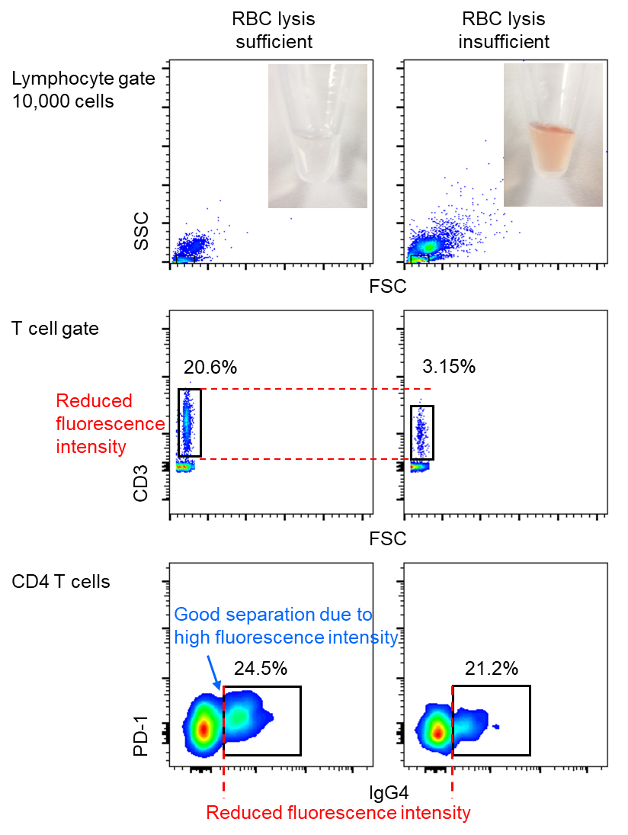

Some data that links this test with clinical outcomes would strengthen the manuscript. The authors report a similar test had been developed but it appears none of the authors on this paper were part of that study. It seems to me that they need to show this assay does indeed correlate with irAEs.
We appreciate this helpful comment. The authors of this manuscript mainly work on developing novel and useful analysis methods for clinical specimens. We also work together with physicians in our department to collect specimens. As described in our previous report (Osa et al JCI insight 2018, reference 10), we would like to apply this strategy to further evaluate the efficacy of PD-1–blocking antibodies and clarify the mechanism of irAE. irAE is a systemic disease, and collecting biopsy samples from affected tissues is sometimes difficult. At the same time, a subset of circulating T cells bound to PD-1–blocking antibody can recognize autoantigen because treatment triggers the onset of irAE. We confirmed that our method was applicable to liquid samples from a limited number of irAE cases. Future research will focus on applying this strategy to analyzing biopsy samples, combining with TCR sequences of antibody-bound T cells, and antigen screening using collected tissue samples.

