Supplementary Information

A Proof-of-concept for Gas-entrapping Membranes (GEMs) Derived from Water-loving SiO₂/Si/SiO₂ Wafers for Green Desalination

AUTHORS AND AFFILIATIONS:
Ratul Das¹, Sankara Arunachalam¹, Zain Ahmad¹, Edelberto Manalastas¹, Ahad Syed², Ulrich Buttner², and Himanshu Mishra¹

¹King Abdullah University of Science and Technology (KAUST), Water Desalination and Reuse Center (WDRC), Biological and Environmental Science and Engineering (BESE) Division, Thuwal 23955-6900, Saudi Arabia.
²King Abdullah University of Science and Technology (KAUST), Core Labs, Thuwal 23955-6900, Saudi Arabia

Email addresses of co-authors:
Ratul Das (ratul.das@kaust.edu.sa)
Sankara Arunachalam (sankara.arunachalam@kaust.edu.sa)
Zain Ahmad (zain.ahmad@kaust.edu.sa)
Edelberto Manalastas (edelberto.manalastas@kaust.edu.sa)
Ahad Syed (ahad.syed@kaust.edu.sa)
Ulrich Buttner (ulrich.buttner@kaust.edu.sa)

Corresponding author:
Himanshu Mishra (himanshu.mishra@kaust.edu.sa)

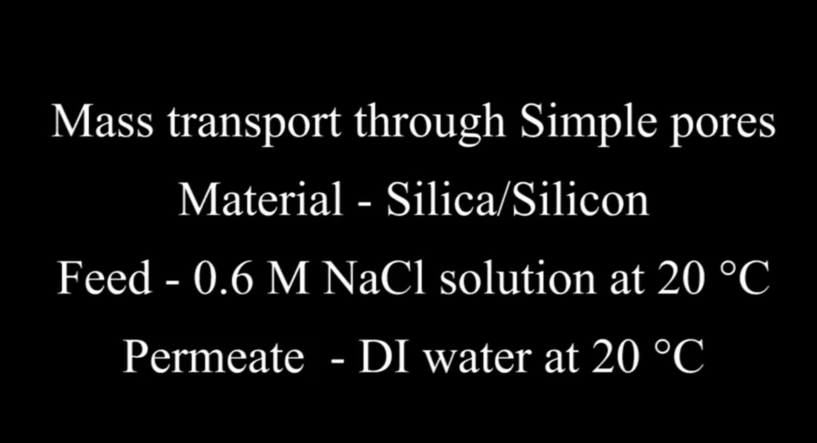

Movie S1. Simple pores separating 0.6 M NaCl solution from fresh DI water at 20 °C in a 3D printed module. This movie was reprinted from Ref.³⁶, Copyright (2019), with permission from Elsevier.

