JoVE Editorial Office

Erlangen, 9 October 2019

Dear Editors,

Hereby we wish to submit the revised version of our manuscript “Investigating intestinal barrier breakdown in living organoids”. Thank you for your helpful comments.

We tried to address all the suggested improvements in a point by point manner:
Editorial comments:
Changes to be made by the Author(s):
1. Please take this opportunity to thoroughly proofread the manuscript to ensure that there are no spelling or grammar issues. The JoVE editor will not copy-edit your manuscript and any errors in the submitted revision may be present in the published version.
Proofreading was performed.
2. Please provide an email address for each author.
All email addresses were filled into the form.
3. Please ensure that the long Abstract is within 150-300-word limit and clearly states the goal of the protocol.
172 words – goal of the protocol: measuring of intestinal barrier integrity
4. Please do not cite any references in the abstract.
Citation was removed from the abstract.
5. For in-text formatting, corresponding reference numbers should appear as numbered superscripts after the appropriate statement(s). Also number the references in the reference section in the order.
References were formatted according to the journal’s guidelines.
6. Please ensure the Introduction contains all of the following with citation:
a) A clear statement of the overall goal of this method
The assay was established to investigate the effect of IFN-γ on the barrier integrity and respective tight junction proteins⁸.
b) The rationale behind the development and/or use of this technique
The application of 3D intestinal organoids for functional analyses requires the adaptation of available methods from 2D models.
c) The advantages over alternative techniques with applicable references to previous studies
In contrast to the technique applied by Leslie⁴, Zietek⁵ or Pearce⁶….
d) A description of the context of the technique in the wider body of literature
Various models have been developed to investigate the regulation….
e) Information to help readers to determine whether the method is appropriate for their application
We tried to present the advantages and disadvantages of the available methods. This should enable the readers to define the method, that matches their requirements.

7. Please remove all commercial language from your manuscript and use generic terms instead. All commercial products should be sufficiently referenced in the Table of Materials and Reagents.
For example: Falcon, Matrigel, etc.
All commercial language was removed from the manuscript.
8. Please include an ethics statement before your numbered protocol steps, indicating that the protocol follows the animal care guidelines of your institution.
All steps were completed in accordance and compliance with all relevant regulatory and institutional animal care guidelines.
9. Please ensure that all text in the protocol section is written in the imperative tense as if telling someone how to do the technique (e.g., “Do this,” “Ensure that,” etc.). The actions should be described in the imperative tense in complete sentences wherever possible. Avoid usage of phrases such as “could be,” “should be,” and “would be” throughout the Protocol. Any text that cannot be written in the imperative tense may be added as a “Note.”
We changed the text of the protocol section to the imperative tense.
10. The Protocol should contain only action items that direct the reader to do something.
We moved additional information as “Notes”.
11. Please revise the protocol text to avoid the use of any personal pronouns in the protocol (e.g., "we", "you", "our" etc.).
We removed personal pronouns from the protocol
12. The Protocol should be made up almost entirely of discrete steps without large paragraphs of text between sections. Please ensure that individual steps of the protocol should only contain 2-3 actions per step.
We tried to be as short as possible…
13. Please ensure you answer the “how” question, i.e., how is the step performed?
We tried to answer all “how” questions within the protocol section
14. 1.1: What kind of organoids are used in this experiment? Please briefly describe the organoid culture protocol to make this a stand-alone manuscript.
We increased the information for the culture of organoids.
15. 1.7: Crop to what size?
Crop large organoid structures by pipetting the organoid suspension 5 times through a 10 µl pipet tip to receive structures with a size of 40-60 µm.
16. 1.13: What kind of barrier integrity question was asked in your experiment. Please be as specific as you can with respect to your experiment.
The assay was established to investigate the effect of IFN-γ on the barrier integrity and respective tight junction proteins⁸.
Within the cited publication, we showed that the breakdown of the observed barrier integrity was a consequence of proteasomal degradation of the tight junction proteins Claudin-7, -12 and -15.
17. 2.5-2.6: Please include how is this done. Please provide all the button clicks, knob turns etc. For steps involving software usage, please include a click by click instruction. For example, Click Live to image the cells, then turn the knob on the right side of the microscope to adjust the focus.
With respect to the variability within microscopic setups, we can only describe the required conditions or settings. The position of the buttons is usually specific for each user or instrument.

18. Line 162: Adjust to what?
The power of the laser is individual for each instrument. Therefore, we tried to describe the way to do this according to good scientific practice:
Adjust the imaging settings of the microscope. Add LY to one well of your organoid culture, prepared for the assay. Incubate within the microscope for one hour and adjust the focus for the imaging of the organoids lumen. Define the required laser energy for LY excitation (488 nm) and respective detection sensitivity of your instrument. Try to image the LY fluorescence at 30-40% of the available dynamic range of your instrument.
19. There is a 10-page limit for the Protocol, but there is a 2.75-page limit for filmable content. Please highlight 2.75 pages or less of the Protocol (including headings and spacing) that identifies the essential steps of the protocol for the video, i.e., the steps that should be visualized to tell the most cohesive story of the Protocol.
We highlighted (yellow) the 2.5 pages, which include the filmable content.
20. Please remove the embedded figure(s) from the manuscript. All figures should be uploaded separately to your Editorial Manager account. Each figure must be accompanied by a title and a description after the Representative Results of the manuscript text.
We removed all figures from the manuscript and uploaded the figures according to your suggestion.

21. Please include all the Figure Legends together at the end of the Representative Results in the manuscript text.
All figure legends are within the manuscript test at the end of the results.
22. Please obtain explicit copyright permission to reuse any figures from a previous publication. Explicit permission can be expressed in the form of a letter from the editor or a link to the editorial policy that allows re-prints. Please upload this information as a .doc or .docx file to your Editorial Manager account. The Figure must be cited appropriately in the Figure Legend, i.e. “This figure has been modified from [citation].”
Figures are not identical to the figures published in Bardenbacher et al., 2019. We added “This figure has been modified from [citation].” within the respective figure legend. In addition, I applied for a license to use figures from the previous publication:

Licensee: Optical Imaging Centre Erlangen
Order Date: Oct 7, 2019
Order Number: 4683690863563
Publication: Stem Cell Research
Title: Permeability analyses and three dimensional imaging of interferon gamma-induced barrier disintegration in intestinal organoids
Type of Use: reuse in a journal/magazine

23. As we are a methods journal, please revise the Discussion to explicitly cover the following in detail in 3-6 paragraphs with citations:
a) Critical steps within the protocol
Within the discussion we present technical solutions to reduce the challenges of the live organoid based imaging technique.
b) Any modifications and troubleshooting of the technique
We added additional figure to enable troubleshooting.
c) Any limitations of the technique
Each of the established methods to measure barrier integrity have advantages and disadvantages. Within the Discussion we tried to compare our assay with previously used methods.
d) The significance with respect to existing methods
In contrast to methods previously described, our method allows to quantify barrier function over time. This allows to expose organoids to additional stimuli over the course of the experiment.
e) Any future applications of the technique
The fact, that the method is based on living organoids, offers opportunity to discover substances, inhibiting the breakdown of the intestinal barrier integrity. This passage was added to the manuscript:
We applied the assay to investigate the function of IFN-γ on the tight junction of small intestinal mouse organoids. The fact, that we analyze the barrier integrity in living organoids, offers future possibilities to apply this technique to describe inhibitors for the inflammation induced breakdown of the intestinal barrier. Substances which counteract the impaired barrier function caused by IFN-γ could be candidates for the treatment of inflammatory bowel diseases, in which impaired barrier function is one of the pathogenic factors¹¹.
24. Please do not abbreviate the journal titles in the references section.
We removed all journal title abbreviations from the reference section.
25. Please number the citations in the reference section.
Citations were numbered within the text and the reference section.
26. Please revise the table of the essential supplies, reagents, and equipment. The table should include the name, company, and catalog number of all relevant materials in separate columns in an xls/xlsx file. Please remove trademark (™) and registered (®) symbols from the Table of Equipment and Materials and sort the table in alphabetical order.
Table of materials was revised and indicated symbols were removed.
Reviewers' comments:
Reviewer #1:
* Summary
In the manuscript "Investigating intestinal barrier breakdown in living organoids", Barenbacher et al. describe a method of quantitatively measuring non-specific permeability of the intestinal epithelial barrier in tissue-derived murine intestinal organoids. The authors present data demonstrating that IFN-induced permeability is abrogated in IFN receptor deficient intestinal organoids. The authors suggest that this method offers improved throughput compared to other previously reported methods. Overall, the protocol is clearly described and the data is well presented.
* Major issues
The authors make it a point to refer to this method as "medium throughput", however there are several steps that I think significantly impair throughput and rely on subjective or manual interpretation.
The term “medium throughput” was removed from the manuscript.
- First, step 2.7 advises to replace organoids with high autofluorescence. High autofluorescence is not defined and no examples are given. How is this done uniformly across experiments? More guidance is needed on this issue.
We added fluorescent images to enable troubleshooting and to depict autofluorescence within the sample.
- Second, data analysis (3) in ImageJ is completely dependent on manual operation of the software. Working with the recommended 5 minute intervals and considering biological and technical replicates, even a short 70 minute experiment with just a few groups such as that the example given would take a significant amount of time to compile. Larger screens would be prohibitively time consuming. ImageJ has an entire macro programming language for automating these kinds of analyses. This type of approach not only greatly enhances throughput, it also provides a structure for documented reproducibility and consistency of application in image analysis. The authors should strongly consider developing an ImageJ macro for automating image analysis, and share source data demonstrating this approach.
The 5 min intervals were chosen to follow the accumulation of the fluorescent marker over time. For the measurement of barrier integrity, it is sufficient to measure fluorescence before and 60 minutes after the addition of the dye. This reduces the number of images and also the effort for image analysis. We added this helpful comment to the protocol:
NOTE: We imaged the organoids with an interval of 5 minutes, to visualize the LY uptake over time. To measure intestinal barrier breakdown, it is sufficient to record the fluorescence before and 60 minutes after LY addition and once again 10 min after the addition of EGTA.
The lateral movement of the organoids within the imaging period of 1 hour and changes of the structure, required the positioning of the respective ROIs by hand. This prevented us from developing an automated ImageJ macro for the automated analysis. This would clearly increase the throughput of our method.
* Minor Issues
- The authors should justify why they used Lucifer Yellow. Could other fluorescent markers be used?
We discussed this issue within the text. The selection of the dye should be done in accordance with the scientific question.
- In a previous publication by Leslie et al. Infect Immun. 2015 Jan;83(1):138-45, a highly similar "outside in" strategy for measuring epithelial barrier permeability in organoids was applied. The authors should make mention of this paper and draw contrasts with their method.
We discussed our results in the context of Leslie et al., 2015:
In contrast to methods previously described^{4–7} our method allows to quantify barrier function over time. This allows to expose organoids to additional stimuli over the course of the experiment.
- Line 32: The statement "monolayer cell cultures are dissected" is unclear.
We removed the statement:
Moreover, monolayer cell cultures are good in-vitro-model systems but do not represent the complex cellular differentiation processes and functions, which rely on the three-dimensional structure.
- Line 55: The statement "These systems are good to assess and enable medium throughput but lack many features of primary cells..." is poorly worded. It's not at all clear what makes these systems "good to assess" or what you mean by "medium throughput".
We changed the statement:
These systems are good to assess by optical and biochemical methods and enable the analysis of many samples at the same time, but lack many features of primary cells and differentiation processes, present in vivo.
The statement medium throughput was removed from the manuscript.

- Line 75: It is not clear that microinjection produces long term injury. Prior studies (included the ones you site i.e. Hill et al.) demonstrate that microinjected organoids retain fluorescent dyes for an extended period of time in the absence of chemical or biological perturbation.
We changed the statement:
The technical effort of microinjection clearly reduces the throughput of this method. In contrast to the here described model, the microinjection enables the measurement of effects that require biologic activation on the apical epithelial surface.
- Line 156: Why 5 minute intervals? This generates high resolution data, but given the effort required to process these images I'm not sure that the same conclusions would not be possible at 10-20 minute intervals with dramatically less effort.
The 5 min intervals were chosen to follow the accumulation of the fluorescent marker over time. For the measurement of barrier integrity, it is sufficient to measure fluorescence before and 60 minutes after the addition of the dye. This reduces the number of images and also the effort for image analysis. We added this helpful comment to the protocol:
NOTE: We imaged the organoids with an interval of 5 minutes, to visualize the LY uptake over time. To measure intestinal barrier breakdown, it is sufficient to record the fluorescence before and 60 minutes after LY addition and once again 10 min after the addition of EGTA.
- Line 216: Does the use of minimal relative fluorescence bias your interpretation? I expect there will be some variation in the amount of external fluorescence between wells.
The relative quantification is used to reduce the impact of external fluorescence. We choose confocal imaging to reduce well specific differences.

- Line 334: the claim that the fluorescent dye has no function should be cited.
The statement was removed:
The fluorescent dye LY is small (457 Da) and is only used to visualize the tightness of the intestinal barrier.

Reviewer #2:
Major Concerns:
Parts of the protocol need more detail to be able to be followed by a user not experienced with organoids. i.e. line 94: "vigorous pipetting": How many times? which size pipette tip?
The materials list seems to lack material needed to follow the protocol, such as BSA, PBS,.....
I recommend showing an image with an example of outside ROI and organoid ROI indicated
We substantiated the protocol and the respective materials list. Thank you for the idea to show an image to explain ROI positioning. We added a figure to clarify this:
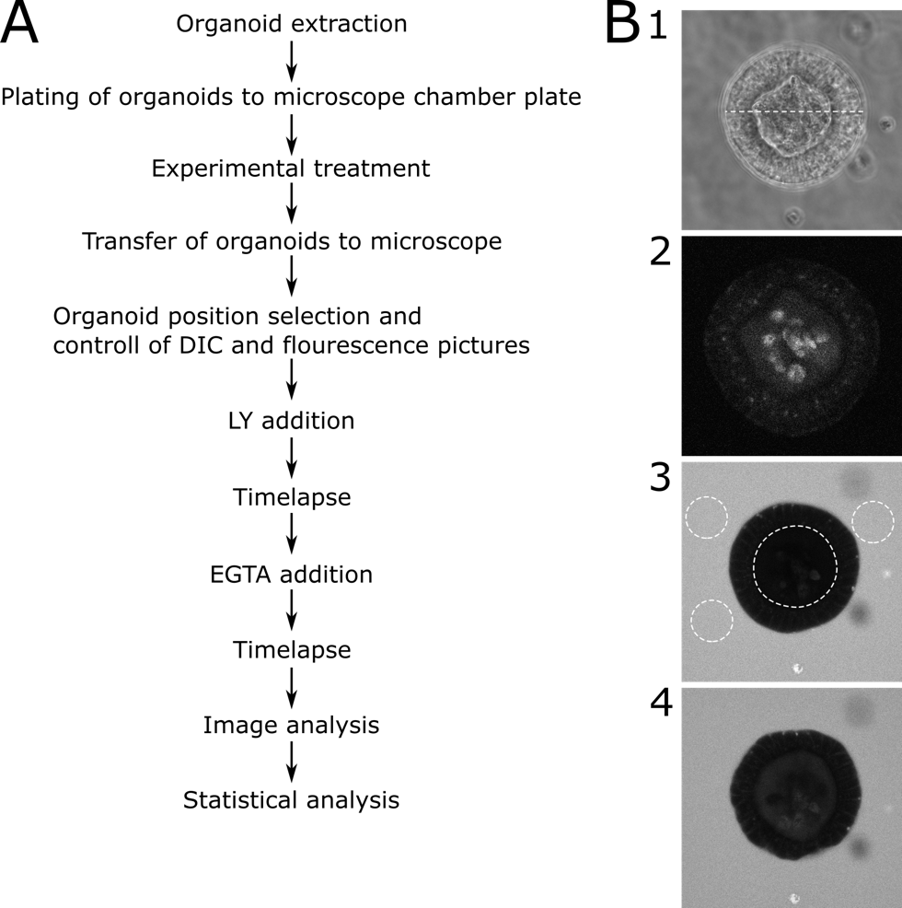
Fig. 3: Schematic protocol with representative images
(A) Schematic description of the main steps of the protocol (B) Representative pictures of major steps of the protocol. (1) DIC microscopy image of a central slice through a suitable organoid which was selected for permeability analysis. The dotted line represents a width of 89 µm. (2) Fluorescence microscopy picture of the same organoid as in (1) before adding LY. The image shows an autofluorescence of the organoid. (3) Picture 70 minutes after the addition of LY. The depicted organoid shows no uptake of LY and therefore an intact barrier function. Dotted lines depict the ROIs for further analysis. The inner lumen of the organoid and 3 representative areas around the organoid are marked. (4) Organoid after the addition of EGTA. The organoid is valid for further analysis as it shows LY uptake after EGTA treatment.
Minor Concerns:
Please refrain from using colloquial terms such as "falcon" for research material
Commercial language was removed from the protocol.
I am not sure this protocol can be called medium throughput as the time spent per treatment seems to be quite long.
We removed the term medium throughput from the manuscript.
It should be mentioned that diffusion time for compounds inside matrigel is slower than in liquid medium and that effects of compounds reaching organoids at the borders of the blobs earlier than organoid in the middle have to be taken into consideration.
We described the seeding of the organoids in a fashion to reduce the axial extension of the matrix-organoid blob:
Keep the slide on an ice pack for 5 minutes. This preserves the cell matrix organoid suspension liquid and increases the organoid concentration at the coverslip surface by gravity.
The difference to the protocols published by Zieke and Pearce should be explained in more detail. A short discussion of Co et al 2019 is also recommended, especially as the topic of apical versus basolateral application is brought up.
In contrast to the technique applied by Leslie⁴, Zietek⁵ or Pearce⁶, which measure fluorescence after removing LY from the medium, our approach allows to quantify the luminal uptake of the fluorophore over time.
lines 328-331: please rephrase to be more clear or remove Boj et al.,
Boj et al., established an organoid based method to study forskolin induced swelling for the individualized therapy of cystic fibrosis. This is independent of barrier integrity and we therefore removed the passage from the manuscript.
Reviewer #3:
Manuscript Summary:
The manuscript entitled "Investigating intestinal barrier breakdown in living organoids" is a protocol describing a new technique to quantify the barrier integrity of intestinal organoids. The protocol is well written, and the authors already published a more detailed study showing part of this method on "Stem Cell Research" journal (Bardenbacher et al., 2019).
Major Concerns:
To increase the value of this manuscript, the authors should include a troubleshooting section (ideally in table format) and include a schematic drawing of the protocol to provide a more accessible overview.
Thank you for this helpful suggestion. We added a figure for the schematic drawing (Fig. 3) and one for the troubleshooting (Fig. 4).
On page 2, line 117, where the authors wrote "as the organoids have obtained the desired size," a specific size range and representative picture should be included.
In Fig. 2 we show the size distribution of all organoids used for the quantification. Beside this information we added steps within the protocol to ensure seeding of organoids with sizes, that enable a standardized quantification of the intraluminal increase of LY fluorescence:
Discard complete supernatant and resuspend organoids, derived from one well (48-well) in 40 µl cold medium. Crop large organoid structures by pipetting the organoid suspension 5 times through a 10 µl pipet tip to receive structures with a size of 40-60 µm.
Note: Use the 10 µl tip on a 100 µl pipet tip to perform the cropping of the organoid structures. Practice cropping step in advance to ensure consistent results. Control the size of the organoids by phase contrast microscopy within the centrifugation tube. Ensure that there are no more multi-branched organoids are present and that organoid fragments are roughly 40-60 µm long.

Reviewer #4:
In this manuscript, Marco Bardenbacher and colleges introduced a new medium throughput assay to determine the barrier function of tight junctional (TJ) in live mouse small intestinal organoids. As a validation of this method, the authors treated intestinal organoids with IFNg, and found the intraluminal accumulation of Lucifer yellow (LY), while LY was excluded from the organoid lumen by functional intestinal barrier in non-treated wild-type organoids or IFNgR2DIELeven after IFNgtreatment. This is an interesting technique, but has already been shown in their previous report (Bardenbacher M. et al. Stem Cell Res, 2019). Although the authors described the details of the technique and the tips for experimental success, the validation data is almost the same in the previous report, and did not bring any new scientific insights to this manuscript.
This protocol was written upon an invitation to publish the method in JoVE after we published the results in Stem Cell Research. New scientific insights were not the focus of this protocol.
Minor comment:
In the figure legend of Fig.1, EGTA(EGTA) in the last second line is hard to understand. EGTA in "()" should mean the column of representative pictures treated with EGTA. The authors should clarify this point.
The figure legend was changed to be clearer:
Representative images at time point 0 min, 70 min and after addition of EGTA are shown (green: Lucifer yellow, size bar = 20 µm). This figure has been modified from Bardenbacher et al., 2019⁸.

With the help of the reviewer’s comments and the editor´s instructions, we could clearly increase the quality of the manuscript. We hope, that we were able to convince the reviewers of the validity of the presented assay and we were able to fulfil the formal requirements of the Journal.

Yours sincerely,

Philipp Tripal

