Rebuttal Letter

Dear Editors and Reviewers:
We appreciate the comments from the reviewers and the opportunity to improve the quality of our manuscript (Submission No: JoVE60543).
We have carefully addressed all the issues raised by the reviewers, and we have tried to improve this revision, we wish it could meet the high standards of the reviewers and this journal. The modifications are highlighted in red in the revised version of the manuscript.
Protocol text need to be featured in the video is highlighted in yellow.
Our point-by-point responses to reviewers’ critiques are included below in blue.
I am looking forward to hearing from you.
Sincerely,

Guangrui Huang, Ph.D.
Associated Professor of Microbiology and Biochemical Pharmacy
School of Life Sciences, Beijing University of Chinese Medicine
11 Beisanhuandong Road, Chaoyang District, Beijing, People’s Republic of China
Tel: +86-10-64286526 Fax: +86-10-64286526
E-mail: hgr@bucm.edu.cn (Guangrui Huang).

Reviewers' comments:
Reviewer #2:
Manuscript Summary:
This is a very interesting work, however, the resolution of the histological zones could be better.
Response: We agree with the Reviewer and we have replaced revised Figure 4 with high resolution pictures accordingly.
Minor Concerns:
I think that the figure 1 was not necessary included
Response: We agree with the Reviewer and we have deleted Figure 1.
Reviewer #4:
Manuscript Summary:
This manuscript describes three frequently used methods for evaluating the migration of normal neutrophils induced both in vivo and in vitro, as well as the infiltration of pathological neutrophils in a mouse joint-specific inflammation model.
The manuscript clearly sets out its objective and describes the protocols in a very straight forward manner with enough detail to repeat the procedures. The advantages of using these procedures and manners in which they can be modified to broaden their applications are nicely discussed. These methods are important methods for those working in the field and I would enjoy seeing the published videos.
Minor Concerns:
Perhaps I missed this, but it isn't clear to me what High-solution Buffer A/ Low solution buffer B and Retrieval buffers A/B are. Are these buffers purchased ready, if not can authors provide the recipes?
Response: We are sorry for our carelessness. The recipes have been included in the Material lists. For clarity, we have replaced “high-solution buffer A” with “70.2% Percoll” and replaced “low solution buffer B” with “54.8% Percoll”.
Reviewer #5:
Manuscript Summary:
The manuscript contains the methodologic details to evaluate the capacity of murine neutrophils to in vivo migrate in the inflammatory sites, by using the "air pouch assay" and the "adjuvant-induced arthritis". Even if no particular originality and novelty can be observed, the manuscript contains important technical information that can be useful for other researchers in the field. However, a more detailed and updated introduction is needed.
Response: We do appreciate Reviewer’s suggestion. We have added “Traditionally, neutrophils were considered as pathogen eliminators in acute phases of inflammation. However, recent findings have demonstrated that neutrophils are complicated cells capable of a significant array of specialized functions. Neutrophils are able to regulate many processes such as acute injury and repair, tumorigenesis, autoimmune response, and chronic inflammation^{12,13}. Neutrophils also modulate adaptive immune responses and can regulate B cells and T cells^{14,15}. Substantial shortage of neutrophils leads to mortality or severe immunodeficiency in humans and depletion of neutrophils in mice also leads to fatality. While excessive activation or recruitment of neutrophils in organs causes several immune diseases, such as RA and systemic lupus erythematosus (SLE)⁶.” in the Introduction section at line 73-81.
Major Concerns:
A Figure related to protocol 1. peritoneal neutrophils and also some comments on the level of activation can be useful to understand the number and the state of neutrophils that can be obtained with this protocol.
Response: We agree with the reviewer. New Figure 1 has been added to illustrated neutrophil isolation.

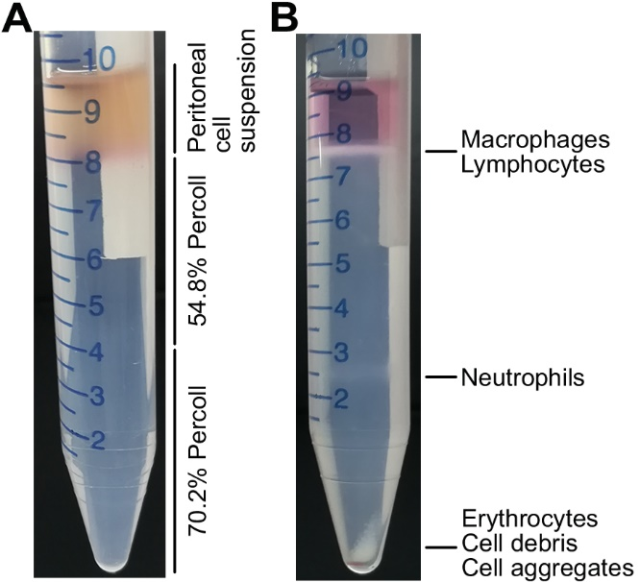
Figure 1: Neutrophil isolation. (A) Peritoneal exudate cells were collected from lavage fluid of mice. Cells were resuspended in 1 ml of RPMI-1640 complete medium, layered onto a two-step (54.8%/70.2%) discontinuous Percoll gradient. (B) After centrifuged at 1500 ×g for 30 min at 22 °C, neutrophils (≥ 95%, approximately 1×107 neutrophils/mouse) were recovered from the lower interface.
Line 196: the grade arthritis severity should be better described: what the authors intend as mild, moderate, severe, the most severe? Figures related to different grading can be very useful to reproduce the protocol. In addition, picture showing the measurements with pocket gauge can be very useful too.
Response: We do appreciate Reviewer’s suggestion. We have added “4.7. Every 3 days, assess arthritis severity by arthritis scoring criterion. 0, normal, no evidence of erythema and swelling; 1, the mildest arthritis, erythema and mild swelling confined to the tarsals or ankle joint; 2, moderate arthritis, erythema and mild swelling extending from the ankle to the tarsals; 3, severe arthritis, erythema and moderate swelling extending from the ankle to metatarsal joints; 4, the most severe arthritis, erythema and severe swelling encompass the ankle, foot and digits, or ankylosis of the limb.” at line 206-211.
We have added pictures of each arthritis score and measurement of ankle joint diameter using a pocket thickness gauge to revised Figure 3.
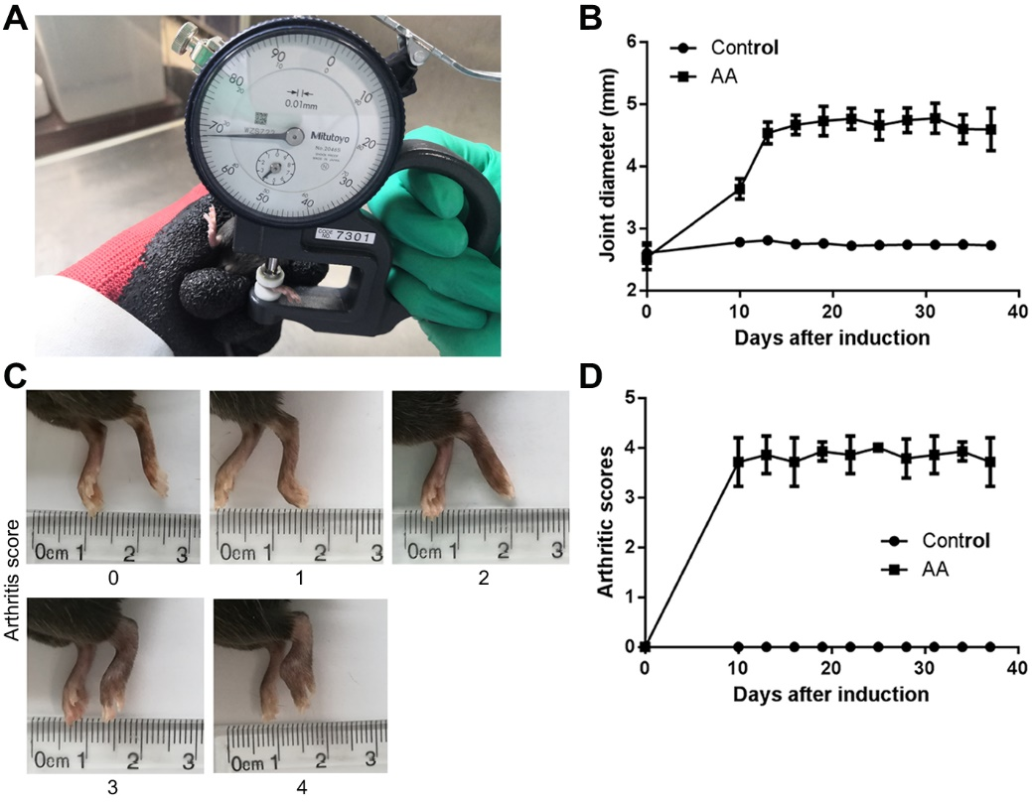
Figure 3: Representative results of the adjuvant-induced arthritis (AA) mouse model. (A) Measurement of ankle joint diameter using a pocket thickness gauge (B) Joint swelling was assessed by measuring the ankle joint diameter (n=7). (C) Pictures of each arthritis score. (D) The severity of arthritis was graded on a scale of 0-4 points (n=7). Data are presented as the mean ± SD.
Minor Concerns:
Line 85: please, indicate the solution used to dissolve proteose peptone, which, I assume, may represent the negative control (please, specify).
Response: Done as advised.
Line 130: please indicate what high-isolation buffer A is.
Response: The recipe has been included in the Material lists.
Line 132: please indicate what low-isolation buffer A is.
Response: The recipe has been included in the Material lists.
Line 137: please indicate the volume of peritoneal cell suspension.
Response: Done as advised.
Line 177: wash buffer is not specified in the list.
Response: The wash buffer has been included in the Material lists as “wash buffer in air pouch assay”.
Line 186: in which solution is suspended CFA? Final concentration?
Response: CFA was purchased from sigma, which can be used directly. However, when stored at 4 °C, precipitation usually occurs in CFA solution and suspending is recommended before using. We have added “by vortex at least 5 seconds” at line 197.
Line 190: please, specify which joint (ankle? knee?)
Response: Done as advised.
Line 235: please specify what retrieval buffer is.
Response: The recipe has been included in the Material lists.
Line 287: it is not clear which parts of the joints are originated Figure B. A minor magnification where Figure B derives can be very useful.
Response: We do appreciate Reviewer’s suggestion. We have revised the Figure 4 as advised.
Line 297: statistics is missing
Response: We have revised Figure 2 as advised.
Line 303: statistics is missing
Response: We have revised Figure 3 as advised.
Line 307: as already mentioned it is not clear the origin of Figure B
Response: Done as advised.
Line 315: no anti-inflammatory or antioxidant studies are shown in peritoneal neutrophils
Response: This study focused on the migration and infiltration of neutrophils. We have used peritoneal neutrophils to investigate the anti-inflammatory and/or antioxidant effects of tanshinone IIA, celastrol, triptolide and emodin on arthritis. Our published articles are listed as follows:
1. Zhang S, Huang G, Yuan K, et al. Tanshinone IIA ameliorates chronic arthritis in mice by modulating neutrophil activities. Clin Exp Immunol. 2017 Oct;190(1):29-39.
2. Yuan K, Huang G, Zhang S, et al.Celastrol alleviates arthritis by modulating the inflammatory activities of neutrophils. Journal of Traditional Chinese Medical Sciences. 2017 Jan; 4(1):50-58.
3. Huang G, Yuan K, Zhu Q, et al. Triptolide inhibits the inflammatory activities of neutrophils to ameliorate chronic arthritis. Mol Immunol. 2018 Sep;101:210-220.
4. Zhu M, Yuan K, Lu Q, et al. Emodin ameliorates rheumatoid arthritis by promoting neutrophil apoptosis and inhibiting neutrophil extracellular trap formation. Mol Immunol. 2019 Aug;112:188-197.
The Name of Material/equipment needs some revision. For example, high and low solutions A and B as well as retrieval buffer A and B and wash buffer need to be specified.
Response: We are sorry for our carelessness. The recipes have been included in the Material lists. For clarity, we have replaced “high-solution buffer A” with “70.2% Percoll” and replaced “low solution buffer B” with “54.8% Percoll”.
Comments lack the end of the sentence: The secondary antibody used in the immunohistochemical staining………what?
Response: We are sorry for our carelessness. We have corrected the error.

An accurate editing of English is suggested throughout the manuscript.
Response: Done as advised.

