Phone: +45 35 33 70 05 Department of Biomedical Sciences,
Email: clare.hawkins@sund.ku.dk University of Copenhagen
Panum Institute
Blegdamsvej 3
Copenhagen N, 2200, Denmark

12th August 2019
Manuscript submission: JOVE

Dear Vineeta,

Thank you for your recent correspondence in regards to an opportunity to revise our manuscript titled “Stimulation and visualization of extracellular trap release in differentiated human monocyte-derived macrophages in vitro.”, for publication in JoVE. We have revised the manuscript carefully according to the editorial and reviewers comments, as detailed in the attached response letter. All changes made to the manuscript are shown in tracked changes.

We hope that the filming for the article can be completed by the end of September 2019, as the first author, who will be demonstrating the protocol is a final year PhD student, and will be submitting her thesis and completing her studies by this date.

In addition, would it be possible to copy all correspondence in relation to this manuscript to Dr Benjamin Rayner (Benjamin.rayner@hri.org.au) who is the co-corresponding author for this manuscript. This is particularly important for coordination of the filming, which will be undertaken at the Heart Research Institute in Sydney, and not at my location in Denmark.

Thank you again for your kind invitation and this publication opportunity,

Yours sincerely,
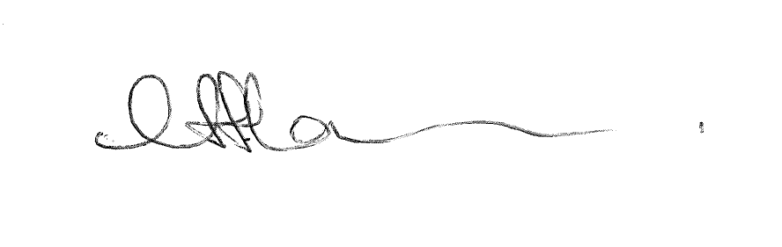
Professor Clare L. Hawkins

