Software Usage
(A) Click “Play” button to preview image, as indicated by red circle
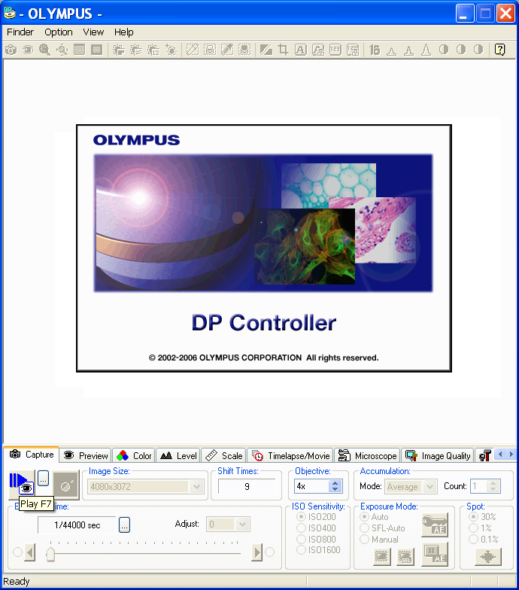
(B) Adjust fine focus knob on microscope until image appears sharp/clear/focused in the software preview window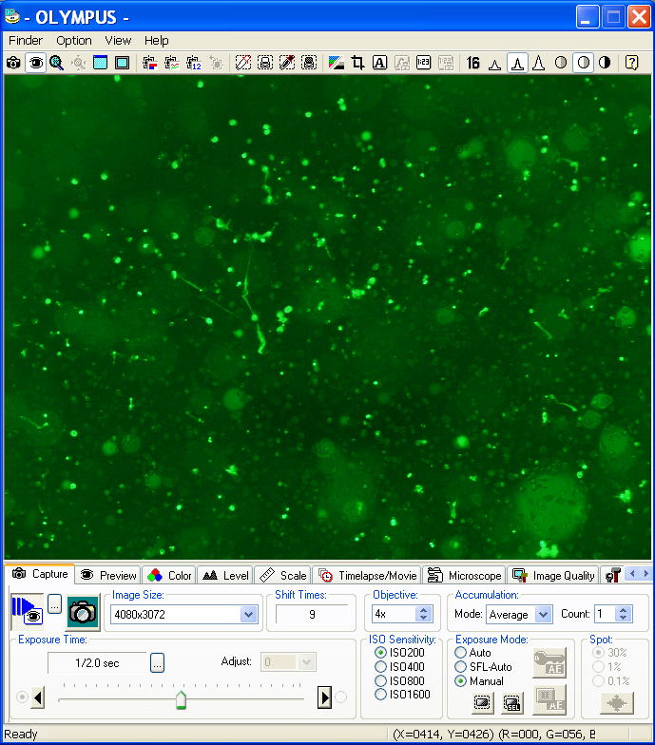
Figure1. Screenshot images corresponded to step 4.14.
(A) Click “Capture” button, as indicated by red circle
(B) Captured image displays in the accompanying DP Manager software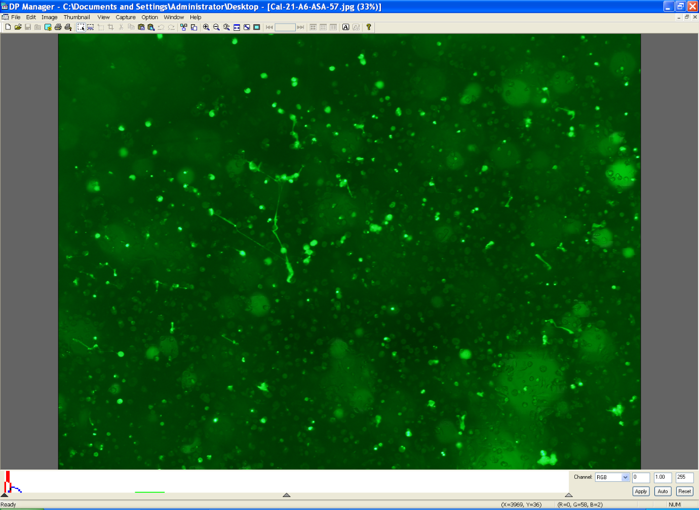
Figure2. Screenshot image corresponded to step 4.15.
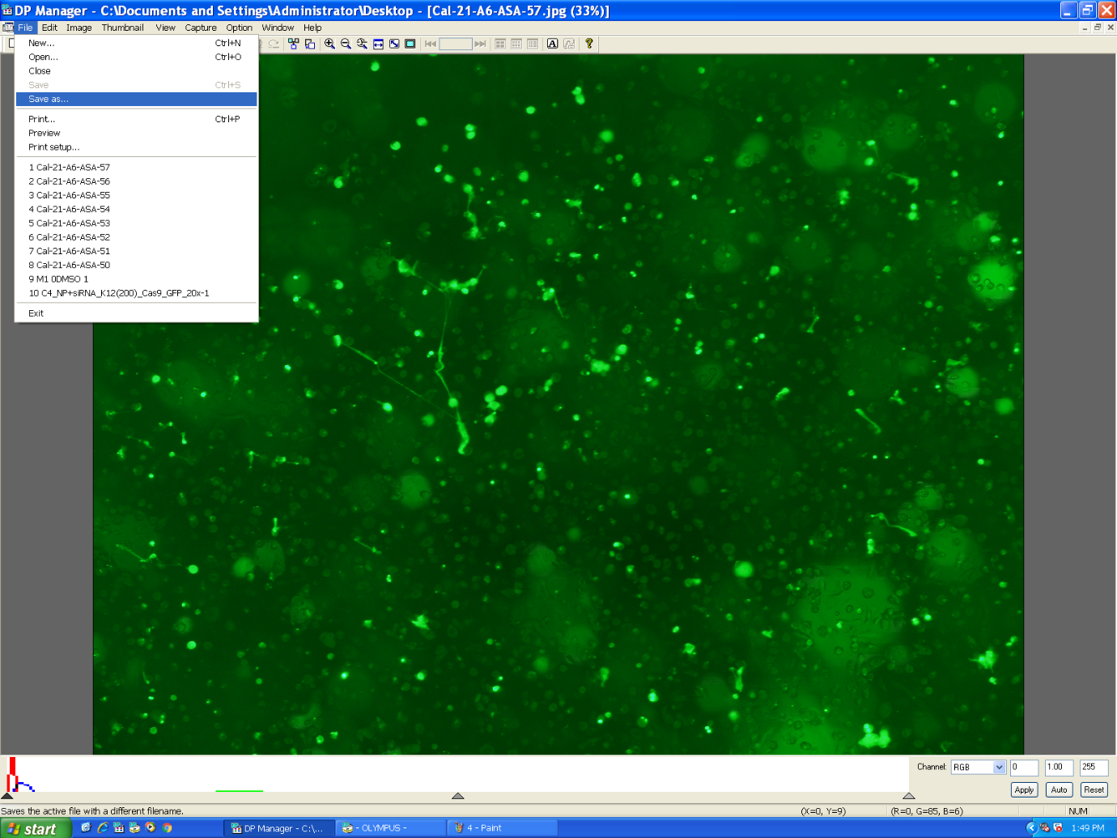
Figure 3. Screenshot image corresponded to step 4.16
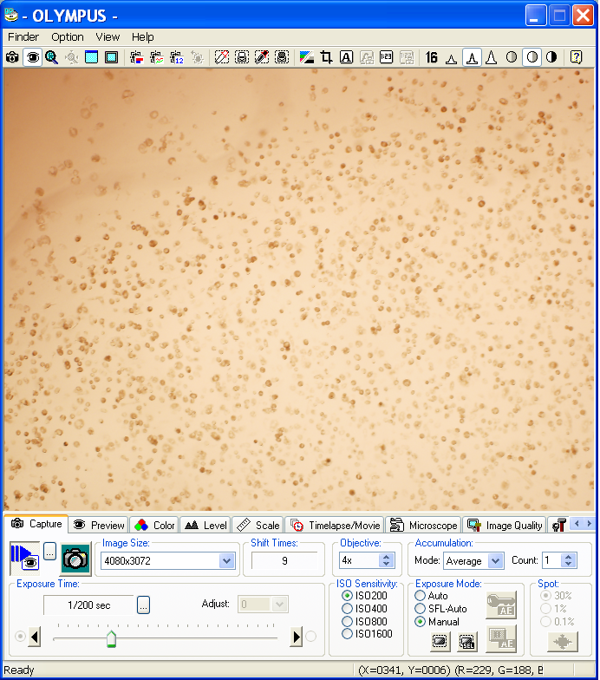

Figure 4. Screenshot image corresponded to step 4.17

