Editorial Comments:
• Please take this opportunity to thoroughly proofread the manuscript to ensure that there are no spelling or grammatical errors.

Response: The spelling and grammatical errors have been corrected.

Protocol Detail: Please note that your protocol will be used to generate the script for the video, and must contain everything that you would like shown in the video. Please add more specific details (e.g. button clicks for software actions, numerical values for settings, etc) to your protocol steps. There should be enough detail in each step to supplement the actions seen in the video so that viewers can easily replicate the protocol. Some examples:
- 1.1: Mention animal strain.

Response: The animal strain we used in the experiment is C57BL/6 and has been indicated in the revised manuscript.

- 1.3: Do you perform toe pinch to test depth of anesthesia?

Response: Actually we didn’t perform toe pinch to test depth of anesthesia. In this experiment we observe the heart beat of mice to judge whether anesthetization is appropriate.

• Protocol Highlight: After you have made all of the recommended changes to your protocol (listed above), please re-evaluate the length of your protocol section. There is a 10-page limit for the protocol text, and a 3- page limit for filmable content. If your protocol is longer than 3 pages, please highlight ~2.5 pages or less of text (which includes headings and spaces) in yellow, to identify which steps should be visualized to tell the most cohesive story of your protocol steps.
1) The highlighting must include all relevant details that are required to perform the step. For example, if step 2.5 is highlighted for filming and the details of how to perform the step are given in steps 2.5.1 and 2.5.2, then the sub-steps where the details are provided must be included in the highlighting.
2) The highlighted steps should form a cohesive narrative, that is, there must be a logical flow from one highlighted step to the next.
3) Please highlight complete sentences (not parts of sentences). Include sub-headings and spaces when calculating the final highlighted length.
4) Notes cannot be filmed and should be excluded from highlighting.

Response: The protocols for filming have been highlighted according to the rules above.

• Discussion: JoVE articles are focused on the methods and the protocol, thus the discussion should be similarly focused. Please ensure that the discussion covers the following in detail and in paragraph form (3-6 paragraphs): 1) modifications and troubleshooting, 2) limitations of the technique, 3) significance with respect to existing methods, 4) future applications and 5) critical steps within the protocol

Response: Discussion has been written according to the rules above.

• Tables: Table 1–4 appear to be missing from the submission.

Response: Tables have been submitted.

• References: Please spell out journal names.

Response: We inserted the reference using the JoVE EndNote style file.

• Please define all abbreviations at first use.
Response: All abbreviations have been defined at first use.

• If your figures and tables are original and not published previously or you have already obtained figure permissions, please ignore this comment. If you are re-using figures from a previous publication, you must obtain explicit permission to re-use the figure from the previous publisher (this can be in the form of a letter from an editor or a link to the editorial policies that allows you to re-publish the figure). Please upload the text of the re-print permission (may be copied and pasted from an email/website) as a Word document to the Editorial Manager site in the "Supplemental files (as requested by JoVE)" section. Please also cite the figure appropriately in the figure legend, i.e. "This figure has been modified from [citation]."

Response: All the data are original and haven’t been published.

Reviewer #1

Line 90: it would be helpful if the authors would include a description of the kinetics of the immune response in this model and explain why they would look at day 10 for the T cell response and 14 for the AB.
The authors should also indicate at what stage infection risk or BSL2 concerns are mitigated.

Response: We added the kinetics of Tfh and GC B response in the manuscript (Fig.2c and Fig.2e). Fig.2c shows that T cell response peaked at day 10 and Fig.2e shows GC B reaction continued to increase at day 14. We reasoned the influenza virus-specific antibody titer should also peak at day 14.

It has been indicated that at which steps procedures infection risks or BSL2 concerns could be mitigated (lane 208, lane 474).

98: what strain of mice is being used? Disease severity can vary between strains, so this is crucial information. The authors should indicate if female mice have the same magnitude of response in this strain.

Response: The mouse strain we used is C57BL/6 and the female mice have the same magnitude of response, all of which have been added in the revised protocol.

100: there are several incorrect words throughout the entire protocol. For example, the authors use refrigerator instead of freezer.

Response: the words have been corrected

104 the authors later mention this in the discussion, but it would be appropriate to give the rationale here why mice are being anesthetized. In addition, the authors should indicate why they pick this specific injectable (which is not necessarily easily approved by animal care committees around the globe due to its variability in efficacy and risk of overdosing compared to other injectables (they should make a case that injectables are preferred over inhaled anesthetics).

Response: we agree with the reviewer that the rationale of anesthetization should be mentioned in the protocol section and it has been added in the note following step
1.3. With regard to reagents for anesthetization, inhaled anesthetics is indeed a better choice for its greater safety and easier control of anesthetization depth. However, there is not special equipment for treatment of inhaled anesthetics in our institute. So we have to choose injectable reagent for anesthetization. Actually pentobarbital is a commonly used injectable reagent¹, the amount of which for appropriate anesthetization has been studied in previous paper and titrated in our lab so that the risk of overdosing could be avoided.

117: presumably the mice are placed in a warm cage

Response: It’s true that the mice for infection are placed in the warm cage and we have modified the description.

123: the authors should indicate that euthanasia should be performed according the institutional animal care committee and should include a secondary method of euthanasia. The current description does not fall under allowable practices at many institutes

Response: All the protocols have been approved by the institutional animal care and use committee and we have mentioned this in the beginning of this section. In brief, the euthanization protocol we described here includes CO₂ euthanization and a second physical euthanization (cervical dislocation). This protocol has also been applied in the other institute ².

128: proper language would include dissection board, dissection needles etc.

Response: Words have been corrected.

132-141: part is missing. Presumably the organs go in a tube or dish and not on ice.

Response: The missing part has been added (lane 186-194).

156: counting point 2.10 should be a sub point from 2.9. counting calculations should be provided.

Response: We agree with the reviewer that counting point 2.10 should be a sub point from 2.9 and the edition has been made in the revised protocol. In addition, the calculation method has been added in the step 2.10.3 in the revised protocol.

166> it is completely unclear why biotinylated Ab are preferred over directly conjugated Ab. This makes the protocol more complex, results in increased background in biotin-high animals (such as those on a high fat diet or on a NOD like background)
Viability staining should be added to this section.

Response: Actually biotinylated antibody is commonly used for CXCR5 staining. We compared the Tfh staining using directly conjugated anti-CXCR5 antibody (eBioscience; Clone: SPRCL5) and biotinylated antibody with the same sample. as shown in Res Fig.1. Combined with PD1, staining with biotinylated CXCR5 generated more distinguished Tfh population than directly conjugated antibody.

Indeed, we have ever tried including viability staining in Tfh analysis. We found that viability staining didn’t affect the analysis of Tfh frequency as lymphocyte gating in the first step exclude almost all the dead cells(Fig.2a). So we don’t think viability staining is necessary in this section.
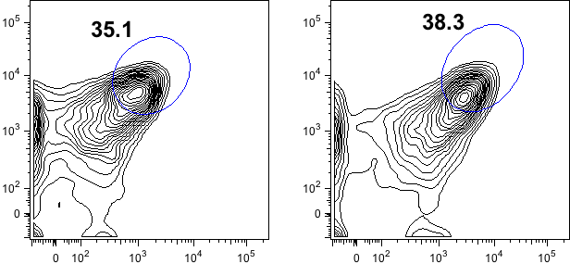
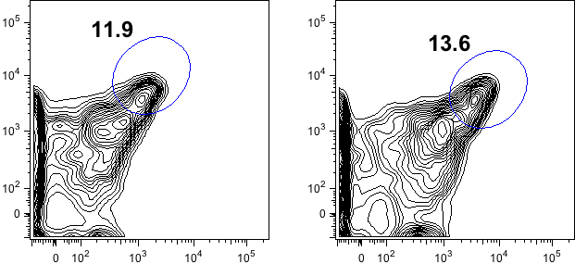
Direct
Indirect
Spleen
mLN
CXCR5
PD1

D

Res Fig 1. Tfh population staining with directly conjugated or biotinylated antibody. mLN and spleen cells from influenza virus-infected mice were stained for Tfh population with PD1 and CXCR5 antibody. “Direct” indicates using directly conjugated PE-anti-CXCR5 antibody and “Indirect” indicates using biotinylated anti-CXCR5 antibody, followed by stained with PE-streptavidin. FACS plots are gated from CD4⁺CD44^{hi}CD62L^{low} activated cells. Numbers indicate the frequency of Tfh cells in activated cells.

168: staining buffer is presumably PBS, indications on magnesium and calcium should be added.

Response: Indeed, staining buffer is mainly PBS and the recipe of PBS has been indicated (lane 111).

212: the authors indicate that this protocol is different from published protocols. They should explain what the advantage of this protocol is over the published ones. An irrelevant tetramer control should be included as negative control. The authors should indicate that specific CD4 Ab might interfere with the optimal binding. The authors should refer to mechanism that improve tetramer binding, such as other multimeric structures or inclusion of specific protein kinase inhibitors.

Response: Actually, the tetramer staining we described is just a more detailed edition than that in published paper. Staining results with an irrelevant tetramer control have been shown in Fig.3e.
We agree with the reviewer that CD4 Ab could interfere with tetramer staining. Thus tetramer was stained firstly before staining CD4 (lane 335). This strategy works in avoiding the interference of optimal tetramer binding. As shown in Res Fig 2, we stained tetramer with two strategies: The first (Left, tetramer first) is to add tetramer first, as what we describe in the manuscript; the other (Right, CD4 Ab first) is to add CD4 Ab first. We could see that tetramer frequency stained with the first strategy is 2-fold of the frequency stained with the second strategy in the same sample. We agree with the reviewer that such strategy should be indicated in the protocol and note has been added following step 4.2.

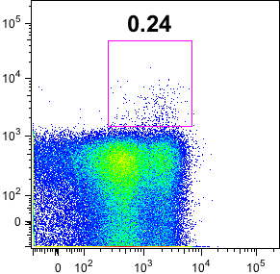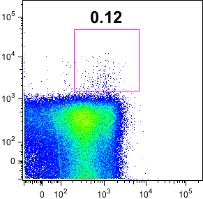
CD4 Ab first
Tetramer first
Tet

Res Fig 2. Tetramer staining with two different strategies. mLN samples from influenza virus-infected mice were stained for tetramer with two different strategies. “Tetramer first” (Left) indicates staining of tetramer is before addition of CD4 Ab. “CD4 Ab first” indicates staining of CD4 is before staining tetramer. FACS plots are gated from CD4⁺ T cells. Numbers indicate the frequency of Tetramer⁺ cells in CD4⁺ T cells.

CD44

239. The authors use in-house made buffers. It is likely that readers will use kits. A note should be included that kits should be appropriate for nuclear/transcription factor staining and not just for general intracellular staining.

Response: We agree that the kits should be appropriate for nuclear/transcription factor staining, especially for Bcl6^{3,4}. However, we don’t use kits for Bcl6 staining in our lab and don’t know exactly the staining results. So we don’t think such note should be added here.

262. the intracellular staining is very complex by using human Fc-IL21 R followed by anti-human Ig(H+L). Why is this better than directly conjugated ab?

Response: Actually we don’t know why human Fc-IL21 R is better than directly conjugated ab. Besides IL21-reporter mice, it seems to be a common strategy to detect the production of IL21 in this field.

355. what type of milk is added?

Response: It is skimmed milk that is used in this step and has been specified in the revised protocol (lane 486).

367. the dilution factor should be replaced by the concentration.

Response: As the concentration of HA-specific antibody in serum is unknown, the concentration of diluted serum is also unknown. Actually the aim of this experiment is to compare the concentration of antibody in two samples, so it is not necessary to assay the accurate concentration in each sample.

370. what is an equal volume of balance.

Response: Actually this is a description of the manual from the TMB Substrate Reagent Set and we have added this information below “step 9.6” as a note.

374. analysis information should be provided (wavelength, subtraction of background wavelength, reference to a calculation method).

Response: Analysis method has been added in the step 9.8.

377. Information of isotype controls is missing, dilution of Ab should be replaced by concentration, rationale for use of goat serum should be given (can this be replaced by cow/horse/donkey/rabbit). Organization and word choice are not great: example quickly wash the tissue with shaking slowly for 5 min. analysis is missing. information on how to analyze these type of data sets is missing.

Response: We didn’t use isotype controls in this experiment. Instead, in negative controls we directly add fluorochrome-labeld secondary antibody without staining the primary antibodies (not shown in manuscript).

The dilution of antibody has been replaced with concentration.

As the fluorochrome-labeld secondary antibody is generated from goat serum. So to avoid non-specific signals, block buffer should also use goat serum.

The information of how to recognize GC has been provided in Fig.4d. In addition, we add the method of evaluating GC B response in step 10.12.

Reviewer #2:

- The methods are focused on mice and I think this needs to be reflected in the title and abstract as these methods are not applicable for the evaluation of Tfh cells in humans.

Response: We agree with the reviewer and have indicated that this protocol is only applicable in mouse models in the title and abstract.

- The strain of mice needs to be specific in the methods. I am guessing it is C57B6 mice, but it is important to clarify as infection severity may vary in other mice. Additionally, the I-Ab NP tetramer will only work in mice with the I-Ab allele.

Response: It’s true that the mouse strain we used is C57BL/6 and the information has been indicated in protocol 1.1.

- I couldn't find tables listed in lines 510-517. Please check

Response: We are sorry that tables are lost while submission and have been added in the revised edition.

- RBC lysis buffer needs to be described in detail (source? If in-house, what are the ingredients?)

Response: The ingredient of RBC lysis buffer has been indicated in the revised edition (lane 214)

- The clone of antibody would be useful, please include in tables.

Response: The clone of antibody has been included in tables.

Reviewer #3:

Major Concerns:
- Figure 4 is missing from the manuscript.

Response: We are sorry for the mistake. Figure 5 is actually Figure 4.

- Figure 2b-c: showing a better separation for Tfh cells and plasma cells would be more convincing.

Response: We have renewed the FACS image, which shows better separation of Tfh cells (Fig.2b). As for plasma cells, actually we couldn’t find better figures. However, as plasma cells are all IgD^{low} cells, IgD^{hi} cells as negative gating controls for gating CD138⁺ cells.

- Figure 3a: separation of PD-1, CXCR5 double positives is not convincing.

Response: We checked our previous data and found that Tfh population in day 10 influenza virus-infected samples is exactly like what Fig 3a shows. Actually Day 7 Tfh cells is a more distinguished population than Day 10. Res Fig.2 shows Tfh cell differentiation on day 7 and day 10. We could see that though Day 10 samples show worse separation of Tfh cells, Tfh frequency of Day 10 is much larger than that of Day 7 sample.
Day 10
Day 7

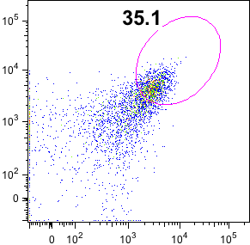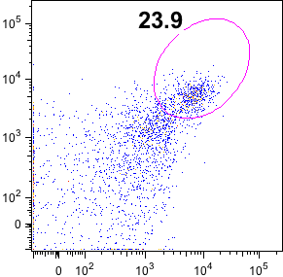
PD1
CXCR5

Res Fig 4. Tfh staining with Day 7 and Day 10 mLN cells. These cells are gated from CD4⁺CD44^{hi}CD62L^{low} activated cells. Numbers indicate the frequency of Tfh cells.

Minor Concerns:
- A native English speaker should edit the manuscript.

Response: Thanks for the suggestion and the manuscript has been edited.

- Please write "influenza virus" instead of influenza throughout the text.

Response: The correction has been made.

- Line 48: first mention of Bcl6, please write "B cell lymphoma 6 (Bcl6)"

Response: The correction has been made.

- Line 96: "PR8 influenza virus" instead of PR8.

Response: The correction has been made.

- Line 111: 10 µl seems to be a very low volume. 25-30 µl is what most people use.

Response: Actually 10 µl is just for one side and the total volume is 20 µl.

- Lines 156-158: I would mention that step 2.9 needs to be repeated if RBC lysis is not complete. It often happens.

Response: Actually, we didn’t encounter such problem in the previous experiment. In this step, I think the key is the ratio of the lysis buffer volume to the cell volume, which is 9 in our protocol and sufficient for effective RBC lysis.

- Line 352: I would add the volume: 100 µl HA protein at 1 mg/ml

Response: We have revised the description to “Coat ELISA plates with 50 µl 2µg/ml HA protein solution per well”.

- Lines 355: step 9.2: 3% BSA in PBS can be used as blocking buffer.

Response: We agree that 3% BSA in PBS could be used as blocking buffer. But with 5% skimmed milk in the PBST, we could also get reasonable result. As shown in Figure 4d, there is hardly background signal in the well of samples from PBS-treated mice.

9. Lines 358-361: adding an anti-HA monoclonal antibody as a positive control can be useful.

Response: The aim of this ELISA protocol is to compare the titer of HA-specific antibody in two samples. So it’s a relative value. We agree with the reviewer that HA-specific antibody in this section would facilitate assaying a definite value of antibody titer. But it’s not necessary in this kind of experiments.

Reviewer #4:

Major Concerns:
- The mice infected with PR8 influenza virus model is well established. In general, the body weight loss is almost 20% in mice infected with PR8 influenza virus at day 8 and maintain at day 10. However, the body weight is decreased to 90% at day 8, and quickly recovered to the initial level at day 10. After the PR8 influenza infection, there are more leukocyte infiltration and severe tissue damage in the lung. It is better to show the Hematoxylin and eosin (H&E) staining images of lung sections in the mice infected with PR8 influenza virus.

Response: The weight change kinetics is affected by several factors, such as virus titer and mice strain. So it’s normal the weight loss we observed is not similar with that in published papers. In addition, weight loss and enlarged mediastinal lymph node could be a good sign of influenza virus infection and the main part should be assay of Tfh-associated response. So we don’t think HE staining of Lung sections is necessary in this protocol.

- The GC B response induced by influenza virus is more robust in mLNs than in spleens, however, in figure 4 d, the confocal microscopy showed the B cell follicles and GCs in the spleen samples of PR8-infected mice and PBS treated mice. Moreover, the quality of confocal image is not well. You should perform the confocal immunofluorescence staining of GCs and B cell follicles in the mLNs clean and clearly.

Response: Actually, both spleen and mLN are appropriate for GC confocal analysis. However, mLNs in PBS-treated mice is too small for confocal analysis. So we just provide the confocal image of mLNs from influenza virus-infected mice here (Res Fig 4), not in the manuscript. Indeed, there was robust GC reaction in mLNs of influenza virus-infected mice.
IgD PNA

Res Fig 5. Confocal image of GC B in influenza virus-infected mLN. On day 10 after infection, mLN from influenza virus-infected mice was isolated and stained with IgD (red) and PNA (green) for GC B detection.

- In the protocol 3 "Immunostaining of Polyclonal Tfh cells with PD1 and CXCR5", the description is not clearly and mess up. Such as "3.1.5. Add 0.3 µl biotin-anti mouse CXCR5 for each tube and vortex by tapping the tube bottom." You can modify the sentence, such as "Resuspend cells in 100 µl of biotin-anti mouse CXCR5 antibody at 1:100 diluted in FACS buffer" might be better.

Response: As described in the “Note” following 3.1.3. The residue volume after we discard the washing buffer is about 25 μl. Then the volume would be 30 μl after Fc-receptor blocker (diluted in 5 μl staining buffer) was added. So the dilution factor is 1:100 when we add 0.3 μl antibody. But we agree with the reviewer that it will be more clear if we indicate the volume of residue staining buffer in the tube (lane 300).

- This Article addresses the details for measuring TFH and GC B cells in PR8 influenza virus model. The authors described that the bodyweight of the mice infected with PR8 was decreased at the highest level on day 8. However, the TFH and GC B cells were analyzed at the day when the mice recovered in this article. It is better to show the kinetics of TFH and GC B cells responses during infection with PR8 influenza virus before picking an appropriate time point for analysis.

Response: We agree with the reviewer that showing immune response kinetics (Tfh and B cells) would be will be more helpful for better understanding this model. We added the kinetics in Fig.2c and Fig.2e.

Reference:

1 Gargiulo, S. et al. Mice anesthesia, analgesia, and care, Part I: anesthetic considerations in preclinical research. ILAR J. 53 (1), E55-69, doi:10.1093/ilar.53.1.55 (2012).
2 Rodriguez, L., Nogales, A., & Martinez-Sobrido, L. Influenza A Virus Studies in a Mouse Model of Infection. J Vis Exp. (127), doi:10.3791/55898 (2017).
3 Leavenworth, J.W., Verbinnen, B., Yin, J., Huang, H., & Cantor, H. A p85alpha-osteopontin axis couples the receptor ICOS to sustained Bcl-6 expression by follicular helper and regulatory T cells. Nat Immunol. 16 (1), 96-106, doi:10.1038/ni.3050 (2015).
4 Xu, L. et al. The transcription factor TCF-1 initiates the differentiation of T(FH) cells during acute viral infection. Nat Immunol. 16 (9), 991-999, doi:10.1038/ni.3229 (2015).

