Jaydev Upponi September 3, 2019,
Science Editor
Immunology and Infection
Editorial Department
JoVE

Dear Dr. Upponi,

Please find enclosed our revised manuscript entitled “High Frequency Ultrasound Evaluation of Abdominal Aortic Aneurysms in Angiotensin II-Induced Mouse Models” for potential publication in the JOVE.

In the present study, we have all the concerns raised by the Editor with regard to the highlighted steps, resolution of images and significance of using a notch inhibitor. We have also revised the figures and table of materials appropriately.

We hope that the revised article is suitable for publication in the JOVE.

Thank you for your consideration of this paper for potential publication.

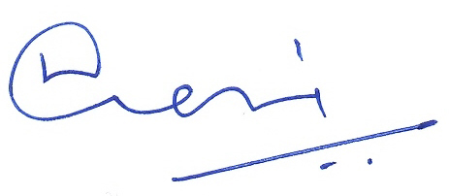
Sincerely,

Chetan P. Hans, PhD
Assistant Professor
School of Medicine - Cardiology & Medical Pharmacology and Physiology &
Dalton Cardiovascular Research Center
University of Missouri
134 Research Park Drive
Columbia, MO 65211
573-884-7225 ph 573-884-4232 fx
HansCP@health.missouri.edu

