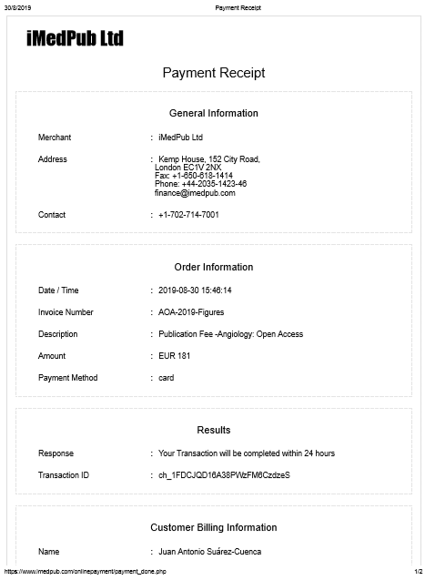

Regarding figure adapted, to be used in other manuscript. Article entitled: “Relation of Coronary Artery Lumen with Baseline, Post-angioplasty Coronary Circulating Pro-Inflammatory Cytokines in Patients with Coronary Artery Disease”

 | 0:34 (hace 12 horas)
  Angiology Open Access
Dear Dr. Juan A. Suárez-Cuenca,

Greetings from Angiology: Open Access..

We thank you for your mail.

To use the figures, you need to pay the charges to get the permission from the Journal. Kindly let us know to which Journal you are going to submit so that we will help you accordingly.

Your quick response makes the process faster.

Awaiting your response.

With kind regards.
Peddinti S
Editorial Coordinator
---------------------------------------------------------------------------------------------------------------------------------
 | vie., 23 ago. 18:11 (hace 5 días)
  Juan A. Suarez-Cuenca <suarej05@gmail.com>
para mí, angiology, angiology, Paul

Dear Dr. Brad A. Bryan
Editor-in-Chief Angiology Open Access
Center of Excellence in Cancer Research,
Paul Foster School of Medicine
Texas Tech University, USA

I hope this e-mail finds you well.
Regarding our article already published in Angiology, Open Access, entitled: “Relation of Coronary Artery Lumen with Baseline, Post-angioplasty Coronary Circulating Pro-Inflammatory Cytokines in Patients with Coronary Artery Disease”

I let you know that our study reached a lot of visibility thanks to the publication in your renowned journal, which is of high acknowledge. I was invited to publish on this subject in a Video Journal, mainly devoted to describe useful methods used in biomedical research. Although we focused our Video Journal manuscript in the "step-by-step" description of our methods, there is a section of the manuscript where some results obtained with the detailed methods are requested.
Therefore, I have prepared figures, which were adapted from the manuscript already published in your Journal. But before continue with the process of submittion to the video Journal, I want to make sure that there is no ethical or copyright issues that might be involved from this action; considering that citation acknowledge ("adapted from...Angiology Open Access") was stated in the figure prepared for the manuscript to submit to the video Journal.

I would appreciate your advice, and do not hesitate to let me know if any additional information or action is required.

Warm regards,

Dr. Juan A. Suárez-Cuenca

