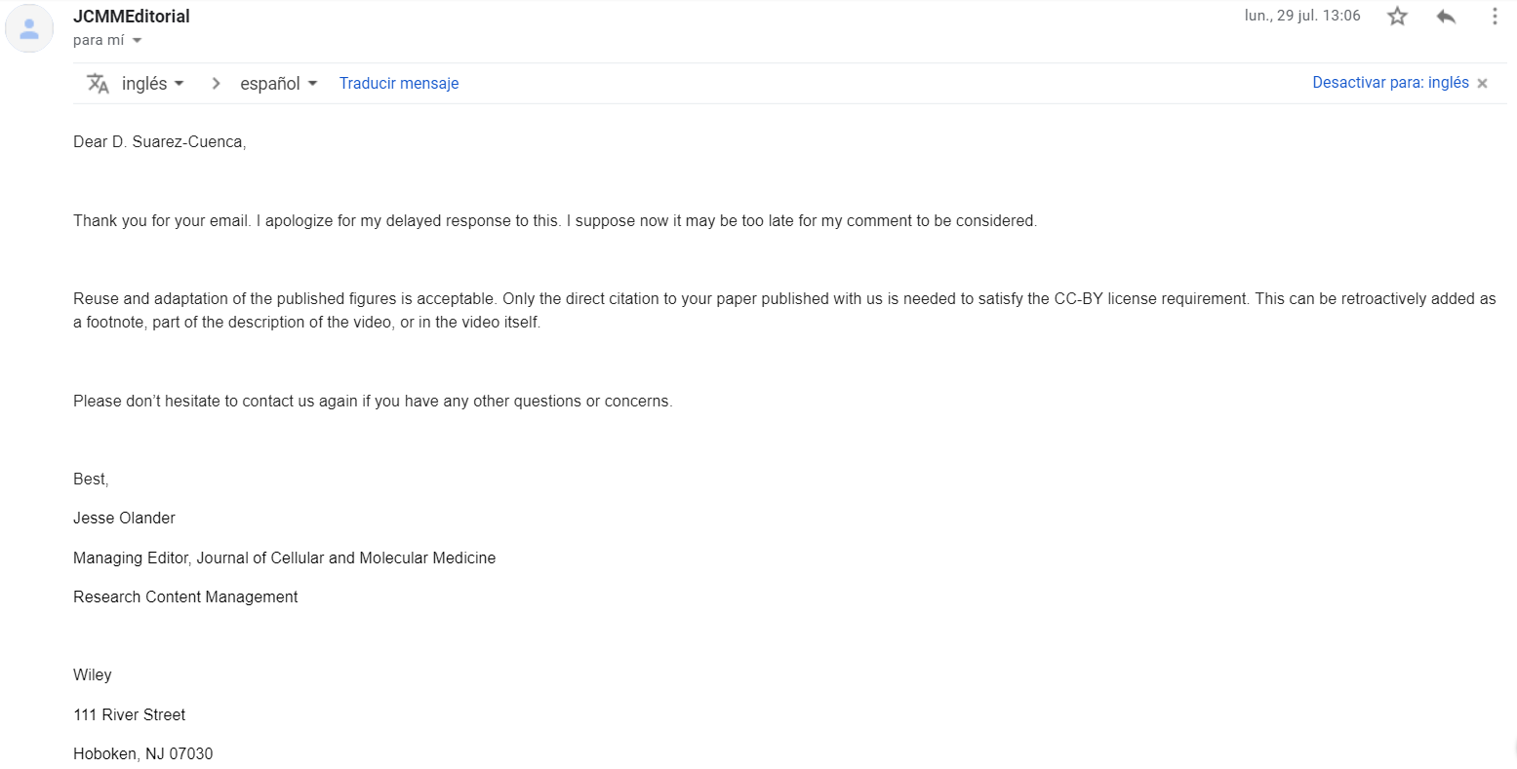

 | lun., 29 jul. 13:06
  JCMMEditorial
Dear D. Suarez-Cuenca,
Thank you for your email. I apologize for my delayed response to this. I suppose now it may be too late for my comment to be considered.
Reuse and adaptation of the published figures is acceptable. Only the direct citation to your paper published with us is needed to satisfy the CC-BY license requirement. This can be retroactively added as a footnote, part of the description of the video, or in the video itself.
Please don’t hesitate to contact us again if you have any other questions or concerns.
Best,
Jesse Olander
Managing Editor, Journal of Cellular and Molecular Medicine
Research Content Management
Wiley
111 River Street, Hoboken, NJ 07030, USA
www.wiley.com, jolander@wiley.com

