Dear Editor,

In the manuscript, we adopted figures from a paper on Soft Matter that we previously published (Bate et al. Soft Matter 15 5006 (2019)). Since we are the authors of the paper, according to their policy, we can reuse the published figures as long as the Royal Society of Chemistry is acknowledged. Please find policy about reusing the figures on the website: https://www.rsc.org/journals-books-databases/journal-authors-reviewers/licences-copyright-permissions/ along with attached screenshots and emails from the Roayl Society of Chemistry. If you have further concern about the copyright permission, please do not hesitate to contact us. Thank you.

Sincerely,
Kun-Ta Wu
Assistant Professor
Department of Physics
Phone: 508.831.6057
Email: kwu@wpi.edu

Email with the Royal Society of Chemistry:
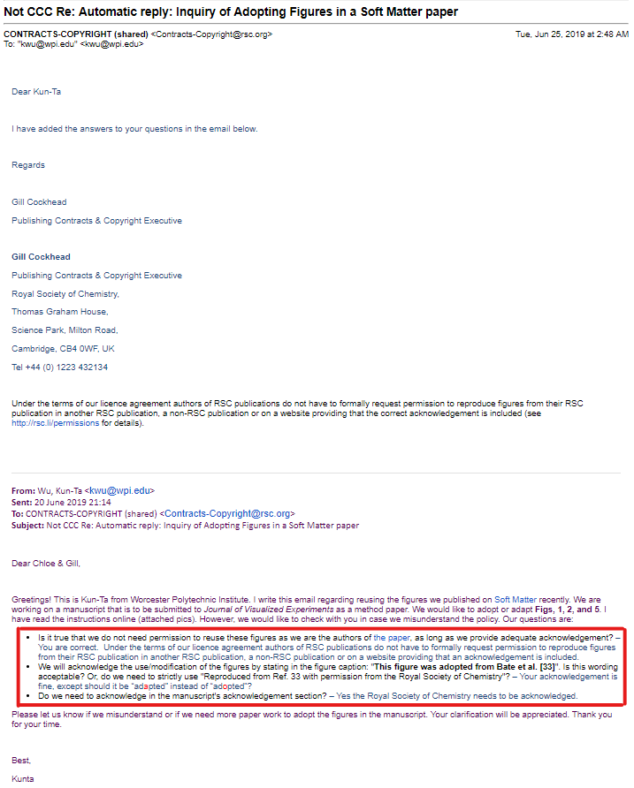

Re-Use Permission of the Royal Society of Chemistry:
